.

PROFESSIONAL CONSULTANCY SERVICES FRAMEWORK
FOR
HOUSING DEVELOPMENT
FOR
THE HAVEBURY HOUSING PARTNERSHIP
AND ITS OTHER SUBSIDIARIES

INVITATION TO TENDER
November 2019
Contents
1. Introduction and Background 3
Introduction 3
Background 3
Brief description of Tender Process 5
TUPE 6
2. Tender Guidelines and Process 7
Completion and Submission of Invitation to Tender 7
Clarity of Documents 9
Timetable 10
Third Party Verifications 10
Rejection of tender responses or other documents 10
Disqualification 11
Employer's Requirements 12
3. Scope of Services 15
Lot 1 Architect and Planning Consultant 15
Lot 2 Employer’s Agent and Principal Designer 20
Lot 3 Valuer 30
4. Award Criteria and Evaluation Methodology 32
Introduction 32
General information on the evaluation process 32
Initial screening assessment 33
Part 2 to 3 – Award Stage Evaluation 38
Part 2 – Award Stage Evaluation – Quality 38
Part 3 – Award Stage Evaluation – Price 51
5. Financial Information and Requirements 53
Price Framework Lot 1 Architects and Planning Consultant 54
Price Framework Lot 2 Employer’s Agent and Principal Designer 60
Price Framework Lot 3 Valuer 68
6. Form of Tender 71
7. Declarations 73

Appendix 1. Receipt of Tender Documents 79
Appendix 2. Havebury Client’s Development Brief 80
Appendix 3. Safety Requirements for Contractors 129
Appendix 4. Contract Conditions 141
Appendix 5. Form of Agreement 169
Appendix 6. Data Protection Risk Assessment 171
Appendix 7. Written Instruction of the Data Controller 174

Introduction and Background

Introduction

  - Established in 2002, Havebury Housing Partnership (Havebury) is a registered housing provider based in Bury St. Edmunds. Havebury own, manage and develop a range of different housing types and tenures across the East Anglian Region.

Havebury is a not-for-profit housing association and a Community Benefit Society (in terms of charitable status) with over 6,000 properties under management. Havebury operates from their head office in Bury St. Edmunds and is governed by a Strategic Board which has overall responsibility for the Governance Framework.

  - Havebury intends to commission a framework agreement with professional consultants with the ability to support its housing development programme for a period of 4 years. The procurement strategy that is being adopted will ensure that it meets its duties under the Public Procurement Directives of the European Union and the Public Contracts Regulations 2015 .
  - Havebury are seeking submissions and tenders from the suppliers responding in respect of the OJEU Contract Notice: To be confirmed

Background

  - Havebury are seeking on-going support for the following disciplines in relation to the procurement and delivery processes of its Housing Development programme.
- Architects and Planning Consultant (Lot 1),
- Employers Agent and Principal Designer (Lot 2),
- Valuers (Lot 3).

Organisations are permitted to bid for one or more lots with no limit on the maximum number of lots applied for. Organisations tendering for more than one Lot are required to provide a full tender submission for each Lot. Havebury will apply the award criteria set out in this Document in relation to the award of each individual Lot.

For the avoidance of doubt this document is issued with the understanding that any organisation appointed will need the in-house capacity to undertake all areas of work for the discipline for which it has been appointed. Organisations attention is particularly drawn to the appointment of the Principal Designer service which will be direct with Havebury, as under the CDM Regulations 2015 Client Duties the appointment cannot be sub-contracted.
Havebury is seeking to appoint experienced Organisations to a Framework Agreement to provide the services set out in this Document.
  - Havebury’s intention is that the provision of each discipline (Lot) will be provided by a maximum of six organisations.
Furthermore, Havebury reserve the right to engage specialists or other consultants not appointed on to the Framework Agreement, particularly in relation to any S106 project, off market opportunities, market testing, etc.
  - The delivery programme over 4 years is estimated to be approximately 600Nr dwellings, divided into approximately 40Nr individual schemes/projects. It is envisaged that all such schemes/projects will be new build. However, redevelopment or rehabilitation of existing dwellings may also be included.
Additionally, it is envisaged that there is likely to be a further 840Nr dwellings, over 44Nr schemes during the 4-year period in relation to S106 projects.
  - The Agreement will be for a period of 4 years.
  - The principals of delivery will be Design and Build, utilising Havebury Client’s Development Brief. The current version of the Brief (3.0 – June 2017) is attached, for information, to this document as Appendix 2 The Brief is periodically reviewed with the next review scheduled for 2020, but it should be noted that this will have no material effect on the Framework Agreement.
The emphasis will be on self-managed delivery by the constructor to pre-defined finish standards, although traditional monitoring, quality notification (snagging) and completion inspections will remain within Havebury’s remit and obligations.
  - The Contract Conditions are attached to this document as Appendix 4. The Contract Conditions and this Invitation to Tender shall be treated as complementary for the purposes of this Agreement. However, the Invitation to Tender will take precedence should any discrepancy be found between them.

Brief description of Tender Process

  - The Framework Agreement for each discipline will include a panel of Consultants who will be selected through evaluation of their completed Tender Submission by an assessment panel consisting of a combination of Havebury employees, Development Committee and Tenants’ Forum members.
  - On acceptance of their tender, the organisation will be placed on a panel of Consultants and may be approached to provide the specified consultancy service during the period stated, at the sole discretion of Havebury.
  - Havebury is not able to state the number of commissions that may be placed for the above services during the period stated, as this will depend on the number of projects which may arise during the period.
  - Organisations will be selected and appointed on to the framework agreement on the basis of the most economically advantageous tender and in accordance with the methodology set out in Section 4 of this document. The main components of this are:
- Part 1 – Suitability Assessment;
- Part 2 – Award Stage Evaluation - Quality;
- Part 3 – Award Stage Evaluation - Price;
Tenders that do not meet the selection criteria at the Suitability Assessment will be disqualified from further consideration in this Procurement and will not be evaluated at the Award Stage.
  - Organisations are invited to submit tenders for the appointment on to the framework agreement, in accordance with this Invitation to Tender and any other document issued in connection with this Invitation to Tender.
  - Tenderers must return the completed Receipt of Tender Documents pro-forma at Appendix 1:
- indicating whether they intend to submit a Tender; and, if so,
- confirming they are prepared to accept the conditions of Tendering set out in this ITT.
This should be sent to the indicated return address or via email to contracts@havebury.com no later than Wednesday 4th December 2019.
Any organisation that does not wish to Tender should return the Tender acknowledgement completed to say this, to the above address. Copies of the Procurement Documents should also be deleted/destroyed. Havebury confirms that an organisation that does this will not be prejudiced in relation to any future procurements with Havebury.

TUPE

  - Havebury does not believe that the provision of the identified Consultant services, to an alternative Consultant will amount to a relevant transfer or transfers for the purposes of the Transfer of Undertakings (Protection of Employment) Regulations 2006 (TUPE) as amended by the Collective Redundancies and Transfer of Undertakings (Protection of Employment) (Amendment) Regulations 2014 (“the Regulations”). Tenderers should, therefore, assume that no employees currently engaged in connection with any existing contracts will transfer in accordance to the regulations to the relevant Consultants.
  - Tenderers are advised to seek their own professional advice in order to form their views on the question of TUPE and should specify the view that they have taken together with the reasons for that view within their submission document.

Tender Guidelines and Process

  - The contents of this Invitation to Tender and that of any other documentation issued in respect of this process are provided on the basis that they remain the property of Havebury and must be treated as confidential. If you are unable or unwilling to comply with this requirement you are required to destroy this Invitation to Tender and all associated documents immediately and not retain any electronic or paper copies.

  - This Invitation to Tender is made available in good faith. No warranty is given as to the accuracy or completeness of the information contained in it and any liability for any inaccuracy or incompleteness is, therefore, expressly disclaimed by Havebury and its advisers provided that nothing in this document seeks to exclude or limit the liability of any person for fraudulent misrepresentation.

  - Havebury reserves the right, without prior notice and in their absolute discretion, to change or terminate the selection process at any point. Havebury is not liable for any costs resulting from the cancellation of this process or any costs incurred by Applicants taking part in the selection process.

  - Any invitation based on this Invitation to Tender does not imply any guarantee by Havebury as to the Applicant’s financial standing or technical competence. The right to return to these matters as a part of the formal evaluation process is reserved.

  - No guarantee as to the volume of the work can be given and Havebury will reserve the right to engage specialists or other consultants in order to achieve their expected and committed aims.

Completion and Submission of Invitation to Tender

  - An electronic version of the invitation has been made available to all Tenderers; Tenders should be completed and returned, so as to be received no later than 12.00pm on Monday 16th December 2019. Please complete and return via email to tender.submission@havebury.com
  - The following requirements should be complied with when submitting a response to this Invitation to Tender;
- Please ensure that you submit your submission in good time and the size of any document doesn’t exceed 10 MB to prevent issues with technology – late tender responses will be rejected by Havebury.
- Please ensure that information provided as part of the response is of sufficient quality and detail that an informed assessment of it can be made by Havebury.
- Please identify the Lot to which the tender response relates. In the instance that submissions are being made for more than one Lot, that a full tender response is required for each Lot.
- The information that needs to be provided and the documents that need to be completed and returned in order to submit a compliant Tender are;
  - Standardised Selection Questionnaire;
  - Receipt of Tender Document;
  - Confidential Reference Forms (x 3Nr);
  - Award Questionnaire (Method Statements);
  - Form of Tender;
  - Compliance Certificates;
    - Anti-Collusion Certificate;
    - Declaration of Interests;
    - Receipt of Safety Requirements for Contractors;
  - Data Protection Risk Assessment;
  - All relevant Contractor’s Insurance Polices/ Certificates;
  - Any additional documents that have been specifically requested within the questions (such as copy certificates / licences, organisational structure diagrams).

- Do not submit any additional supporting documentation with your Invitation to Tender response except where specifically requested to do so as part of this Invitation to Tender. PDF, JPG, Word and Excel formats can be used for any additional supporting documentation (other formats should not be used without the prior written approval of Havebury).
- All attachments/supporting documentation should be provided separately to your main tender response and clearly labelled to make it clear as to which part of your tender response it relates.
- If you submit a generic policy / document, you must indicate the page and paragraph reference that is relevant to a particular part of your tender response.
- Unless otherwise stated as part of this Invitation to Tender or its Annexes, all tender responses should be in the format of the relevant Havebury requirement with your response to that requirement inserted underneath.
- Where supporting evidence is requested as ‘or equivalent’ – you must demonstrate such equivalence as part of your tender response.
- Any deliberate alteration of a Havebury requirement as part of your tender response will invalidate your tender response to that requirement and for evaluation purposes you shall be deemed not to have responded to that particular requirement.
- Responses should be concise, unambiguous, and should directly address the requirement stated.
- Your tender responses to the tender requirements and pricing will be incorporated into the Contract, as appropriate.
  - The tender offer by the Organisation shall remain open for acceptance by Havebury for a period of twenty six (26) weeks the date of tender.

Clarity of Documents

  - In order to ensure fairness of the process no verbal information requests will be accommodated.
  - Tenderers wishing to seek clarification with regard to the tender documents should do so via email to contracts@havebury.com so as to be received no later than Wednesday 4th December 2019.
  - Such communications will be replicated with the response from Havebury at https://www.havebury.com/corporate/procurement/development-framework Confidentiality in terms of company names etc. will be respected.
  - Havebury is under no obligation to consider any clarifications/amendments to the Contract requested following the Clarification Deadline, but before the Tender Response Deadline. Any proposed amendments that are received from an organisation as part of its tender response shall entitle Havebury to reject that tender response and to disqualify that organisation from this Procurement Process.

Timetable

  - Set out overleaf is the indicative timetable envisaged for the selection process. Whilst Havebury does not intend to depart from the timetable, it reserves the right, at any time, to do so at its sole discretion.
14 November 2019 | Availability of Invitation to Tender documents
4 December 2019 | Latest Date for confirmation of Tender Submission
4 December 2019 | Latest Date for receipt of Invitation to Tender queries
9 December 2019 | Latest Date for receipt of References
12:00 on 16 December 2019 | Submission of Tender Returns
18 December 2019  - 28 January 2020 | Evaluation and marking of Tender Returns
4 February 2020 | Notification of preferred Suppliers
5 February 2020 | Commencement of Standstill Period
17 February 2020 | Contract Award
w/c 2 March 2020 | Pre-Contract Meeting
1 April 2020 | Commencement of Framework Agreement

Third Party Verifications

  - Any tender response is submitted on the basis that the submitting organisation consent to Havebury carrying out all necessary actions to verify the information that has been provided, and the analysis of the tender response being undertaken by one or more third parties commissioned by Havebury for such purposes.

For the avoidance of doubt the tender response includes any completed Confidential References which is submitted on the basis that the submitting organisation and its referee consent to Havebury carrying out all necessary actions to verify the information.

Rejection of tender responses or other documents

  - A tender response or any other document requested by Havebury may be rejected which:
- contains gaps, omissions, misrepresentations, errors, uncompleted sections, or changes to the format of the tender documentation provided;
- contains hand written amendments which have not been initialled by the authorised signatory;
- does not reflect and confirm full and unconditional compliance with all of the documents issued by Havebury forming part of the tender documentation;
- contains any caveats or any other statements or assumptions qualifying the tender response that are not capable of evaluation in accordance with the evaluation model or requiring changes to any documents issued by Havebury in any way;
- is not submitted in a manner consistent with the provisions set out in this ITT;
- is received after the tender response deadline.

Disqualification
  - If any organisation breaches the tender conditions, if there are any errors, omissions or material adverse changes relating to any information supplied by the organisation at any stage in this Procurement Process, if any other circumstances set out in this Invitation to Tender, and/or in any supporting documents, entitling Havebury to reject a tender response apply and/or if the organisation or its appointed advisers attempt:
- to inappropriately influence this Procurement Process;
- to fix or set the price for goods or services;
- to enter into an arrangement with any other party that such party shall refrain from submitting a tender response;
- to enter into any arrangement with any other party (other than another party that forms part of your consortium bid or is your proposed sub-contractor) as to the prices submitted;
- to collude in any other way;
- to engage in direct or indirect bribery or canvassing by the organisation or its appointed advisers in relation to this Procurement Process; or
- to obtain information from any of the employees, agents or advisors of Havebury concerning this Procurement Process (other than as set out in these Tender Conditions) or from another potential supplier or another tender response,
Havebury shall be entitled to reject the organisations tender response in full and to disqualify them from this Procurement Process.

Employer's Requirements

  - The tenderer is referred to the Employers Requirements as detailed in the tender documentation as a whole but is directed to the following particular documents: -
- Receipt of Tender Documents – as included in Appendix 1.
- Contract Conditions - as included in Appendix 4.
- Data Protection Risk Assessment – as included in Appendix 6.
- Written Instructions of Data Controller – as included in Appendix 7.
- Safety Requirements for Contractors – as included in Appendix 3.
- Award Criteria and Evaluation Methodology - included as Section 4 of this document
- Form of Agreement – as included in Appendix 5.
  - Havebury Housing Partnership will require consultants and contractors in its employment to hold the following levels of professional insurance cover:
- Public Liability: £10 million
- Employers Liability: £10 million
- Professional Indemnity: £5 million

All tenderers will currently hold the above required level of insurance cover or will increase their insurance cover levels to the above should their bid be successful. Evidence of insurance levels will be required prior to appointment.
Successful tenderers will be expected to maintain insurance liability cover levels for the duration of 12 years as a deed.
  - Havebury will require consultants appointed to the Framework to enter into a formal agreement. A draft of the document the Form of Agreement (the “Contract Documents”) form Appendix 5 to this Document.
The final Contract Documents will include the Organisation’s tendered response to the above documents in the form of:
- the Invitation to Tender;
- Form of Tender; and
- Anti-Collusion Tendering Certificate
The Organisation may also be required to provide a Parent Company Guarantee from its ultimate holding company or other holding company approved by Havebury where the Organisation is a subsidiary.
Havebury does not intend to enter into any contractual relationship with Tenderers until the completion of the Contract Documents for this procurement. In particular Havebury is not required to consider any Tender, to accept any Tender or to award any contract for the Works.
  - Havebury requires that consultants in its employment have the necessary skills, qualifications and competence to undertake the role for which they are appointed. The minimum Professional Qualifications for the disciplines to be included in the Framework Agreement are as follows:

Professional Qualifications:

Lot 1: Architects and Planning Consultants

- Registered with the Architects Registration Board (ARB), or equivalent
- Member of the Royal Institute of British Architects (RIBA), or equivalent,
- Member of the Chartered Institute of Architectural Technologists (CIAT), or equivalent,
- Member of the Royal Town Planning Institute (RTPI), or equivalent.

Lot 2: Employer’s Agents and Principal Designers

- Member of the Royal Institute of Chartered Surveyors (RICS), or equivalent,
- Construction Chartership (engineer, surveyor, architect) or relevant degree and able to demonstrate technical experience.
- IOSH Managing Safely in Construction, or equivalent,
- NEBOSH Construction Certificate, or equivalent,
- Other ways to demonstrate suitable levels of H&S knowledge and understanding:
  - ICE H&S Register
  - Chartered IOSH
  - Member of IIRSM
  - NEBOSH Diploma

Lot 3: Valuers

- Member of the Royal Institute of Chartered Surveyors (RICS), or equivalent,
- RICS Registered Valuer, or equivalent.

Scope of Services

  - Havebury Housing Partnership’s aspirations are for consultants to deliver a robust service within all aspects of the development programme, within which the following items represent the key elements of the roles:

Lot 1 Architect and Planning Consultant

  - Core Services

To provide architectural design and planning consultancy services.
The Architectural Design service provided in line with the Royal Institute of British Architects (RIBA) Plan of Works 2013 Stages 1 – 5, as well as other bespoke services listed in this scope of service. The Scope of Service for Architect is to be read in conjunction with Havebury Housing Partnership’s latest version of Client’s Development Brief and Appendices.
The Planning Consultancy services to be provided to mitigate planning risk on a selection of Havebury land led schemes - Set out a staged approach to mitigate planning risks identified at the formative stages of any commission. Prepare a Planning Project Risk Register which would effectively form a live document to be reviewed and updated on a monthly basis throughout the various stages of the project.

  - The Architectural Design Service

    - Preparation of sketch proposals based on the Client’s Development Brief.
    - Ensuring proposals reflect local and national planning policy and specific village design criteria where appropriate.
    - Ensuring proposals reflect and fully comply with all appropriate statutory requirements and other regulatory requirements and standards required by the Client; including but not limited to Homes England Design Standards, Technical Housing Standards - Nationally Described Space Standards March 2015, the latest version of the Building Regulations, the latest version of the Construction (Design and Management) Regulations, Secured by Design Gold Standard, Building for Life, Lifetime Homes (scheme specific), Wheelchair Standards (scheme specific), etc.
    - Procurement and payment of supporting/specialist services and consultants necessary for design and planning proposals including but not limited to topographical surveyors, ecologists, geotechnical/structural engineers, arboriculturalist, archaeologists, flood risk assesses, utility information and apparatus maps, etc. Three quotes for each supporting/specialist services and consultant are to be obtained and agreed with Havebury prior to appointment. Associated fee costs will be reimbursed by Havebury and are to be included in Architect’s stage payment invoices.
    - Negotiation with local planning authorities including attendance at meetings when required.
    - Preparation of drawings suitable for planning approval purposes, together with normal amendments during the planning process.
    - Preparation of design and access statement (in consultation with the client), completion of planning application forms and collation of information received from others for formal planning submission.
    - Production and distribution of all pre-planning drawings and documents (including final planning application) to the client in both hard copy and electronic format, including BIMX virtual walkthrough models.
    - Hosting pre-planning and consultation events as required to demonstrate public/community engagement for planning purposes, including attendance at Parish Council and/or Town Council planning meetings when required; provision of all suitable presentation media; obtaining, collating and responding to reasonable consultation feedback responses, etc.

  - RIBA Stage 1 – Preparation (Pre-contract – Employer/Client):

Develop project objectives, including quality objectives and project outcomes, sustainability aspirations, project budget, other parameters of constraints and develop initial project brief, undertake feasibility studies and review of site information:

    - Identification of Client’s needs and objectives, business case and possible constraints on development to assist the client to define the project brief.
    - Preparation of feasibility studies and assessment of options to enable the client to decide an appropriate course of action with regard to the progression of the scheme.
    - Procurement of supporting/specialist services and consultants and assembly of projects team – see item 3.3.4 of ‘The Service’ section above.
    - Obtain statutory services utility information and apparatus maps, etc.
    - Undertake measured and/or other surveys necessary to progress design proposals.
    - Preparation of risk assessments
    - Assist preparation of design responsibility matrix.
    - Assisting with the development of the design programme.
    - Establish procurement route with Employer’s Agent (generally Design & Build).

  - RIBA Stage 2 - Concept Design (Pre-contract – Employer/Client):

Prepare concept design, including outline proposals for structural design, building services, outline specifications and preliminary cost information along with relevant project strategies in accordance with the design programme. Agree alterations to the brief:
    - Development of initial statement of requirements into the Design Brief by or on behalf of the Client confirming key requirements and constraints.
    - Implementation of Design Brief and preparation of additional data.
    - Prepare feasibility study for consideration by client.
    - Pre-planning sketch proposals will be provided with 10 working days of instruction.
    - Preparation of Concept Design including outline proposals for structural and building services, specifications and preliminary cost plan.
    - Consideration of construction method, e.g. traditional, panelised, MMC, etc.
    - Assisting Energy Consultant and/or Contractor with a Sustainability Strategy.
    - Consideration of maintenance and operational strategy.
    - Preparation of risk assessments.
    - Assisting Principal Designer to develop the health and safety strategy and prepare pre-construction information.
    - Assisting Employer’s Agent/Quantity Surveyor and/or Contractor to prepare a budget estimate.
    - Conduct pre-planning application process.
    - Host pre-planning and consultation events as require.
    - Production of BIMX virtual walkthrough models.
    - Identification of contract procurement method and range of supporting/specialist services and consultants to be engaged for the project.

  - RIBA Stage 3 - Develop design to Planning Application (Pre-contract – Employer/Client):

Prepare developed design, including coordinated and updated proposals for structural design, building services, outline specification, cost information and project strategies in accordance with the design programme.

    - Review scheme in relation to sustainability strategy.
    - Undertake interim Building Regulations Part F and Part L assessment.
    - Development of concept design to include structural and building services, updated outline specifications and cost plan.
    - Developed concept design will be provided in a reasonable timeframe, with subsequent revisions provided within 10 working days.
    - Value Engineer Scheme in conjunction with Employer’s Agent/Quantity Surveyor and/or contractor.
    - Review and update construction and health & safety strategies.
    - Production and distribution of all planning drawings and documents (including final planning application) to the client in both hard copy and electronic format, including BIMX virtual walkthrough models; provided in a reasonable timescale and in accordance with the Client’s design programme.
    - Prepare and submit application for detailed planning permission.
    - Prepare and issue design package for tender.

  - It is Havebury Housing Partnership’s preference that the design architect remains an active participant to the design team as the proposed scheme progresses into JCT Design & Build Contract. However, Havebury do not ‘Novate’ architectural services to the main works contract. Instead the design architect’s services and Stages 4 & 5 fees will be included in the Employer’s Requirements/Tender documents with the intention of ‘Nominating’ the design architect to the main works contract. It will then be for the successful tenderer to confirm whether the design architect will be taken on by the successful contractor or provide reasons for progressing with an alternative design consultant.

  - RIBA Stage 4 - Technical design (Post contract – Principal Contractor):

Prepare technical design in accordance with design responsibility matrix and project strategies to include all architectural, structural and building services information, specialist sub-contractor design and specification in accordance with the design programme:

    - Co-ordinate the discharge of planning conditions where necessary prior to the start of works on site.
    - Prepare Technical drawings necessary to achieve building regulation full plans submission unconditional approval.
    - Prepare working drawings to include 1:10 details of all critical junctions, abutments, etc.
    - Prepare window and door schedules.
    - Prepare schematic co-ordinated mechanical and electrical layouts (to be developed by others where necessary).
    - Prepare kitchen and bathroom elevations at 1:20 minimum
    - Prepare external drainage scheme (to be developed by others where necessary).
    - Prepare external levels / hard landscaping design (to be developed by others necessary)
    - Prepare specification of internal materials, fixtures and fittings, colour scheme, etc.
    - Prepare Specification
    - Prepare and issue information for principal/sub-contractor tender package

  - RIBA Stage - 5 Construction Phase (Post Contract – Principal Contractor):

Offsite manufacturing and onsite construction in accordance with the construction programme and resolution of design queries for site as they arise:

    - Responding to queries from site.
    - Assisting with the preparation of the construction phase health & safety plan.
    - Commenting on third party drawings and design information, including but not limited to beam and block floors, roof trusses, other specialist items, etc.
    - Attend site meetings (bi-monthly minimum).
    - Site visits and construction stage inspections.

  - Other Bespoke Architectural Design Services:

    - Preparation of conveyance plans
    - Preparation of Marketing material, including but not limited to BIM 3-Dimensional walkthroughs, fully rendered colour visuals, 360º VR visuals, etc.
    - Building for Life 12 Assessment and Planning design and practical completion stages.
    - Secured by Design Application – Gold Standard.

The Planning Consultant Service:

  - Stage 1: Project familiarisation and planning strategy:

    - Researching relevant information, plans, reports etc. to ensure the fullest possible understanding of the site, the proposals, the planning policy context and all other ‘material considerations’.
    - Set out a ‘road map’ for the town planning stages of the development project. This would include an associated programme up to determination which will be agreed as far as possible with the planning authority.

  - Stage 2: Pre-application engagement:

    - Work with Havebury Housing Partnership’s chosen architects to review options for the scheme whilst local authority relationship building and ‘context setting’ engagement with key stakeholders commences.
    - Provide clear instructions to the Client in respect of roles and responsibilities for the preparation of all submission material. It may be identified during this stage that a Planning Performance Agreement (PPA) with a local planning authority is appropriate to ensure clarity and working efficiencies during the pre-application process.
    - Attend pre-planning and consultation events as required to demonstrate public/community engagement for planning purposes, including attendance at Parish Council and/or Town Council planning meetings when required, etc.

  - Stage 3: Preparation of Submission Material:

    - Support and manage the Client team’s preparation of supporting material. The exact scope of the planning application would be agreed with the Council at an early stage.

  - Stage 4: Submission and negotiation:

    - During this stage, planning activities are to focus on assisting the local planning authority during the determination process, providing clarification where required, monitoring objections and responding to objections as necessary, and addressing potential risks to the planning process.
    - Attend Planning Committee meetings as necessary.

Lot 2 Employer’s Agent and Principal Designer

  - Core Service

To provide employer’s agent and principal designer services.
The Employer’s Agent Services provided in line with the Royal Institution of Chartered Surveyors (RICS) Standard Form of Consultant’s Appointments (Employers Agent Services) including project stages from Royal Institute of British Architects (RIBA) Plan of Works 2013 Stages 1 – 7. The Scope of Service for Employer’s Agent is to be read in conjunction with Havebury Housing Partnership’s latest version of the Client’s Development Brief and Appendices.
The CDM Principal Designer (CDMPD) duties and advisory services to be provided to Havebury Housing Partnership in their fulfilment of the role of “Client” under the Construction (Design and Management) Regulations 2015 (CDM 2015) or any successive Regulations. To provide further duties (identified below) and undertaken to assist the “Client” in discharging their enhanced duties under CDM 2015.

The Employer’s Agent Service:

  - General:

The Role would be expected to cover the following:

    - Attend, chair and minute Client, Design, Project, Pre-Contract, Site and other meetings as necessary under this appointment, issuing meeting minutes within 5 working days.
    - Issue instructions, on behalf of the Client, to the Professional Team and Principal Contractor in accordance with the terms of their appointment / the Building Contract.
    - Agree project reporting and recording procedures with the Client, the Professional Team and the Principal Contractor and implement the agreed procedures. The Employer’s Agent role is to be the ‘conduit’ for all communications between the Client and Professional/Construction Teams, with the Client included in all communication.
    - Provide works cost estimates at key stages throughout the project, e.g. concept/feasibility, release of pre-planning design and any subsequent amendments, planning submission, pre-tender, etc. and regular key stage cost reviews.
    - Monitor the performance of the Professional Team and Principal Contractor against the design / construction programme and report to Client cost and programme impacts as part of any change, slippage, etc.
    - Liaise with the Professional Team and prepare regular/monthly quality, cost and programme reports; advise the Client of any decision required and obtain necessary authorisations.
    - Ensure that there are no errors or ambiguities in documentation; and specifically address key areas of dispute, including an Exceptions Report between the Principal Contractor’s proposals (CP’s) and the Client’s Development Brief and specification.
    - Maintain a clear audit trail and clear communications.
    - Establish/agree arrangement for valuation of complete works and certification of valuations, to be accompanied by a full breakdown of valuations costs to review by Client.
    - Set out key completion criteria.
    - Prepare, manage and maintain a risk register throughout the course of the project.
    - Prepare recommendations for Client approval in a timely manner.
    - Liaise with Professional Team and advise Client of their obligations under the latest version of the CDM Regulations and provide a process to address shortcomings and potential breaches.
    - Comply with the latest version of the CDM Regulations insofar as they relate to this appointment.
    - Oversee the construction delivery phase(s)
    - Provide a breakdown of scheme costs and details at pre-contract and practical completion to enable completion of Homes England IMS online grant submissions as required. Required breakdown of scheme costs to be provided two weeks prior to ‘start on site’ and ‘practical completion’ as defined by the Capital Funding Guide.
    - Co-ordinate and monitor the following activities that may be required:
      - Completion of sectional agreements, ensuring all are in place and any related defects periods commence on or before the date of practical completion.
      - Completion of design consultant/sub-contractor Collateral Warranties, ensuring all are in place as stipulated in Client’s Development Brief.
      - Visit site prior to Client pre-handover visit and ensure properties are completed to the required standard as per the Client’s Development Brief.
      - Advanced planning of commissioning and handover process at least eight weeks prior to Partial Possession and/or Practical Completion.
      - In accordance with the Employer’s Requirements/Client’s Development Brief, present to the Client prior to handover all documents specified in the Employer’s Requirements/Client’s Development Brief, confirming that all have been checked and verified as correct and the necessary fields on gas, electric, etc. certificates have been completed; being mindful of, and reiterating to the Principal Contractor, the potential consequences of not providing the necessary and correct documents in the required timeframe.
      - Record and provide meter readings and log of keys received at handover.
      - Prepare a schedule of outstanding works and/or documents at handover and ensure that works and/or documents are issued to the Client within seven days of handover. Provide Client with clarification on what is an acceptable omission that will not prevent handover and/or legal occupation.
      - Issue Notice of Partial Possession and/or Practical Completion on, or one working day after, the day or Partial Possession and/or Practical Completion to enable the Client to achieve Homes England IMS online grant claim commitments.
      - Co-ordinate, attend and provide written schedule of 12 months defects rectification items to Client and Construction Team.
      - Issue Notice of Completion of Making Good Defects following confirmation from the Client that all defects rectification works have been completed to their satisfaction.
      - Assist the Client in resolving any latent defects that occur during the life of the contract that should have reasonably been foreseen during construction and defects rectification period.

  - Concept/Strategy/Design – RIBA Plan of Works Stages 1 & 2:

    - Confirm Client’s brief
    - Establish/Confirm Clients priorities
    - Agree terms of reference
    - Agree overall project programming and confirm the project master programme.
    - Visit site and carry out initial inspections and advise Client on areas of concern.
    - Identify barriers to development and provide advice on how to overcome these.
    - Confirm client’s budget; monitor and up-date Total Project Development Costs.
    - Establish design responsibilities of consultants, contractor and sub-contractors.
    - Throughout the progress of the project maintain constant liaison with Client, inform of events, and seek timely agreement and appropriate approvals.
    - Liaise with Professional Team and advise Client on all surveys, site investigations, condition reports, soil reports, testing, etc. that may be required.
    - If necessary advise Client on all enabling works contracts required before entering into Building Contract, e.g. demolition, strip out, etc. and liaise with the Client/Professional Team for their procurement.
    - In conjunction with the Professional Team provide advice on specialist services, consultants, sub-contractors, suppliers, etc. required in connection with the project.
    - Advise Client on design services required under the Building Contract.
    - Liaise with Professional Team and advise Client on statutory approvals required, along with all fees due in respect to the project.
    - Liaise with Professional Team and prepare design report summarising the scheme design, cost, programme and risk register.
    - Liaise with the Client and Professional Team and prepare Employer’s Requirements.
    - Provide advice on contract procurement and selection of appropriate Building Contract/Development Agreement

  - Contract Procurement – RIBA Plan of Works Stage 3:

    - Prepare/obtain the Tender Documents, including Employer’s Requirements, tender drawings and specification, contract preliminaries and conditions of contract in conjunction with Havebury Procurement Team.
    - For shared ownership and market sale projects include a requirement for the provision of all necessary property conveyance drawings.
    - Provide specialist procedural advice to comply with EU procurement regulations and/or other legislation as may apply.
    - Advise on suitable tenderers for the Building Contract, including the provision of commentary on previous works undertaken on schemes of similar size and scope, sourcing of references, etc. and prepare recommendations for the Client’s consideration and approval.
    - Liaise with Professional Team and prepare a pre-tender report summarising the project design, costs, programme and risk register.
    - Review price(s) tendered/negotiated, examine and report thereon including assessing Contractor’s Proposals and evaluating Contract Sum Analysis. Provide tender report; write recommendations and confirmation of value for money if so deemed.
    - Attend pre and post tender interviews as applicable.
    - Co-ordinate and manage responses to tender queries in conjunction with Havebury Procurement Team.
    - Liaise with Professional Team and advise on errors, omissions, exclusions, qualifications and inconsistencies between the Employer’s Requirements/Client’s Development Brief and the tenders received. Prepare recommendations for Client consideration and approval.
    - Advise on tenderer’s design and construction programme and method statements.
    - Liaise with Professional Team and obtain costs and design studies to assess alternative contractor’s proposals and prepare recommendations for Client consideration and approval.
    - Conduct negotiations with tenderers and prepare documents to confirm adjustments to tender sums. Prepare recommendations to Client for consideration and approval.
    - Agree contract sum.
    - Liaise with Client and Professional Team and advise on methods to progress design and/or construction works prior to the execution of the Building Contract.
    - Agree terms of contract with Contractor
    - Prepare contract documentation in conjunction with Havebury Procurement Team.
    - Check contract requirements such as insurances, warranties, performance bonds, etc.
    - Develop with the Contractor the appropriate programming and progress reporting system.
    - Comment upon drawings, layouts and specifications prior to endorsement by Client
    - Establish arrangements for issue for fully co-ordinated construction information.
    - Check and approve all construction and consultant monies due.
    - Prepare and provide monthly up-dates to the cash flow forecast, referencing previously certified valuation payments.
    - Hold, chair and minute regular project control meetings as described above, issuing meeting minutes within 5 working days.
    - Obtain evidence that the required insurances are in place prior to the commencement of site works.

  - Construction – RIBA Plan of Works Stages 5 & 6:

    - Administer the Building Contract/Development Agreement and advise on the implementation of contracts and contractual clauses.
    - Advise on the rights and obligations of the parties to the Building Contract.
    - Advise on the Contractor’s entitlement to extension(s) of time. Analyse and report on the Contractor’s application(s) for extension(s) of time. Prepare recommendations to Client for consideration and approval.
    - Advise on the Contractor’s entitlement to loss and expense. Analyse and report on the Contractor’s loss and expense claim(s). Prepare recommendations to Client for consideration and approval.
    - Prepare documentation and/or provide advice to support adjudication proceedings; and attend adjudication proceedings as necessary.
    - Prepare documentation and/or provide advice to support arbitration and/or litigation proceedings; and attend arbitration/litigations proceedings as necessary.
    - Advise on the cost, contractual and programme consequences arising from an acceleration instruction.
    - Manage the provision and completion of Collateral Warranties for all consultant and sub-contractors with a design liability as per the requirements laid down in Havebury’s Client Development Brief.
    - Monitor costs and progress of works and issue progress/project status and financial reports to the Client throughout the duration of the Building Contract on a bi-monthly minimum frequency.
    - Liaise with Client and Professional Team on all variations to the contract works and conduct negotiations with the Contractor. Prepare appropriate documentation to confirm agreements reached. Issue instructions as required under the contract, and authorise changes and advise on cost and programme implications.
    - Obtain advice on quality, cost and programme effect of all contract variations prior to issue of instruction under the Building Contract. Prepare recommendations to the Client for consideration and approval.
    - Hold, chair and minute monthly site meetings, issuing meeting minutes within 5 working days.
    - Provide and maintain full and proper communication with Client with regard to all matters concerned with acting in the capacity of Employer’s Agent, provide all reasonable advice to Client relating to contact administration.
    - Review programme control as exercised by the Contractor throughout the construction period and provide comment accordingly.
    - Endeavour to pre-empt problems and difficulties. Prepare recommendations to the Client for consideration and approval.
    - Check that the established information release dates are achieved and challenge where necessary.
    - Communicate to the Contractor and Client any observations regarding quality of materials and workmanship.
    - Oversee and inspect the quality and safety of work on site, making sure that approved/agreed building plans and specifications are being followed correctly. Conduct regular site inspections to make an assessment of the works undertaken, checking the quality of the build, M&E, structural and architectural works and compare completed works with drawings and specifications and the expectation of the end user. Highlight potential specification design issues for comment before they affect construction and programme. Check for component clashes. Provide a view on completion dates as works progress. Report on any unresolved concerns. Produce regular reports and dialogue with the Client, Professional Team and Contractor and include as an agenda item in monthly site meetings.
    - Establish cash flow forecast and monitor and report on them on a bi-monthly minimum frequency.
    - Provide advice on all variances between cash flow forecast (as provided by the Contractor) and actual cost of site works prior to that month’s valuation/request for payment being processed to enable the Client to manage cash flow assumptions with in house Finance system and Funders.
    - Check and agree the contractor’s monthly applications for payment on account and issue appropriate certificates, valuation breakdown, etc. on behalf of Client.
    - Liaise with Client and Contractor/Developer to ensure application made to the Local Authority for the naming and numbering of properties to obtain postal addresses. Forward details to the Client once obtained. List addresses against plot numbers for the project.
    - Undertake monthly (minimum) site inspections. Obtain progress and quality reports from site staff and/or operatives representing the Client, e.g. “Clerk of Works”, Professional Team and Contractor.
    - Agree all test certificates, statutory and non-statutory approvals and sectional agreements required from the Professional Team and Contractor.
    - Review all Building Control and Building Warranty site inspection logs. Report findings, requests for outstanding information, etc. to Client, Professional Team and Contractor; Produce regular reports and dialogue with the Client, Professional Team and Contractor and include as an agenda item in monthly site meetings.
    - Liaise with Client, Professional Team and Contractor and prepare and maintain a handover management plan identifying the roles and responsibilities of all parties at practical completion/handover.
    - In conjunction with the Principal Designer, review and make comment on the Contractor’s draft Health and Safety File, Building Owner/Operations and Maintenance Manual and Home User Guide prior to final publication/issue.
    - In the event of Partial Possession agree the value of any ‘relevant part’ in accordance with Building Contract/Development Agreement.

  - Post Construction – RIBA Plan of Works Stage 7:

    - Agree arrangements for and oversee the handover procedure in accordance with the Employer’s Requirements/Client’s Development Brief.
    - Obtain as-built drawings, manuals, compliance certification, etc. necessary for legal occupation of the completed scheme.
    - Provide to the Client 5 working days after Partial Possession and/or Practical Completion a per unit component cost breakdown including costs for, but not limited to, structure, roof, heating, electrical, kitchens, bathrooms, windows, etc.
    - Liaise with the Client, Professional Team and Contractor to prepare and maintain a defects administration plan, identifying the roles and responsibilities of all parties.
    - Co-ordinate any post-contract construction works.
    - Consolidate arrangements for maintenance procedures.
    - Liaise with all parties and set-up and administer the 12 months maintenance inspection in accordance with timescales set down in the Building Contract/Development Agreement.
    - Monitor prompt completion of remedial works identified at the 12 months maintenance inspections.
    - Facilitate the agreement of the final account from the parties to the Building Contract/Development Agreement and issue the final account statement/certificate.
    - Advise on re-instatement values in respect of insurance and VAT assessments.
    - Advise on the recovery of liquidated and ascertained damages as may be necessary.

  - Supplementary Services:

    - Facilitate, set-up, manage and contribute to early warning and risk reduction meetings.
    - Facilitate, set-up, manage and contribute to ‘Lessons Learned’ workshops.

The CDM Principal Designer/CDM Advisor Service:

  - General Duties:

    - Cooperate with any other person working on or in relation to a project at the same or an adjoining construction site to the extent necessary to enable any person with a duty or function to fulfil that duty or function.
    - Report to the Client anything the CDMPD is aware of in relation to the Project, which is likely to endanger their own health or safety or that of others.
    - Provide any information or instructions as soon as is practicable and in a comprehensible and user-friendly form.

  - CDM Principal Designer Duties:

    - Plan, Manage and Monitor the Pre-Construction Phase and Co-ordinate matters relating to Health & Safety during the Pre-Construction Phase to ensure that, so far as is reasonably practicable, the Project is carried out without risks to health or safety at the following stages through the project:
      - When design, technical and organisational aspects are being decided in order to plan the various items or stages of work which are to take place simultaneously or in succession; and
      - When estimating the period of time required to complete such work or work stages.
    - Take into account the General Principles of Prevention and, where relevant, the content of any Construction Phase Plan and any Health & Safety File.
    - Identify and Eliminate or Control, so far as is reasonably practicable, Foreseeable Risks to the Health & Safety of any person:
      - Carrying out or liable to be affected by Construction work,
      - Maintaining or Cleaning a Structure; or
      - Using a Structure Designed as a Workplace.
    - Ensure all Designers comply with their Duties in Regulations.
    - In carrying out the above tasks, the CDMPD must Co-operate with and ensure that all persons working in relation to the Pre-Construction Phase Co-operate with the Client, the CDMPD and each other.
    - Assist the Client in provision of the Pre-Construction Information required by Regulations this will also include advice on additional enquiries, surveys and investigations needed for the completeness of the above information.
    - So far as it is within the CDMPD’s control, provide Pre-Construction Information, promptly and in a convenient form, to every Designer and Contractor appointed, or being considered for appointment, to the Project.
    - Liaise with the Principal Contractor for the duration of the CDMPD’s appointment and share with the Principal Contractor information relevant to the planning, management and monitoring of the Construction Phase and the co-ordination of health and safety matters during the construction phase.
    - Assist the Principal Contractor in preparing the Construction Phase Plan by providing to the Principal Contractor all information the CDMPD holds that is relevant to the Construction Phase Plan including Pre-Construction Information obtained from the Client and any information obtained from Designers.
    - During the Pre-Construction Phase Prepare a Health & Safety File appropriate to the characteristics of the Project.
    - Ensure that the Health & Safety File is appropriately reviewed, updated and revised from time to time, up to the date the CDMPD’s appointment has ended to take account of the work and any changes that have occurred.
    - If the CDMPD’s appointment concludes before the end of the Project, pass the Draft Health & Safety File to the Principal Contractor.

  - CDM Principal Designer Further Duties:

    - Provision of one hard copy for review and one electronic copy of the Health and Safety File at the end of the project to the Client.
    - Provide advice to the Client on the Health & Safety skills, knowledge and experience and, if they are an organisation, the organisational capability and resources of up to five proposed designers prior to arrangements being made for design works to begin.
    - Provide advice to the Client on the Health & Safety skills knowledge and experience and, if they are an organisation, the organisational capability and resources of up to five proposed Contractors before an approved list of tenderers is agreed.
    - Provide advice to the Client on the Health & Safety skills knowledge and experience and, if they are an organisation, the organisational capability and resources of the lowest and/or preferred tendering/negotiating prospective Principal Contractor prior to arrangements being made for design works to begin.
    - Issue and maintain the F10 Notification to the local HSE office on behalf of the Client.
    - Provide advice to the Client on the suitability or otherwise of the Construction Phase Plan and the provision of the proposed Welfare Facilities, prior to construction work starting on site.
    - Provide advice and assist the Client in making suitable arrangements for managing a project and ensuring that these arrangements are maintained and reviewed throughout the project.
    - Provide site inspections and report to ensure work is carried out safely, as an independent review of standards to those provided as part of the contract work by the Principal Contractor.

Lot 3 Valuer

  - Core Service

Provide property Valuation and Appraisal services in accordance with the Royal Institute of Chartered Surveyors (RICS) valuation professional, technical and performance standards as required for the latest version(s) of the ‘The Red Book’. To carry out a valuation, the surveyor must be suitably qualified in terms of its purpose and have undergone relevant training for the specific valuation type.

  - The Service / Valuations required:

    - Land valuation
    - Existing use valuation
    - Market sale valuation
    - Market rent valuation

  - Timescales for Provision of Valuations, Reports, etc.:

Valuations, Reports, Assessments, etc. shall be provided in electronic PDF format within 5 working days from formal instruction. In exceptional circumstances this period can be extended subject to prior written agreement by Havebury Housing Partnership.

Award Criteria and Evaluation Methodology

Introduction

  - Havebury will conduct a qualitative and financial evaluation of the Tenders received and the Consultants will be selected on the basis of the most economically advantageous tender and in accordance with the methodology set out in this annex. The agreement will be awarded under the open procedure of the Public Contracts Regulations 2015 (as amended) (the PCR), and in accordance with the PCR.

The Tenders will be assessed according to the criteria set out below and in proportion to the following weighting:
    - Part 2 - Award Stage Evaluation – Quality Questionnaire – 70%
70% of the marks available will be allocated to Award Questionnaire.
    - Part 3 - Award Stage Evaluation - Price – 30%
30% of the marks available will be allocated according to the prices and rates indicated in the Tender Submission.
The successful Tender(s) will be the six highest scoring organisations for each Lot.
The Evaluation Panel

  - An evaluation team comprising of various Havebury stakeholders will undertake a comprehensive, systematic and consistent evaluation of each Tender.

General information on the evaluation process

  - Tenders will be subject to a three-part evaluation process:
Part 1 – Suitability Assessment;
Part 2 – Award Stage Evaluation - Quality;
Part 3 – Award Stage Evaluation - Price;
Tenders that do not meet the selection criteria at the Qualification Stage will be disqualified from further consideration in this Procurement and will not be evaluated at the Award Stage.

Qualification Stage Evaluation

Initial screening assessment

  - Tenders will be subject to an initial screening assessment to confirm:
    - the Tender has been submitted on time, is completed correctly, is materially complete and meets the requirements of these Invitation Documents;
    - the Tender is sufficiently complete to enable it to be evaluated in accordance with this evaluation process; and
    - the Contractor has not contravened any of the terms and conditions of the Open Procedure or the tender process – either provided in the PCR and/or the Invitation Documents.
    - the Contractors financial viability base on a Creditsafe credit check report.
Suitability Assessment

  - The objective of the evaluation process is to assess the responses to this Standardised Selection Questionnaire (SQ) and identify those Tenderers meeting the selection criteria to proceed to the next stage of the procurement.
In particular, the following thresholds will be applied to the various selection criteria:
Responses will be assessed to ascertain whether they pass the relevant thresholds as follows:
 | Section |  | Guidance
2.1 | Breach of any provisions of Regulations 57(1) and 57(2) | Pass/Fail | Answering ‘Yes’ to any of the circumstances set out in Regulation 57(1) and (2) may result in a ‘fail’ mark being awarded
2.3 | Breach of any provisions of Regulation 57(3) | Pass/Fail | Answering ‘Yes’ to any of the circumstances set out in Regulation 57(3) may result in a ‘fail’ mark being awarded
3.1 | Breach of any provisions of Regulation 57(8) | Pass/Fail | Answering ‘Yes’ to any of the circumstances set out in Regulation 57(8) may result in a ‘fail’ mark being awarded
4.1 | Provide audited accounts or evidence of demonstrating financial standing | Pass/Fail | Failure to be able to provide audited accounts or alternative means of demonstrating economic and financial standing may result in a ‘fail’ mark being awarded
4.2 | Minimum level of economic and financial standing | Pass/Fail
Section 5 | Parent Company Guarantees | Pass/Fail | Failure to confirm as required may result in a ‘fail’ mark being awarded
Section 6 | Contract Examples | Pass/Fail | Tenderers that are unable to supply three contract examples relevant to the services / goods that we wish to procure will receive a ‘fail’ mark unless they are able to demonstrate an acceptable reason for being unable to supply such examples.  Tenderers may also receive a ‘fail’ mark where references taken up in relation to the three contract examples fail to support the information provided and/or indicate poor or inadequate performance of the contract.
Section 7 | Modern Slavery Act 2015 | Pass/Fail | Failure to confirm that adequate procedures are in place will result in a ‘fail’ mark being awarded
8.1 | Public liability insurance, Employer's liability insurance and Professional indemnity insurance | Pass/Fail | Failure to confirm that your organisation holds or can obtain insurance cover of the amounts required prior to entry into the contract if successful will result in a ‘fail’ mark being awarded
9A.1 | Staff | Info | Information Only
9A.2 | Required Trade Associations | Pass/Fail | Answering ‘No’ to the question relating to the “Lot” tendered for, will result in a ‘fail’ mark being awarded.
9A.3 | Health and Safety | Pass/Fail | Failure to self-certify that a Tenderer has a compliant H&S policy will result in a ‘fail’ mark being awarded.  Tenderers that have been in receipt of enforcement / remedial action orders and are unable to adequately demonstrate that sufficient actions have been taken to prevent a reoccurrence will result in a ‘fail’ mark being awarded  Tenderers that do not have processes to ensure the health and safety arrangements of their subcontractors will result in a ‘fail’ mark being awarded
9A.4 | Equality and Diversity | Pass/Fail | Failure to comply with current anti-discriminatory legislation will result in a ‘fail’ mark being awarded.  Failure to self-certify that a Tenderer has a compliant E&D policy will result in a ‘fail’ mark being awarded.  Tenderers that have had any findings of unlawful discrimination (9A.3c) or complaints upheld (9A.2d) and are unable to adequately demonstrate that sufficient actions have been taken to prevent discrimination reoccurring will result in a ‘fail’ mark being awarded.  Tenderers that do not have processes to ensure the equality and diversity arrangements of their subcontractors will result in a ‘fail’ mark being awarded.
9A.5 | Environment and Sustainability | Pass/Fail | Failure to self-certify that a Tenderer has a compliant environmental and sustainability policy will result in a ‘fail’ mark being awarded.  Tenderers that have been convicted of breaching environmental legislation or have had notices served and are unable to adequately demonstrate that sufficient actions have been taken to prevent a reoccurrence will result in a ‘fail’ mark being awarded.  Tenderers that do not have processes to ensure the environmental and sustainability arrangements of their subcontractors will result in a ‘fail’ mark being awarded.
9A.6 | Statutory Compliance | Pass/Fail | Tenderers that are unable to confirm compliance with the DPA 2018 will result in a "fail" mark being awarded.  Tenderers that are unable to confirm compliance with the Bribery Act 2010 will result in a "fail" mark being awarded.
9B.1 | References | Scored Assessment | Questions which carry a “weighting” and will be scored against the stated evaluation criteria.
9B.2 | Relevant Experience | Scored Assessment | Questions which carry a “weighting” and will be scored against the stated evaluation criteria.
Where a question is marked "information" responses will be considered in as far as they relate to the circumstances set out in Regulation 57 (as set out in Schedule 2 of the SQ) and/or as verification of any answers provided in relation to other questions as part of this SQ.
Failure to provide a satisfactory response, or provision of a response which is inadequate or incomplete, to any of the questions may result in Havebury not proceeding further with a Tenderer.
The information supplied will be checked for completeness and compliance before responses are evaluated.
  - All information supplied by Tenderers in response to Part 3 of the Selection Questionnaire will firstly be evaluated against the “Pass/Fail” Criteria, where Applicants are required to provide information and/or responses that must achieve a “Pass” to ensure that further evaluation is undertaken. Where information requested is not provided – then the Selection Questionnaire will be deemed as incomplete and may not be further assessed. Responses will then be assessed against the Scored Criteria, where Applicants will be assessed based on their response to the “Selection Question”.
Tenderers who achieve a “pass” against all of the “Pass/ Fail” criteria will then be scored in accordance with the weightings and specific scorings as indicated in the Selection Questionnaire.
Responses will be reviewed by the Evaluation Panel. Each scored question will be marked using the ‘Evaluation Criteria’ as set out for each “Selection Question” in the Selection Questionnaire. Each score being converted to give the Tenderer’s percentage mark for the particular question.
Havebury has set a minimum requirement for participation and subsequent award to the Framework Agreement, based on the past experience and technical capacity of Tenderers. To ensure that Havebury selects Applicants that have the required experience and technical capacity to undertake the services required under the Framework Agreement, a minimum score of 65% has been set by Havebury in relation to the scored assessment set out in 9B Scored Assessment. Tenderers who have achieved a “Pass” in relation to the Pass/Fail tests but fail to achieve a minimum score of 65% for the Scored Assessment will be disqualified.
  - Havebury uses a credit reference agency (Creditsafe) as the first step in determining financial risk. Havebury will request a Creditsafe financial risk score based on the information provided in response to the Background Questions. The report provided by Creditsafe will be used to determine the level of financial risk the Tenderer represents. If the score provided by Creditsafe is 30 or more then the Tenderer will be allocated a “pass‟.
If either of the following circumstances arise:
    - the score provided by Creditsafe is less than 30; or
    - no standard Creditsafe score is available for the Tenderer,
then Havebury may ask the Tenderer to provide a copy of its audited accounts for the most recent two years and one or more the of following in respect of its organisation or its guarantor (as the case may be):
    - a statement of its turnover profit and loss account and cash flow for the most recent year of trading;
    - a statement of its cash flow forecast for the current year and a bank letter outlining the current cash and credit position; and/or
    - an alternative means of demonstrating financial status if trading for less than a year.
Havebury will use the information described above, in addition to a detailed Creditsafe report (where available) to assess whether the organisation’s financial risk is average or better.
If Havebury then determines that the financial risk is determined as being below Average Risk or better, the Tenderer will be allocated a “pass‟. If Havebury determines that the financial risk is determined as being above (i.e. worse than) below Average Risk, then the Tender will be allocated a “fail‟ and will be disqualified from further involvement in this Procurement.
  - Tenders that are not substantially complete and/or compliant with these instructions will be rejected at this Part.

Part 2 to 3 – Award Stage Evaluation

  - Tenders which successfully pass the Part 1 Qualification Stage Evaluation will be subject to a detailed evaluation in accordance with the evaluation criteria and weightings set out below for Parts 2 and 3.
  - During Part 2 and Part 3 Havebury reserves the right to call for further information or clarification from Tenderers, as appropriate, to assist in its consideration of the Tenders.

Part 2 – Award Stage Evaluation – Quality

  - The Award Stage Quality Questionnaire will be scored according to the evaluation criteria set out in the following tables. All Award Stage Quality Questionnaire responses should be via the electronic forms provided and subject to any stated word count restrictions.
  - Award Stage Quality Questionnaire

Table 1A: Approach to providing the Architect and Planning Consultant Services
Ref. | Question | Weighting | Marks available
1 | Added Value  How do you identify new innovative approaches to adding value to your contracts and please provide examples of any cost saving, environmental or quality improvements achieved as a result of this; and provide details of any unique selling points that you believe your organisation may have. Describe how you believe that your company/firm can make a difference to the service received by Havebury.  Maximum word count: 500 words | 12.5% | 8.75
2 | Resources  Please provide details of the resources your organisation will have in place to ensure the successful delivery of the project/instructed works, including staff and their qualifications, etc. and any challenges you may have providing effective resourcing and how you will overcome them?  Maximum word count: 500 words | 12.5% | 8.75
3 | Project Delivery  Provide an explanation of how you would seek to deliver a residential development project from initial instruction to completion, how you will engage with the project team to ensure successful collaborative working, and how your organisation will deal with any urgent matters occurring during both the pre-contract and post contract phases.  Maximum word count: 500 words | 12.5% | 8.75

4 | Good Affordable Design  Demonstrate how you would balance good design, sustainability, compliance and cost of a residential development project to ensure buildability, sustainability, quality and affordability of a scheme.  Maximum word count: 500 words | 12.5% | 8.75
5 | Responsiveness  At times Havebury has to react quickly to non-statutory Regulatory advice that may bring about changes to design and construction techniques, materials, specification, etc. above and beyond the Client Brief/Specification/Scope of Services, or there may be statutory changes impacting the services you provide. Please describe how you would respond to and manage this situation; or for that matter any other Client led changes or alternations to a scheme.  Maximum word count: 400 words | 10.0% | 7.00
6 | Social Value Act 2012 & Equality Act 2010  Havebury aims to increase the quality of life and life chances of those living within our area of operation. Using national data produced by the Government Havebury has certain estates and areas classified as being within 20-30% of the most deprived in the country due to unemployment, relatively low levels of income, education or skills. Please explain how you would deliver Social Value embracing any of these areas:  - Removing barriers between people and jobs in order that ambitions can be realised.  - Advance equality of opportunity between different demographic groups.  - Improve the environment within our communities.  - Provide social initiatives to local communities.  Maximum word count: 500 words | 10.0% | 7.00

7 | Sustainability  A circular economy aims to retain more high value materials within the economy, increase resilience of companies to external supply shocks, incentivise innovation, support labour markets and ultimately reduce carbon dioxide emissions.  Please explain your approach to the conserving of resources to reduce pollution and improve sustainability when delivering the services specific to the contract in such areas as:  - Transportation/Logistics  - Construction materials  - Water usage  - Fuels and non-renewable energy  - Single-use plastics, packaging, recycling  - Repair and the re-use of products and materials  - Designing out waste and waste disposal  - Resource efficiency and Total Cost of Ownership and Lifecycle costing  Maximum word count: 500 words | 10.0% | 7.00
8 | Local Authority Relationships  Please describe your relationships with Local Authority Planning & Highways Departments and Building Control bodies/Approved Inspectors operating within Havebury's geographical area.  Maximum word count: 300 words | 7.5% | 5.25
9 | Project Reporting  Please provide examples of any relevant reporting templates or methods you currently use or will use for Havebury to convey the requirements and progress of projects as specified within the Client Brief/Specification/Scope of Services. | 7.5% | 5.25
10 | Consultant Relationships  Please describe your relationships with Consultants and Surveyors operating within Havebury's geographical area.  Maximum word count: 300 words | 5.0% | 3.50
Total marks available |  |  | 70

Table 1B: Approach to providing the Employer’s Agent and Principal Designer Services
Ref. | Question | Weighting | Marks available
1 | Employers Agent – Project Overruns and Cost Increases  Demonstrate how you would manage a project that overruns and/or costs increase; and when/how you would engage with Havebury at the earliest opportunity.  Maximum word count: 500 words | 12.0% | 8.40
2 | Added Value  How do you identify new innovative approaches to adding value to your contracts and please provide examples of any cost saving, environmental or quality improvements achieved as a result of this; and provide details of any unique selling points that you believe your organisation may have. Describe how you believe that your company/firm can make a difference to the service received by Havebury.  Maximum word count: 500 words | 10.0% | 7.00
3 | Resources  Please provide details of the resources your organisation will have in place to ensure the successful delivery of the project/instructed works, including staff and their qualifications, etc. and any challenges you may have providing effective resourcing and how you will overcome them?  Maximum word count: 500 words | 10.0% | 7.00
4 | Project Delivery  Provide an explanation of how you would seek to deliver a residential development project from initial instruction to completion, how you will engage with the project team to ensure successful collaborative working, and how your organisation will deal with any urgent matters occurring during both the pre-contract and post contract phases.  Maximum word count: 500 words | 10.0% | 7.00
5 | Project Reporting  Please provide examples of any relevant reporting templates or methods you currently use or will use for Havebury to convey the requirements and progress of projects as specified within the Client Brief/Specification/Scope of Services. | 10.0% | 7.00
6 | Responsiveness  At times Havebury has to react quickly to non-statutory Regulatory advice that may bring about changes to design and construction techniques, materials, specification, etc. above and beyond the Client Brief/Specification/Scope of Services, or there may be statutory changes impacting the services you provide. Please describe how you would respond to and manage this situation; or for that matter any other Client led changes or alternations to a scheme.  Maximum word count: 400 words | 8.00% | 5.60
7 | Social Value Act 2012 & Equality Act 2010  Havebury aims to increase the quality of life and life chances of those living within our area of operation. Using national data produced by the Government Havebury has certain estates and areas classified as being within 20-30% of the most deprived in the country due to unemployment, relatively low levels of income, education or skills. Please explain how you would deliver Social Value embracing any of these areas:  - Removing barriers between people and jobs in order that ambitions can be realised.  - Advance equality of opportunity between different demographic groups.  - Improve the environment within our communities.  - Provide social initiatives to local communities.  Maximum word count: 500 words | 8.00% | 5.60
8 | Sustainability  A circular economy aims to retain more high value materials within the economy, increase resilience of companies to external supply shocks, incentivise innovation, support labour markets and ultimately reduce carbon dioxide emissions.  Please explain your approach to the conserving of resources to reduce pollution and improve sustainability when delivering the services specific to the contract in such areas as:  - Transportation/Logistics  - Construction materials  - Water usage  - Fuels and non-renewable energy  - Single-use plastics, packaging, recycling  - Repair and the re-use of products and materials  - Designing out waste and waste disposal  - Resource efficiency and Total Cost of Ownership and Lifecycle costing  Maximum word count: 500 words | 8.00% | 5.60
9 | Principal Designer – Project Overrun  Demonstrate how you would manage a project that overruns; and when/how you would engage with Havebury at the earliest opportunity.  Maximum word count: 400 words | 8.0% | 5.60
10 | Housebuilders and Building Contractors  Please describe your relationships with Housebuilders and Building Contractors operating within Havebury's geographical area.  Maximum word count: 300 words | 6.0% | 4.20
11 | Dispute Resolution  Give examples of situations where there has been serious disputes between the contractor or other parties and the registered housing client; and what role you played in resolving these disputes and how it has helped improve mitigation measures for the future?  Maximum word count: 300 words | 6.0% | 4.20
12 | Consultant Relationships  Please describe your relationships with Consultants and Surveyors operating within Havebury's geographical area.  Maximum word count: 300 words | 4.0% | 2.80
Total marks available |  |  | 70
Table 1C: Approach to providing the Valuer Services
Ref. | Question | Weighting | Marks available
1 | Added Value  How do you identify new innovative approaches to adding value to your contracts and please provide examples of any cost saving, environmental or quality improvements achieved as a result of this; and provide details of any unique selling points that you believe your organisation may have. Describe how you believe that your company/firm can make a difference to the service received by Havebury.  Maximum word count: 500 words | 22.70% | 15.91
2 | Resources  Please provide details of the resources your organisation will have in place to ensure the successful delivery of the project/instructed works, including staff and their qualifications, etc. and any challenges you may have providing effective resourcing and how you will overcome them?  Maximum word count: 500 words | 22.70% | 15.91
3 | Social Value Act 2012 & Equality Act 2010  Havebury aims to increase the quality of life and life chances of those living within our area of operation. Using national data produced by the Government Havebury has certain estates and areas classified as being within 20-30% of the most deprived in the country due to unemployment, relatively low levels of income, education or skills. Please explain how you would deliver Social Value embracing any of these areas:  - Removing barriers between people and jobs in order that ambitions can be realised.  - Advance equality of opportunity between different demographic groups.  - Improve the environment within our communities.  - Provide social initiatives to local communities.  Maximum word count: 500 words | 18.2% | 12.73
4 | Sustainability  A circular economy aims to retain more high value materials within the economy, increase resilience of companies to external supply shocks, incentivise innovation, support labour markets and ultimately reduce carbon dioxide emissions.  Please explain your approach to the conserving of resources to reduce pollution and improve sustainability when delivering the services specific to the contract in such areas as:  - Transportation/Logistics  - Construction materials  - Water usage  - Fuels and non-renewable energy  - Single-use plastics, packaging, recycling  - Repair and the re-use of products and materials  - Designing out waste and waste disposal  - Resource efficiency and Total Cost of Ownership and Lifecycle costing  Maximum word count: 500 words | 18.2% | 12.73
5 | Project Reporting  Please provide examples of any relevant reporting templates or methods you currently use or will use for Havebury to convey the requirements and progress of projects as specified within the Client Brief/Specification/Scope of Services. | 18.2% | 12.73
Total marks available |  |  | 70

Each question within the Award Stage Quality Questionnaires set out above will be scored on a scale of 0 to 100% by each member of the evaluation panel, using the scoring scale set out below and will then be averaged so as to arrive at a combined score for each aspect of the Tender evaluation. This score will be multiplied by the marks available for that question within the Tender evaluation to give the actual score for that aspect of the Tender.
Table 2: Scoring Matrix
Assessment | Score | Performance
Excellent | 100% | Meets all the Client’s requirements in the area being measured in accordance with the Contract Documents so that the Works will be delivered in an excellent way that will be highly responsive to the needs of Customers, the Client and other stakeholders.
Nearly Excellent | 90% | Meets most of the Client’s requirements in the area being measured almost completely so that the Works will be delivered in a nearly excellent way that will be responsive to the needs of Customers, the Client and other stakeholders.
Very Good | 80% | Meets the Client’s requirements in the area being measured well although not completely in one or two aspects but still so that the Works will be delivered in a very good way that will be responsive to the needs of the Customers, the Client and other stakeholders.
Good | 70% | Meets the Client’s requirements in the area being measured well but not completely in some aspects but still so that the Works will be delivered well and in a way that is reasonably responsive to the needs of the Customers, the Client and other stakeholders.
Reasonable | 60% | Meets the Client’s requirements in the area being measured in the majority of aspects but fails in some aspects so that the Works will be delivered in a reasonable way that recognises the needs of Customers, the Client and other stakeholders.
Satisfactory | 50% | Meets the Client’s requirements in the area being measured in the majority of aspects but fails in some fundamental aspects so that there will be only satisfactory arrangements for the Works.
Moderately Satisfactory | 40% | Meets the Client’s requirements in the area being measured in some fundamental aspects but fails in the majority of aspects so that there will be only moderately satisfactory arrangements for the Works.
Unsatisfactory | 30% | Meets the Client’s requirements in the area being measured in some minor aspects but fails in the majority of aspects so that there will be unsatisfactory arrangements for the Works.
Poor | 20% | Fails to meet the Client’s requirements in the area being measured in nearly all aspects so that there will be poor delivery of the Works.
Very Poor | 10% | Significantly fails to meet the Client’s requirements in the area being measured so that there will be very poor delivery of the Works.
Failed | 0% | Either no answer is given or the Tenderer’s proposals in that area completely fail to meet the Client’s requirements in the area being measured or do not answer the question raised.

  - The Evaluation Panel member’s individual scores for each question will be added together in order to find the initial mean average score for each question for each Tenderer. The Evaluation Panel will then meet to undertake moderation and arrive at the final mean average scores. These moderated scores will be then multiplied by the marks available to give a score for that question.

For example, a moderated score of 80% is given x 15.00 marks available = 12 marks awarded for that question.

Part 3 – Award Stage Evaluation – Price

  - Following completion of Part 2 (quality evaluation) Tenders will be evaluated for the remaining 30% on the prices submitted in the Price Framework. The marks available will be evaluated in accordance with the award sub-criteria and weightings set out below.
  - The financial submission will be evaluated and scored. The Tenderer with the lowest total tender submission per Lot within their Financial Model will be awarded the full 30% for price. Other Tenderers will be awarded their price % points based on how far above the lowest tender they are by using the following formula;
Lowest Valid Tender Price | x | 30% | = | Tenderer X Price Score

Tenderer X Tender

For example, the lowest price Valid Tender is £10m and Tenderer X’s Tender is £12m therefore their price score will be;
10,000,000 | x | 30% | = | 25%

12,000,000

  - Tenderers should note that if a submission, or part of, is considered to be priced abnormally low Havebury shall scrutinise that submission to ensure that this is not as a result of a failure to understand the requirements of the Contract. If Havebury considers that the prices in a Tenderer’s submission are abnormally low, it may disqualify that Organisation from further participation.

  - The Quality score will be added to the Price score to determine the overall score in order to find the final score for each Tenderer. This will be used to establish an Evaluation Ranking for each Lot.

Award

  - It is the intention that Havebury will award Frameworks to the top 6 ranked companies for each Lot subject to the responses received from the market being adequate in terms of numbers and quality of submissions.

  - The framework is to provide Consultancy Services in respect of the development of housing schemes. Call-offs under the frameworks will be by means of direct award or mini-competition utilising Havebury’s call off procedure for the monitoring, review and selection of consultants. Havebury reserves the right, from time to time for a proportion of projects/schemes, to engage specialists or other consultants not appointed to the Framework Agreement.

Financial Information and Requirements

  - Introduction

    - Based on 2018/19 expenditure, it is estimated that Havebury Housing Partnership will spend approximately £1,450,000 (exclusive of VAT) per annum on the disciplines as follows:

Service | Annual Expenditure
Architects and Planning Consultant | £500,000
Employers Agent and Principal Designer | £750,000
Valuers | £200,000

    - The Pricing Framework for carrying out the Services should be completed in full. Tenderers should note that Havebury reserves the right to select and order any or all of the elements to support their business and overall objectives. The preambles to this pricing matrix reflect the aspired to ethos of Havebury and should be understood and supported by tenderers seeking to be successful in this procurement process.

    - Quantities within the Price Schedule are an approximation based on information available at the time of preparing the tender and are solely provided to allow a comparison between Tender Submissions. Havebury makes no representation, warranty or guarantee to the accuracy of these estimates.

    - Prices and rates should be exclusive of VAT

    - Tenderer’s are urged to be realistic and practical in their submissions, as Havebury will seek to ensure selection is based on the reality of delivering an efficient support service where costs and time implications are fair and realistic, as opposed to being seen as a opportunity to achieve success in the tendering process by reducing either costs or the quality of the service support. Equally of course over comprehensive costing will fail by equally not being realistic.

    - Havebury is not bound to accept the lowest or any tender, nor to pay any expenses incurred by the Tenderers.

    - All submitted rates are to be fully inclusive and deemed to include:

    - That general office overheads are included
    - That office support overheads are included
    - That general costs of, telephone, fax, e-mail, paper, printing and other like costs are included.
    - That mileage and subsistence costs are included
    - That the number of hours and costs relating to the defined elements will provide for a full and comprehensive provision and provide for the provider to fully engage and lead on the discipline, including differing meeting routines and other disciplines.
    - That the rates are exclusive of VAT.

Price Framework Lot 1 Architects and Planning Consultant

  - Architects Pricing & Payments

    - The Tendered prices / fees shall remain fixed and firm for the duration of the Framework Agreement.

    - Anticipated Annual Works Costs, Units Delivery & Scheme Numbers for Development Schemes - RIBA Plan of Works Stages 1 – 5:

Pricing Band: | Works Costs | Total Estimate of Annual Value of Development Projects | Total Estimate of Annual Unit Delivery of Development Projects | Total Estimate of Annual Scheme Nr’s of Development Projects
Band A | Up to £1,000,000 | £1,000,000 | 8 x dwelling | 3 nr scheme(s)
Band B | £1,000,001 to £3,000,000 | £6,800,000 | 52 x dwellings | 4 nr scheme(s)
Band C | £3,000,001 to £5,000,000 | £5,460,000 | 42 x dwellings | 2 nr scheme(s)
Band D | Over £5,000,000 | £6,240,000 | 48 x dwellings | 1 nr scheme(s)

    - In terms of works relating to RIBA Plan of Works Stages 1 – 5, fee payments will be made by either Havebury (the Employer/Client) for Works Stages 1 – 3; or the Principal Contractor for Works Stages 4 & 5 as indicated below, assuming contract is procured as Design & Build and the design architect’s services are ‘Nominated’ to main contact works.
    - Price Framework A
Band | Stage | Estimated Works Costs for Evaluation Purposes | Percentage Fee of Works Costs* | Total for Evaluation Purposes | To be paid by
Band A | 1 - Preparation | £1,000,000 |  |  | Employer/Client
 | 2 - Concept Design |  |  |  | Employer/Client
 | 3 - Develop Design to Planning Application |  |  |  | Employer/Client
 | 4 - Technical Design |  |  |  | Principal Contractor
 | 5 - Construction Phase |  |  |  | Principal Contractor
Band B | 1 - Preparation | £6,800,000 |  |  | Employer/Client
 | 2 - Concept Design |  |  |  | Employer/Client
 | 3 - Develop Design to Planning Application |  |  |  | Employer/Client
 | 4 - Technical Design |  |  |  | Principal Contractor
 | 5 - Construction Phase |  |  |  | Principal Contractor
Band C | 1 - Preparation | £5,460,000 |  |  | Employer/Client
 | 2 - Concept Design |  |  |  | Employer/Client
 | 3 - Develop Design to Planning Application |  |  |  | Employer/Client
 | 4 - Technical Design |  |  |  | Principal Contractor
 | 5 - Construction Phase |  |  |  | Principal Contractor
Band D | 1 - Preparation | £6,240,000 |  |  | Employer/Client
 | 2 - Concept Design |  |  |  | Employer/Client
 | 3 - Develop Design to Planning Application |  |  |  | Employer/Client
 | 4 - Technical Design |  |  |  | Principal Contractor
 | 5 - Construction Phase |  |  |  | Principal Contractor
 |  | Schedule A Sub-Total
* Percentage of Works Costs (inclusive of all expenses, travel, etc.)

    - Fee Drawdown Schedule:
RIBA Works Stages 1 – 3 (Employer/Client):
    - 25% on Completion of Works Stage 2, provision of agreed concept design and feasibility
    - 75% on Completion of Works Stage 3, submission and successful validation of the agreed planning application.
The preceding Fee Drawdown Schedule is Havebury Housing Partnership’s preference, however, Tenderers are free to propose their own Fee Drawdown Schedule should they wish to do so.

RIBA Works Stages 4 & 5 (Principal Contractor):
    - Fee payments for Works Stages 4 & 5 by arrangement with appointed Principal Contractor. Tenderers are to indicate their fee percentage for Stages 4 & 5 to inform contract design costs should the Tenderers employment carry forward with the appointed Design & Build Contractor.

    - Price Framework B
Duties beyond the scope of service: Should additional services be required beyond the scope of services indicated hourly rates for the following will apply, inclusive of all expenses and travel, etc.: | Estimated Hours for Evaluation Purposes | Hourly Rate | Estimated Days for Evaluation Purposes | Day Rate |  | Total for Evaluation Purposes
Director / Senior Partner | 7 |  | 1
Partner | 7 |  | 1
Associate | 7 |  | 1
Architect | 14 |  | 2
Architectural Technologist | 21 |  | 3
Technical Support/Graduate | 21 |  | 3
 |  |  | Schedule B Sub-Total
One off and Speculative Works: In respect of one-off initial feasibility design proposals Tenderers should indicate their expectations by selecting one of the following statements:
- Will undertake a reasonable number of initial feasibility design proposals at risk |  |  |  |  | Agree |  | Disagree
- Will undertake a reasonable number of initial feasibility design proposals at risk on the basis that their services will be used should the scheme progress into contract |  |  |  |  | Agree |  | Disagree
- Will only undertake initial feasibility design proposals if paid however any payment will be deducted from subsequent charges should scheme progress into contract |  |  |  |  | Agree |  | Disagree
- Will only undertake initial feasibility design proposals if paid |  |  |  |  | Agree |  | Disagree
If statements (c) or (d) have been indicated please confirm your payment expectations per cost estimate.

  - Planning Consultant Pricing & Payments

    - The Tendered prices / fees shall remain fixed for until the first anniversary of the date of the of the framework, and then reviewed annually up to CPI rate thereafter. No provision for an automatic increase in costs is to be considered as part of this agreement, any increase/decrease to these rates will be on a basis of performance, and actual costs as evidenced as part of an annual review meeting.

    - Anticipated Annual Works Costs, Units Delivery & Scheme Numbers for Development Schemes requiring Planning Consultant Services:

Pricing Band: | Works Costs | Total Estimate of Annual Value of Development Projects | Total Estimate of Annual Unit Delivery of Development Projects | Total Estimate of Annual Scheme Nr’s of Development Projects
Band A | Up to £1,000,000 | £650,000 | 5 x dwelling | 2 nr schemes
Band B | £1,000,001 to £3,000,000 | £4,160,000 | 32 x dwellings | 2 nr schemes
Band C | £3,000,001 to £5,000,000 | £3,380,000 | 26 x dwellings | 1 nr scheme
Band D | Over £5,000,000 | £6,240,000 | 48 x dwellings | 1 nr scheme

    - Tenderers are to indicate their fee as a fixed price per Work Stage per Development Scheme (inclusive of all expenses, travel, etc.).

    - Price Framework C
Band | Stage | Estimated Nr of Schemes for Evaluation Purposes | Fee per Scheme * | Total for Evaluation Purposes
Band A | 1 - Familiarisation & planning strategy | 2 Nr
 | 2 - Pre-application Engagement
 | 3 - Preparation of Submission Material
 | 4 - Submission & negotiation:
Band B | 1 - Familiarisation & planning strategy | 2 Nr
 | 2 - Pre-application Engagement
 | 3 - Preparation of Submission Material
 | 4 - Submission & negotiation:
Band C | 1 - Familiarisation & planning strategy | 1 Nr
 | 2 - Pre-application Engagement
 | 3 - Preparation of Submission Material
 | 4 - Submission & negotiation:
Band D | 1 - Familiarisation & planning strategy | 1 Nr
 | 2 - Pre-application Engagement
 | 3 - Preparation of Submission Material
 | 4 - Submission & negotiation:
 |  | Schedule C Sub-Total
* (inclusive of all expenses, travel, etc.)

    - Fee Drawdown Schedule:
    - At the successful completion of each work Stage at rates indicated in the above table.

The above Fee Drawdown Schedule is Havebury Housing Partnership’s preference, however, Tenderers are free to propose their own Fee Drawdown Schedule should they wish to do so.

    - Price Framework D
Duties beyond the scope of service: Should additional services be required beyond the scope of services indicated hourly rates for the following will apply, inclusive of all expenses and travel, etc.: | Estimated Hours for Evaluation Purposes | Hourly Rate | Estimated Days for Evaluation Purposes | Day Rate |  | Total for Evaluation Purposes
Director / Senior Partner | 7 |  | 1
Principal Planner | 7 |  | 1
Planner | 14 |  | 2
Graduate Planner | 21 |  | 3
Assistant / Trainee | 21 |  | 3
 |  |  | Schedule D Sub-Total
One off and Speculative Works: In respect of one-off initial scheme assessments Tenderers should indicate their expectations by selecting one of the following statements:
- Will undertake a reasonable number of initial scheme assessments at risk |  |  |  |  | Agree |  | Disagree
- Will undertake a reasonable number of initial scheme assessments at risk on the basis that their services will be used should the scheme progress into contract |  |  |  |  | Agree |  | Disagree
- Will only undertake initial scheme assessments if paid however any payment will be deducted from subsequent charges should scheme progress into contract |  |  |  |  | Agree |  | Disagree
- Will only undertake initial scheme assessments if paid |  |  |  |  | Agree |  | Disagree
If statements (c) or (d) have been indicated please confirm your payment expectations per cost estimate.

  - Price Framework Schedule Summary
Schedule A Sub-Total
Schedule B Sub-Total
Schedule C Sub-Total
Schedule D Sub-Total
Architects and Planning Consultant Schedule Total |  | To Form of Tender

Price Framework Lot 2 Employer’s Agent and Principal Designer

  - Employer’s Agent Pricing & Payments

    - The Tendered prices / fees shall remain fixed and firm for the duration of the Framework Agreement.

    - Tenderers are to indicate their fee scale subject to work type, (e.g. fees at percentage of works cost for Land Led schemes, fees at £/unit delivered for S106 schemes, etc.)

    - Anticipated Annual Works Costs for Development Schemes:

Pricing Band: | Works Costs | Total Estimate of Annual Value for Development Projects:  Land Led Schemes | Total Estimate of Annual Value for Development Projects:  S106 Schemes
Band A | Up to £1,000,000 | £1,000,000 | £1,500,000
Band B | £1,000,001 to £3,000,000 | £6,800,000 | £10,200,000
Band C | £3,000,001 to £5,000,000 | £5,460,000 | £8,840,000
Band D | Over £5,000,000 | £6,240,000 | £6,760,000

Anticipated Annual Unit Delivery for Development Schemes:

Pricing Band: | Works Costs | Total Estimate of Annual Unit Delivery for Development Projects:  Land Led Schemes | Total Estimate of Annual Unit Delivery for Development Projects:  S106 Schemes
Band A | Up to £1,000,000 | 8 x dwellings | 12 x dwellings
Band B | £1,000,001 to £3,000,000 | 52 x dwellings | 78 x dwellings
Band C | £3,000,001 to £5,000,000 | 42 x dwellings | 68 x dwellings
Band D | Over £5,000,000 | 48 x dwellings | 52 x dwellings

Anticipated Annual Delivery of Scheme Numbers:

Pricing Band: | Works Costs | Total Estimate of Annual Scheme Numbers:  Land Led Schemes | Total Estimate of Annual Scheme Numbers:  S106 Schemes
Band A | Up to £1,000,000 | 3 Nr scheme(s) | 3 Nr scheme(s)
Band B | £1,000,001 to £3,000,000 | 4 Nr scheme(s) | 4 Nr scheme(s)
Band C | £3,000,001 to £5,000,000 | 2 Nr scheme(s) | 3 Nr scheme(s)
Band D | Over £5,000,000 | 1 Nr scheme(s) | 1 Nr scheme(s)

    - Price Framework A
 | A | B |  | C
Land Led Schemes – Minimum Fixed Fee plus Percentage of Works Costs | Estimated Works Costs for Evaluation Purposes | Minimum Fixed Fee per scheme* |  | Percentage Fee of Works Costs* | Calculation of Total for Evaluation Purposes | Total for Evaluation Purposes
Band A | £1,000,000 |  |  |  | 3*B + A*C
Band B | £6,800,000 |  |  |  | 4*B + A*C
Band C | £5,460,000 |  |  |  | 2*B + A*C
Band D | £6,240,000 |  |  |  | 1*B + A*C
 |  |  |  |  | Sub-Total
 | A |  | B | C
S106 Schemes – Minimum Fixed Fee per scheme plus Fee per Unit Delivered | Estimated Nr of Units for Evaluation Purposes | Minimum Fixed Fee per scheme* |  | Fee per Unit/Plot Delivered* | Calculation of Total for Evaluation Purposes | Total for Evaluation Purposes
Band A | 12 Nr |  |  |  | 3*B + A*C
Band B | 78 Nr |  |  |  | 4*B + A*C
Band C | 68 Nr |  |  |  | 3*B + A*C
Band D | 52 Nr |  |  |  | 1*B + A*C
 |  |  |  |  | Sub-Total
 |  |  |  |  | Schedule A Total
* (inclusive of all expenses, travel, etc.)

    - Fee Drawdown Schedule:

Land Led Schemes:
    - 5% on submission of Planning application
    - 15% on issue of Tender Documents
    - 10% on issue of Contract Documents
    - 65% during contract period (charged bi-monthly minimum frequency)
    - 5% on issue of Certificate of Making Good Defects

S106 Schemes:
    - 20% at Pre-construction Phase
    - 70% at construction phase (bi-monthly minimum frequency)
    - 10% at Post Completion Phase (issue of Certificate of Making Good Defects)

The above Fee Drawdown Schedule is Havebury Housing Partnership’s preference, however, Bidders are free to propose their own Fee Drawdown Schedule should they wish to do so.

    - Price Framework B
Duties beyond the scope of service: Should additional services be required beyond the scope of services indicated hourly rates for the following will apply, inclusive of all expenses and travel, etc.: | Estimated Hours for Evaluation Purposes | Hourly Rate | Estimated Days for Evaluation Purposes | Day Rate |  | Total for Evaluation Purposes
Director / Senior Partner | 7 |  | 1
Associate | 7 |  | 1
Senior Project Surveyor | 14 |  | 2
Project Surveyor | 21 |  | 3
Technical Support/Graduate | 21 |  | 3
 |  |  | Schedule B Sub-Total
One off and Speculative Works: In respect of one-off initial cost estimates Tenderers should indicate their expectations by selecting one of the following statements:
- Will undertake a reasonable number of initial cost estimates at risk |  |  |  |  | Agree |  | Disagree
- Will undertake a reasonable number of initial cost estimates at risk on the basis that their services will be used should the scheme progress into contract |  |  |  |  | Agree |  | Disagree
- Will only undertake initial cost estimates if paid however any payment will be deducted from subsequent charges should scheme progress into contract |  |  |  |  | Agree |  | Disagree
- Will only undertake initial cost estimates if paid |  |  |  |  | Agree |  | Disagree
If statements (c) or (d) have been indicated please confirm your payment expectations per cost estimate.

  - Principal Designer Pricing & Payments

    - The Tendered prices / fees shall remain fixed and firm for the duration of the Framework Agreement.

    - Anticipated Annual Works Costs, Units Delivery & Scheme Numbers for Development Schemes requiring CDM Principal Designer Services:

Pricing Band: | Works Costs | Total Estimate of Annual Value of Development Projects | Total Estimate of Annual Unit Delivery of Development Projects | Total Estimate of Annual Scheme Nr’s of Development Projects
Band A | Up to £1,000,000 | £1,000,000 | 8 x dwellings | 3 nr scheme(s)
Band B | £1,000,001 to £3,000,000 | £6,800,000 | 52 x dwellings | 4 nr scheme(s)
Band C | £3,000,001 to £5,000,000 | £5,460,000 | 42 x dwellings | 2 nr scheme(s)
Band D | Over £5,000,000 | £6,240,000 | 48 x dwellings | 1 nr scheme(s)

    - Tenderers are to indicate their fee scale as a percentage of works costs (inclusive of all expenses, travel, etc.).

    - Price Framework C
 | Estimated Works Costs for Evaluation Purposes | Percentage Fee of Works Costs* | Total for Evaluation Purposes
Band A | £1,000,000
Band B | £6,800,000
Band C | £5,460,000
Band D | £6,240,000
 | Schedule C Sub-Total
* (inclusive of all expenses, travel, etc.)

    - Fee Drawdown Schedule:

    - 15% on completion of initial appraisal and issue of F10
    - 15% on issue of Pre-Construction Information
    - 10% on review and comment on Construction Phase Plan
    - 50% during contract period (charged bi-monthly minimum frequency)
    - 10% on issue of Health & Safety File on or after Practical Completion

The above Fee Drawdown Schedule is Havebury Housing Partnership’s preference, however, Tenderers are free to propose their own Fee Drawdown Schedule should they wish to do so.

    - Price Framework D
Duties beyond the scope of service: Should additional services be required beyond the scope of services indicated hourly rates for the following will apply, inclusive of all expenses and travel, etc.: | Estimated Hours for Evaluation Purposes | Hourly Rate | Estimated Days for Evaluation Purposes | Day Rate | Total for Evaluation Purposes
Director / Senior Partner | 7 |  | 1
Associate | 7 |  | 1
Senior Project Surveyor | 14 |  | 2
Project Surveyor | 21 |  | 3
Technical Support/Graduate | 21 |  | 3
 |  |  | Schedule D Sub-Total

  - Price Framework Schedule Summary
Schedule A Sub-Total
Schedule B Sub-Total
Schedule C Sub-Total
Schedule D Sub-Total
Employer’s Agent and Principal Designer Schedule Total |  | To Form of Tender

Price Framework Lot 3 Valuer

  - Pricing & Payments

    - The Tendered prices / fees shall remain fixed for until the first anniversary of the date of the of the framework, and then reviewed annually up to CPI rate thereafter. No provision for an automatic increase in costs is to be considered as part of this agreement, any increase/decrease to these rates will be on a basis of performance, and actual costs as evidenced as part of an annual review meeting.

    - Anticipated Annual Works Costs for Development Schemes:

Pricing Band: | Works Costs | Total Estimate of Annual Value for Development Projects:  Land Led Schemes | Total Estimate of Annual Value for Development Projects:  S106 Schemes
Band A | Up to £1,000,000 | £1,000,000 | £1,500,000
Band B | £1,000,001 to £3,000,000 | £6,800,000 | £10,200,000
Band C | £3,000,001 to £5,000,000 | £5,460,000 | £8,840,000
Band D | Over £5,000,000 | £6,240,000 | £6,760,000

Anticipated Annual Unit Delivery for Development Schemes:

Pricing Band: | Works Costs | Total Estimate of Annual Unit Delivery for Development Projects:  Land Led Schemes | Total Estimate of Annual Unit Delivery for Development Projects:  S106 Schemes
Band A | Up to £1,000,000 | 8 x dwellings | 12 x dwellings
Band B | £1,000,001 to £3,000,000 | 52 x dwellings | 78 x dwellings
Band C | £3,000,001 to £5,000,000 | 42 x dwellings | 68 x dwellings
Band D | Over £5,000,000 | 48 x dwellings | 52 x dwellings

Anticipated Annual Delivery of Scheme Numbers:

Pricing Band: | Works Costs | Total Estimate of Annual Scheme Numbers:  Land Led Schemes | Total Estimate of Annual Scheme Numbers:  S106 Schemes
Band A | Up to £1,000,000 | 3 Nr scheme(s) | 3 Nr scheme(s)
Band B | £1,000,001 to £3,000,000 | 4 Nr scheme(s) | 4 Nr scheme(s)
Band C | £3,000,001 to £5,000,000 | 2 Nr scheme(s) | 3 Nr scheme(s)
Band D | Over £5,000,000 | 1 Nr scheme(s) | 1 Nr scheme(s)

    - Tenderers are to indicate their fee as a fixed price for initial and subsequent scheme specific works, subject to Valuation/Report/Assessment type (inclusive of all expenses, travel, etc.).

    - Price Framework
Valuation/Report/Assessment Type: | Estimated Nr of Valuations and Reports required for Evaluation Purposes | Initial Fee* | Total for Evaluation Purposes | Fee for subsequent or further work(s)  e.g. updated Valuations
Land valuation | 21 Nr
Existing use valuation | 10 Nr
Market sale valuation | 50 Nr
Market rent valuation | 50 Nr
 | Schedule Total |  |  | To Form of Tender
* (inclusive of all expenses, travel, etc.)
Although the total anticipated annual activity is 360 dwellings/21 schemes, Market Sale and Market Rent Valuation fees are to be charged per unit type. For instance, a scheme of 10 nr dwellings may only comprise of two unit types. Therefore, whilst the report would reflect all dwellings on the scheme, the fee payable would only be for the two unit types.
NB: As indicated in the scope of services requirements, successful tenderers will be expected to provide all valuations, reports, etc. in accordance with the latest version of the RICS Red Book methodology.

    - Fee Payment:

Initial/Subsequent fees paid on receipt of associated valuation/report/assessment and accompanying invoice – 30 day payment terms.

One off and Speculative Works: In respect of one-off initial preliminary high level valuation assessments Tenderers should indicate their expectations by selecting one of the following statements:
- Will undertake a reasonable number of initial preliminary high level valuation assessments at risk | Agree | Disagree
- Will undertake a reasonable number of initial preliminary high level valuation assessments at risk on the basis that their services will be used should the scheme progress into contract | Agree | Disagree
- Will only undertake initial preliminary high level valuation assessments if paid however any payment will be deducted from subsequent charges should scheme progress into contract | Agree | Disagree
- Will only undertake initial preliminary high level valuation assessments if paid | Agree | Disagree
If statements (c) or (d) have been indicated please confirm your payment expectations per cost estimate.

Form of Tender

FORM OF TENDER
FOR
Housing Development Professional Consultancy Services Framework
2020-2024
[Name]
Date:
Unconditional and irrevocable offer to The Havebury Housing Partnership (the "Client") in respect of the supply of [Delete as appropriate]
- Architects and Planning Consultant Services (Lot 1),
- Employers Agent and Principal Designer Services (Lot 2),
- Valuers Services (Lot 3).
(the "Services")
I/We, having read the Conditions of Contract, Specification and other contract documents delivered to me/us, do hereby unconditionally and irrevocable offer to The Havebury Housing Partnership (‘Havebury) to execute and complete the works at the rates specified in the contract documents for the sum of

…….………………………………………………………………………………….………………………………………….

……………………..……………………………………………………………………………………… [Insert in words]

(£………………………………………………..….)

If selected as the chosen provider for this Contract, I/We undertake to execute a formal agreement with Havebury embodying all the conditions and terms contained in this tender and our Quality submission. Unless and until a formal agreement is prepared and executed, this tender together with Havebury’s written acceptance thereof shall constitute a legally-binding Contract between us. I/We acknowledge that any such written acceptance shall only be issued by Havebury upon expiry of the standstill period that Havebury are required by Regulation 87 of the Public Contracts Regulations 2015 to observe.

I/We offer an unequivocal written statement that I/We accept the Contract Conditions and that they have been accepted and signed off without amendment by the Board, funders, insurers and legal advisors (as appropriate/required).

I/We certify that we have full power and authority to enter into and carry out the Contract.

I/We certify that the details of this Tender Submission and the Documentation have not been communicated to any other person or adjusted in accordance with any agreement or arrangement with any other person or organisation.

I/We certify that I/we have not canvassed or solicited Havebury or any of its officers in connection with the award of this Tender Submission and to do so would automatically result in our tender not being considered and/or rejected.

I/We certify that this is a bona fide Tender Submission, intended to be competitive, and that we have not fixed or adjusted the amount of the Tender Submission or the rates or prices quoted by or under or in accordance with any agreement or arrangement with any other person or organisation.

I/We understand that Havebury is not bound to accept the lowest or any tender.

I/We agree that, unless specifically withdrawn in writing, this tender will remain open for acceptance for a period of 26 weeks from the closing date set for receipt of tenders.

I/We have completed and returned the Declaration of Interest Statement.

Signed: …………………………………………………………… Name: ………………….………………………………………

Position/Status: ……………………………………………………………………………………………………………….…

Company Name: ……………………………………………..………………………………………………………………

Address: ..…………………………………………………………………………………….……..………………………….…….

…………….…..………………………………………………………………………………………………………….………..…………

Date: ………………………………………………………………………………..…..…………………………..……….…………

Declarations

Each tenderer is required to sign and enclose with their tender a declaration to the effect that no partner or employee of the bidding firm has engaged in collusive bidding or canvassed any officer or adviser of Havebury Housing Partnership. The declaration forms are enclosed for return with your tender documentation.
In order to maintain the highest standards of conduct each bidding organisation is required to declare any known potential or actual conflict of interest by completing and submitting the attached form. An interest may include a family relationship or close personal friendship between consultants, close business associates, contractors or suppliers to Havebury Housing Partnership, and Havebury Housing Partnership staff members, prospective staff members, Board members or Committee members. It may also include private work undertaken and membership of other voluntary organisations and statutory bodies.
Without prejudice to any other civil remedy that may be available to Havebury Housing Partnership, and any criminal liability that may be incurred, Havebury Housing Partnership may disqualify any firm that breaches the terms of either the Declaration of Interests or Non-Collusion disclosures. Any firm that is in breach of the terms may also (subject to the terms of the contract if it has been signed) have to reimburse Havebury Housing Partnership for all its costs of the procurement.

ANTI COLLUSION CERTIFICATE

Havebury Housing Partnership – Housing Development Professional Consultancy Services Framework

Anti-Collusion Certificate

The essence of the public procurement process is that the Contracting Authorities shall receive bona fide competitive tenders from all Bidders. In recognition of this principle we hereby certify that this is a bona fide Bid, intended to be competitive, and that we have not fixed or adjusted the amount of the Bid or the rates or prices quoted by or under or in accordance with any agreement or arrangement with any other Bidder (other than a member of our own consortium). We have not and insofar as we are aware neither has any Supply Chain Member.

- Entered into any agreement with any other person with the aim of preventing Bids being made or as to the fixing or adjusting of the amount of any Bid or the conditions on which any Bid is made;

- Informed any other person, other than the person calling for this Bid, of the amount or the approximate amount of the Bid, except where the disclosure, in confidence, of the amount of the Bid was necessary to obtain quotations necessary for the preparation of the Bid for insurance, for performance bonds and/or contract guarantee bonds or for professional advice required for the preparation of the Bid;

- Caused or induced any person to enter into such an agreement as is mentioned in paragraphs 1 and 2 above or to inform us of the amount or the approximate amount of any rival Bid for the Contract;

- Committed any offence under the Prevention of Corruption Acts 1889 to 1916 nor under Section 117 of the Local Government Act 1972;

- Offered or agreed to pay or give any sum of money, inducement or valuable consideration directly or indirectly to any person for doing or having done or causing or having caused to be done in relation to any other Bid or proposed Bid for the Works any act or omission;

- Canvassed any other persons referred to in paragraph 1 above in connection with the Contract; or

- Contacted any officer of Havebury Housing Partnership about any aspect of the Bid in a manner not permitted including for the purposes of discussing the possible transfer to the employment of the Bidder of such officer for the purpose of the Bid or for soliciting information in connection with the Bid.

We also undertake that we shall not procure the doing of any of the acts mentioned in paragraphs 1 to 7 above before the hour and date specified for the return of the Bid nor (in the event of the Bid being accepted) shall we do so while the resulting contract continues in force between us (or our successors in title) and Havebury Housing Partnership.

In this certificate:
The word "person" includes any person, body or association, corporate or incorporate and "agreement" includes any arrangement whether formal or informal and whether legally binding or not.

Signed:………………………………………………… Signed:……………………………………………………
For and on behalf of: For and on behalf of:

………………………………………………………..... ……………………………………………………………..

Dated: …………………………………………….. Dated..…………………………………………………….

Declaration of Interest STATEMENT
1. The following individuals are the Directors and senior employees of The Havebury Housing Partnership. All companies working with Havebury are required to review the names listed below and to declare any close family or business connection between any individual listed with any senior employee of the contracting company?
(A close relative is deemed to be a relative by blood or marriage (including any close relationship that is not by birth or law) who is so close that there is a real or perceived risk that any decision to grant them a payment or benefit could be influenced by that relationship
Board Directors and Committee Members:
Robert Everitt Clive Springett
Clive Gardner Tibor Pinter
Ian Mashiter Allan Oxborrow
Michael Sheren Mark Tutton
Helen Thomas Nikki Stonebridge
Robin Hayhurst Adam Colby
Mark Webster Sarah Wilson
Keith Harris Kym Hudson
Wil Bryant Simon Burton
Jerry Harkness

Executive Directors and Leadership Team:
Andrew Smith Chief Executive
Anita Jones Director of Operations and Deputy Chief Executive
Marie McCleary Director of Resources and Company Secretary
Scott Bailey Director of Development
Angela Treagust Assistant Director of Finance
Richard Oliver Assistant Director of Asset Management
Amy St Ledger Assistant Director of Customer Services
Paul Rowley Head of Information Services
Katy Frith Human Resources Manager
YES NO

If YES, please provide details

2. Do you have any close relatives who are tenants or are employed by Havebury, or held such a position in the previous 12 months?

YES NO

If YES, please provide details (name, address and relationship to you)

3. Do you or any senior employee of your organisation have a close relative who is directly concerned with the management or ownership of a business which has been recommended by you or invited to tender for this contract?
YES NO

If YES, please provide details

4. Have you given or received any gift or hospitality to or from any organisation which has been recommended by you or invited to tender for this contract?
YES NO

If YES, please provide details

I confirm that to the best of my knowledge and belief, the information I have provided in this declaration is correct, and I understand that any failure to declare any such information may result in the termination or non-appointment of the required services/works.

Signed: Print name:

Company Name & Address: ……………………………………………………………………………………………….

Date:

FOR OFFICE USE ONLY
Any relationship or other matter identified | YES NO
Form inspected by Chief Executive
(to be signed by inspecting officer)

Dated

PROFESSIONAL CONSULTANCY SERVICES FRAMEWORK
FOR
HOUSING DEVELOPMENT
2020 - 2024
Acknowledgement of Receipt
of the Document “Code of Practice – Safety Requirements for Contractors” adopted by The Havebury Housing Partnership.”

I ……………………………………………………………………………………………………………………………

For and on behalf of ……………………………………………………………………………………………

am duly authorised in that behalf to acknowledge that I have received, read and noted a copy of the publication “Code of Practice – Safety Requirements for Contractors” adopted by The Havebury Housing Partnership.

I further accept that if the quotation submitted by the above named Company is considered for acceptance by The Havebury Housing Partnership, then upon request I will submit a copy of the above named Company’s safety policy documentation for consideration as part of the analysis of the priced quotation documents.

Signed: …………………………………………………………………………………………………………………

For and on behalf of: …………………………………………………………………………………………

………………………………………………………………………………………………………………………………

Address: ………………………………………………………………………………………….……………………

…………….……………………………………………………………………………………………….………………

………………………………………………………………………………………………………………………………

Date: ………………………………………………………………………………………………………….…………

- Receipt of Tender Documents
RECEIPT OF TENDER DOCUMENTS FOR
HOUSING DEVELOPMENT PROFESSIONAL CONSULTANCY SERVICES FRAMEWORK
We acknowledge receipt of tender documents for the above works
and confirm that:

[*Delete as necessary]

I/we will be submitting a tender *

I/we will not be submitting a tender *

Signed: ……………………………………………… Print: ……………………………………………………

For and on behalf of: …………………..………………………..……………………………………

……………………………………………………………………………………………..……………………………………

Address: …………………………………………………………….……………………………………………………

……………………………………………………………..……………………………………………………………………

………..…………………………………………………………………………………………………………………………

Date: .…………………………………………

Please return by Wednesday 4th December 2019 to: contracts@havebury.com

Or by post to:
Procurement Team
The Havebury Housing Partnership
Havebury House
Western Way
Bury St Edmunds
Suffolk, IP33 3SP

- Havebury Client’s Development Brief

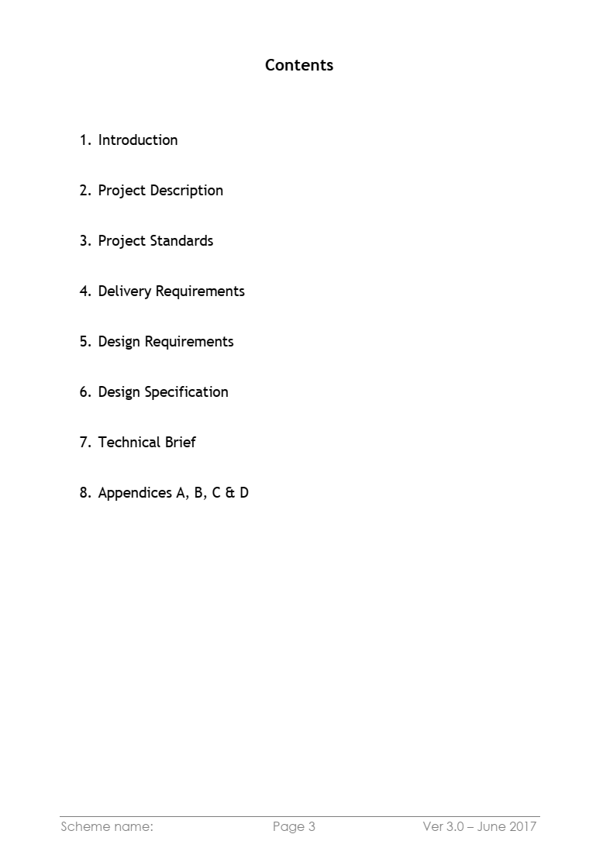

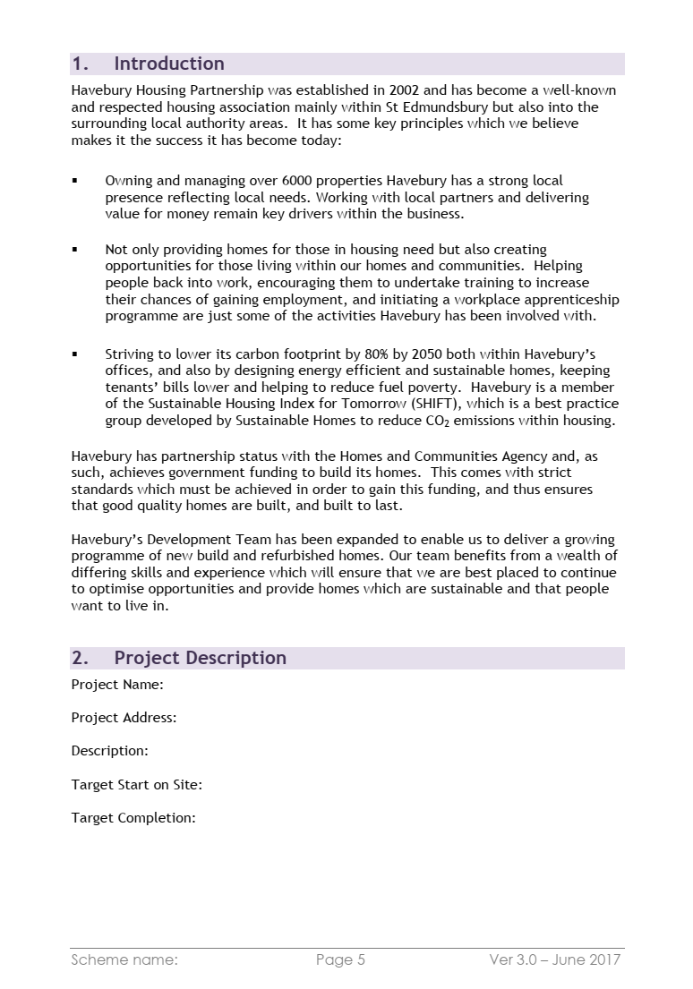

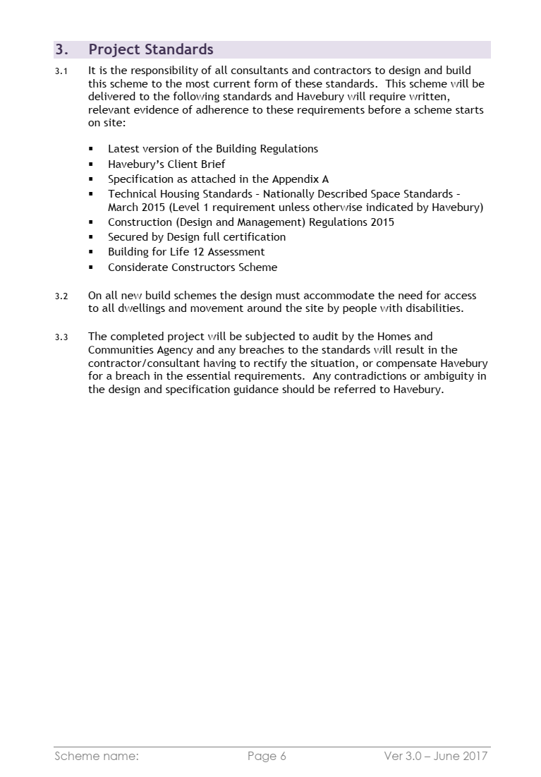

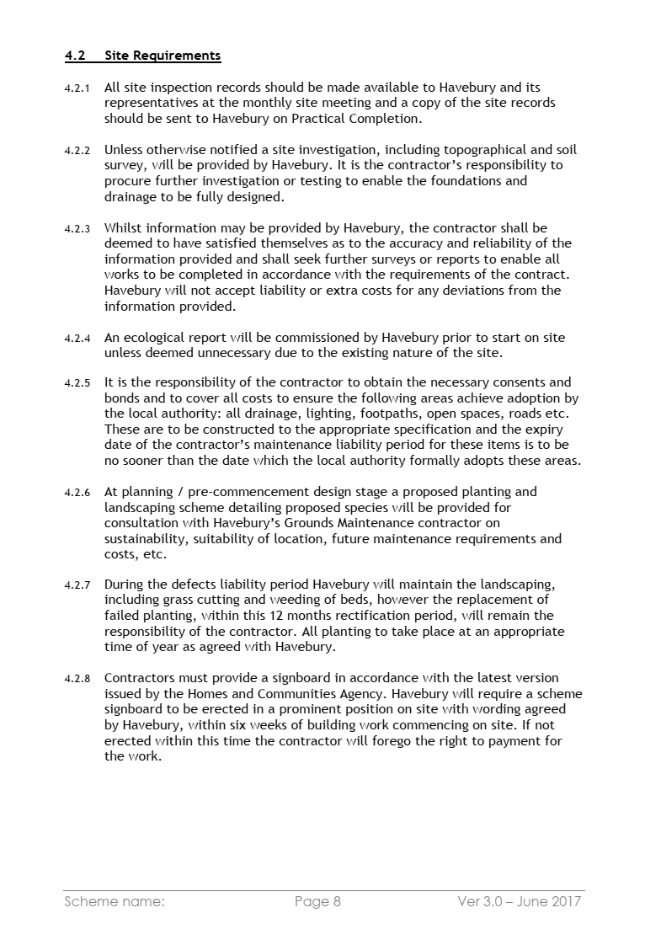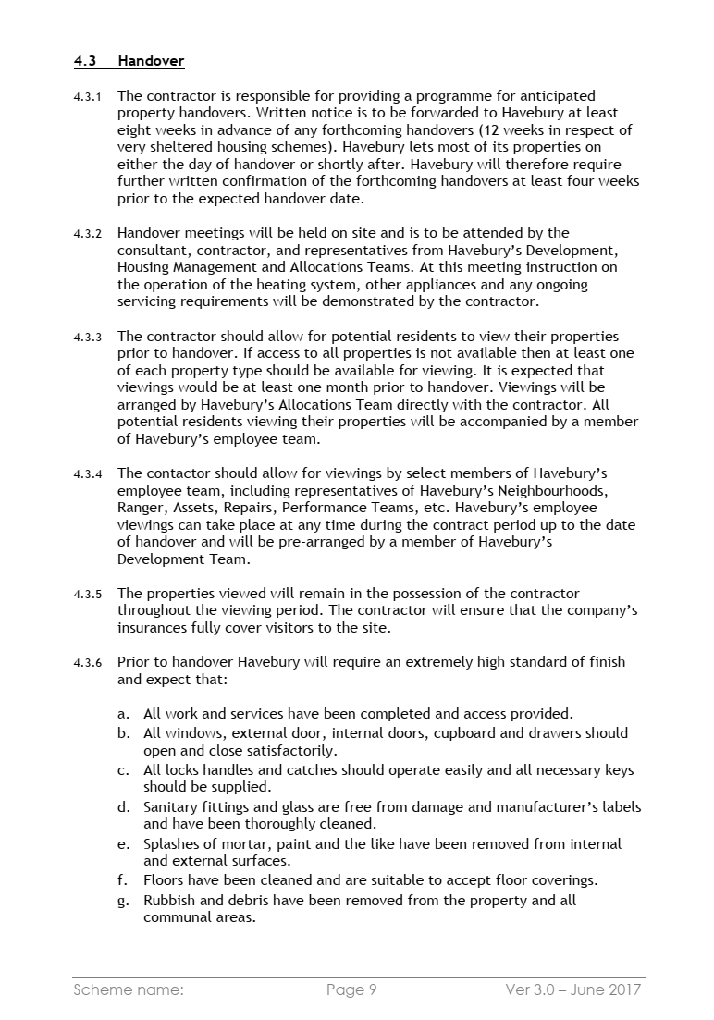

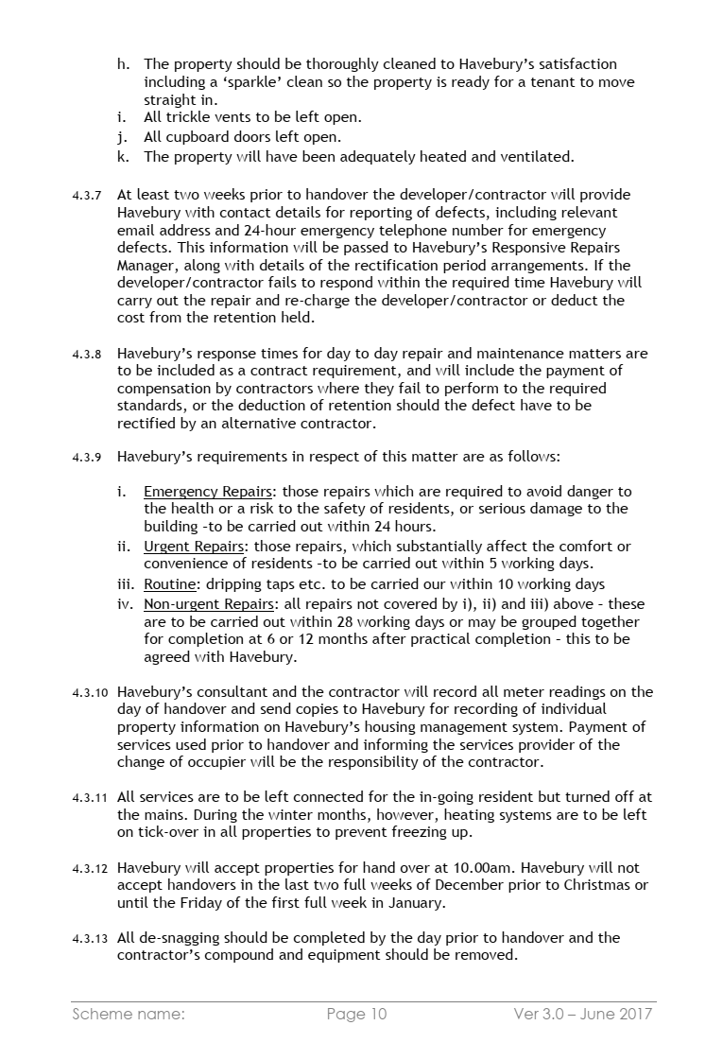

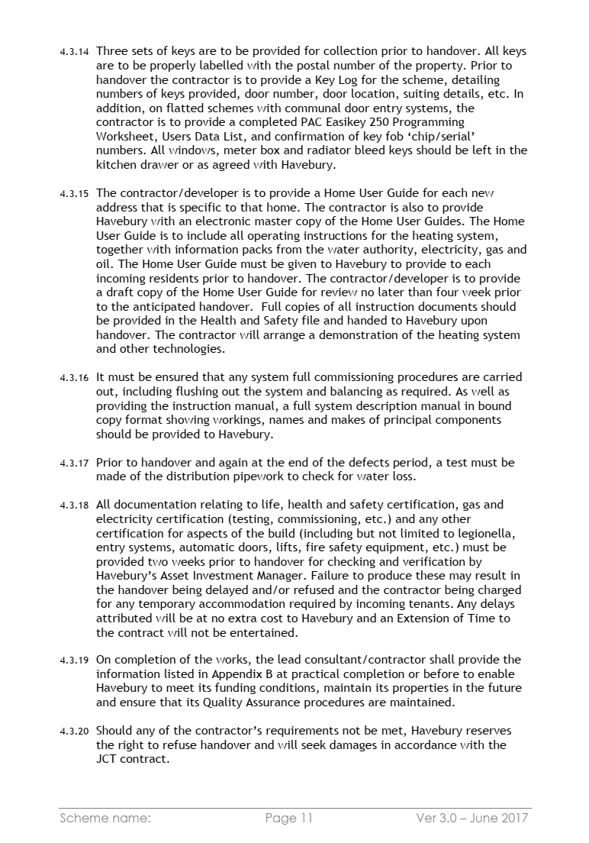

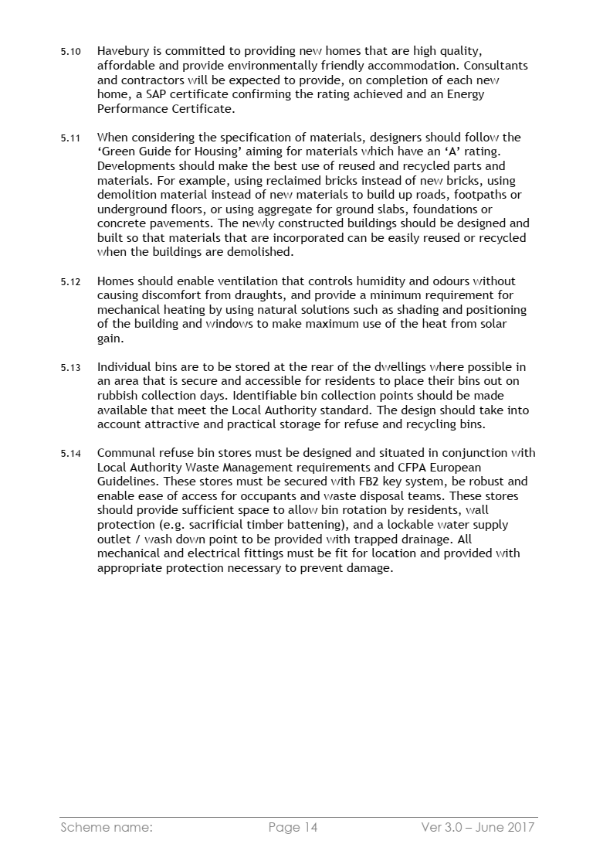

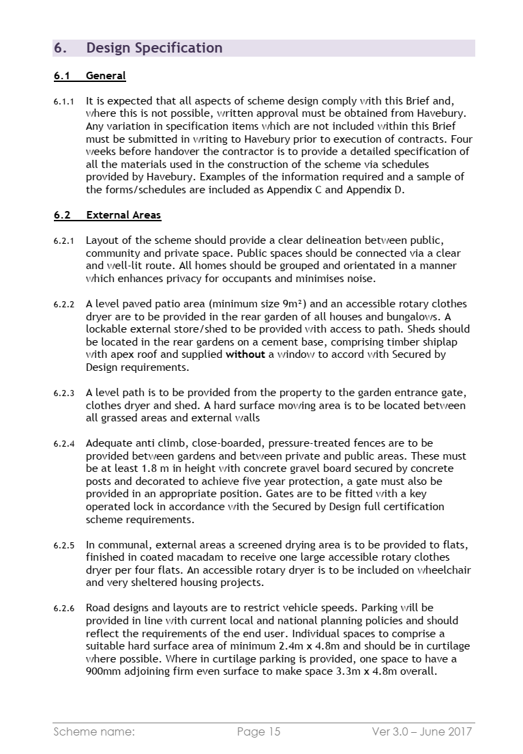

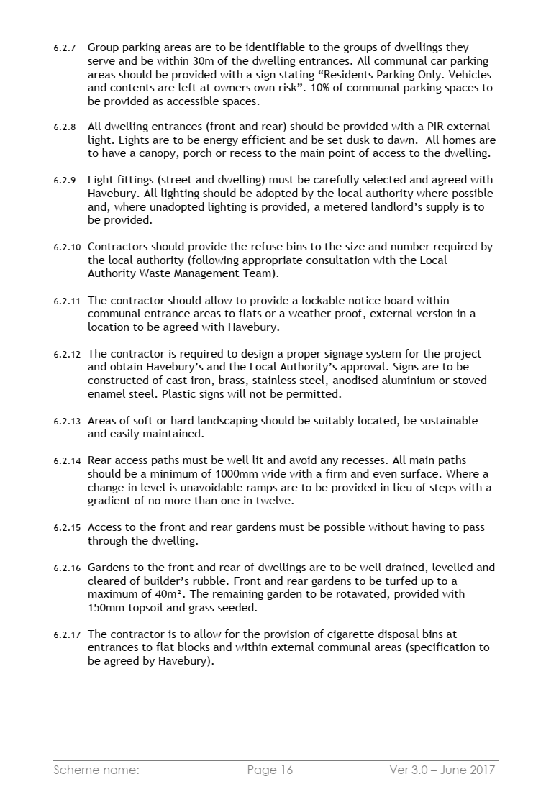

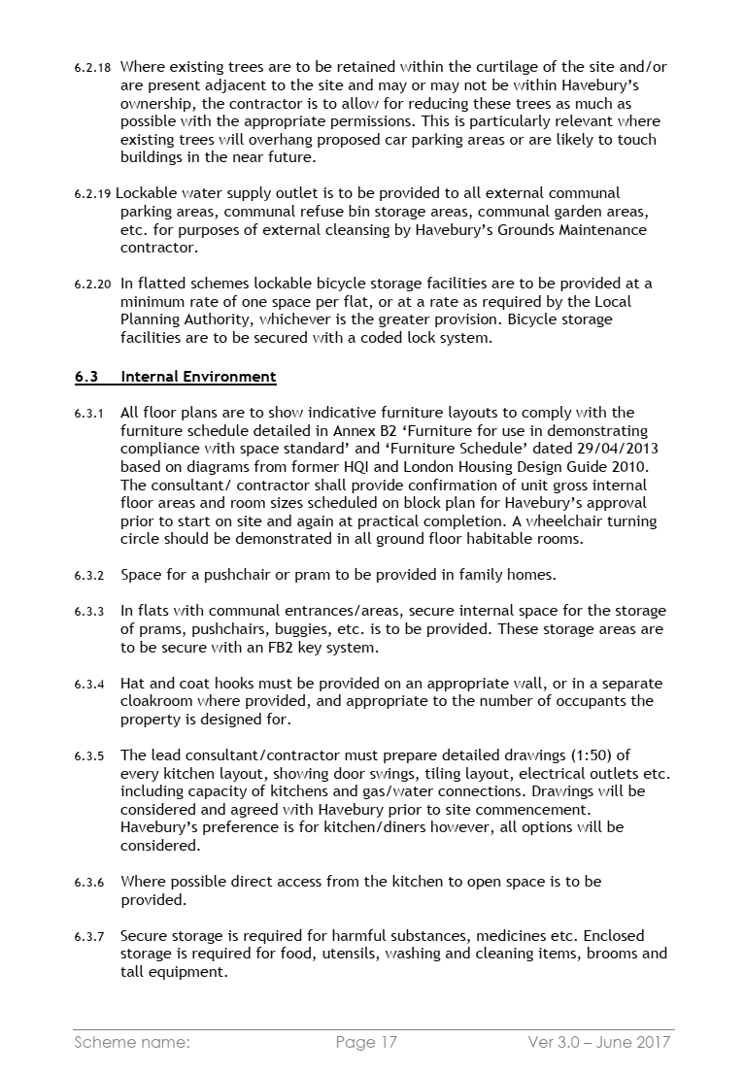

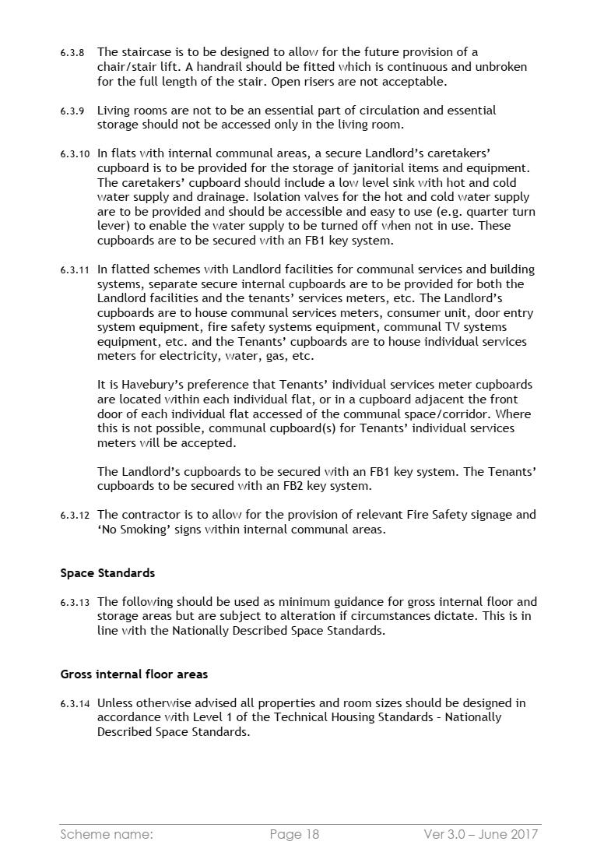

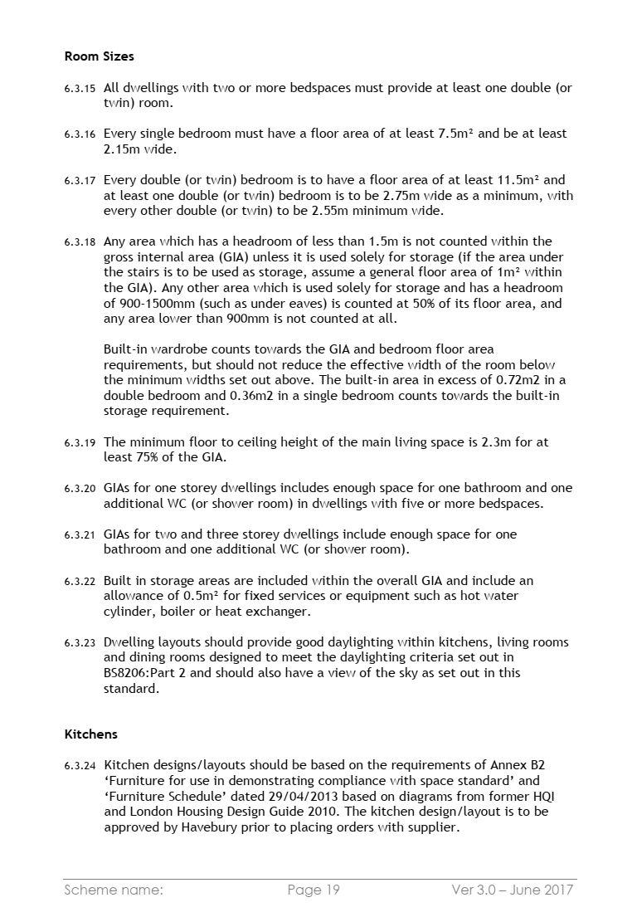

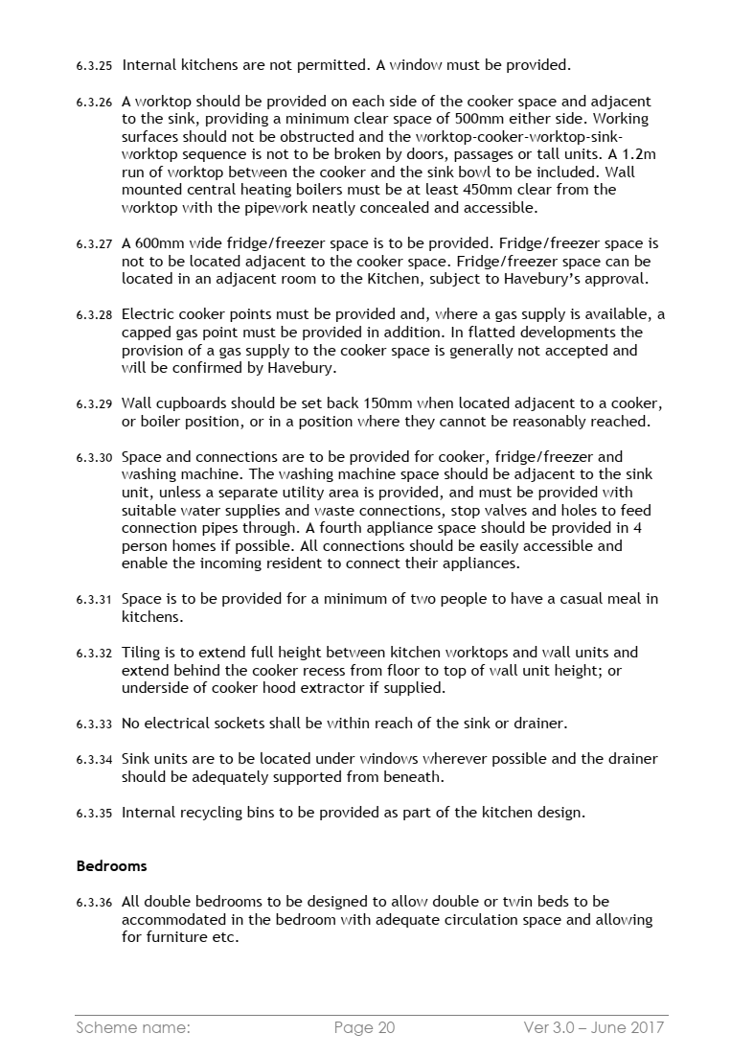

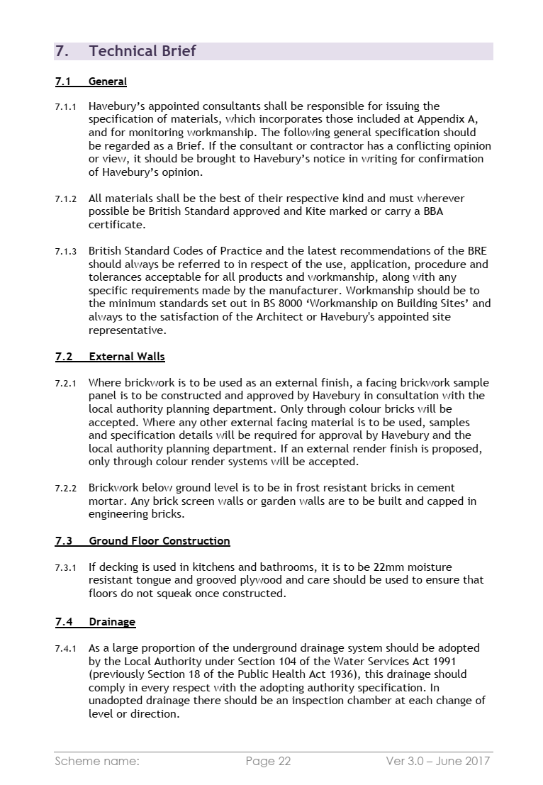

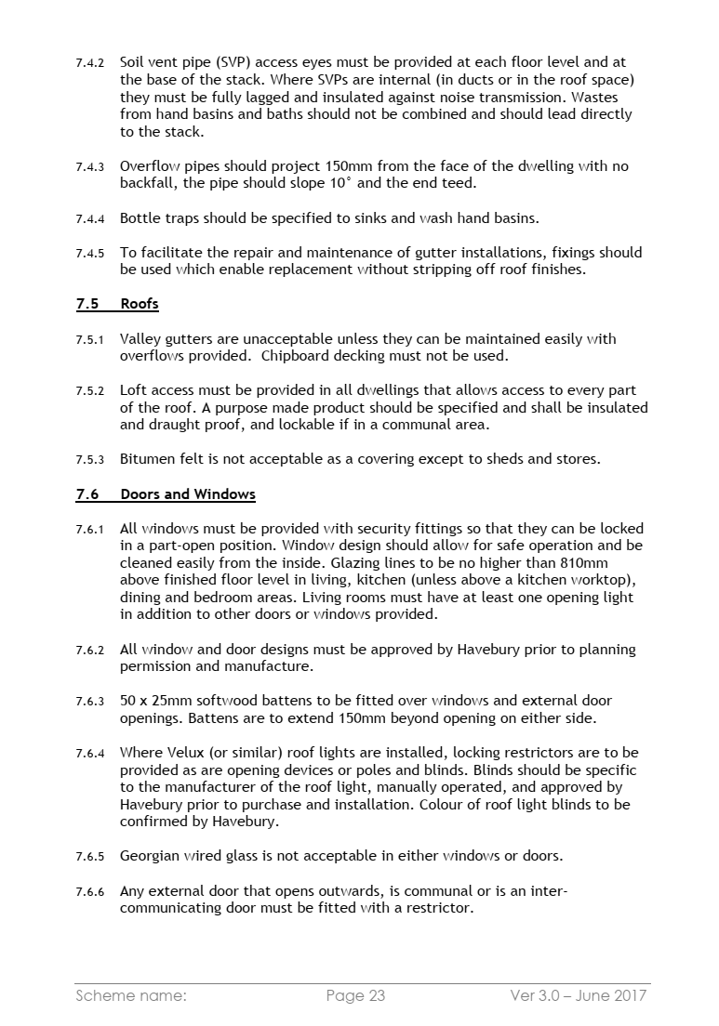

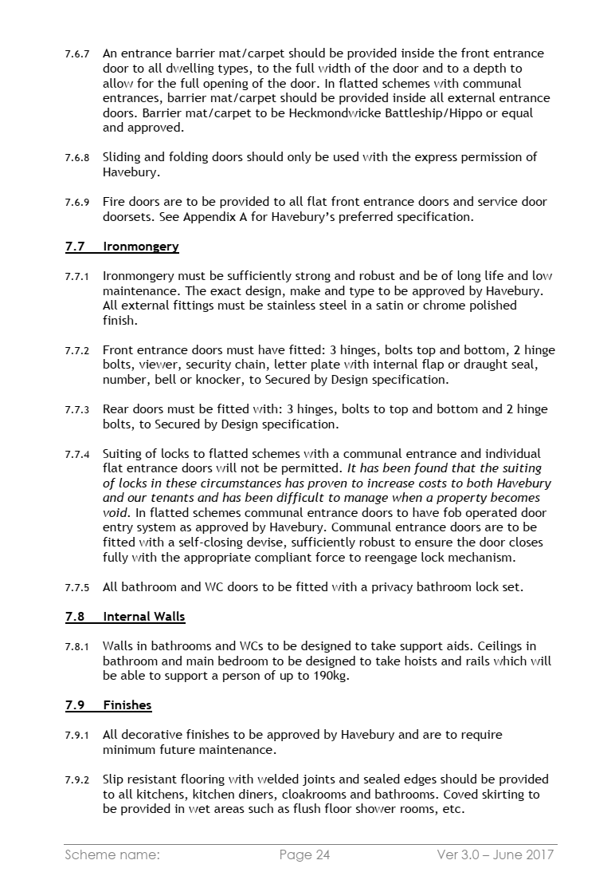

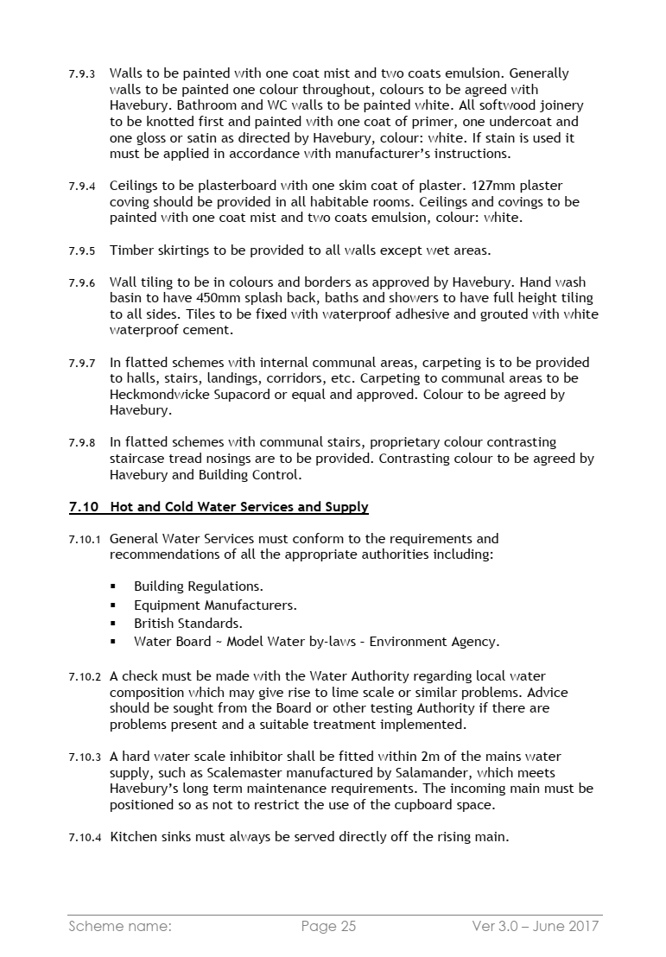

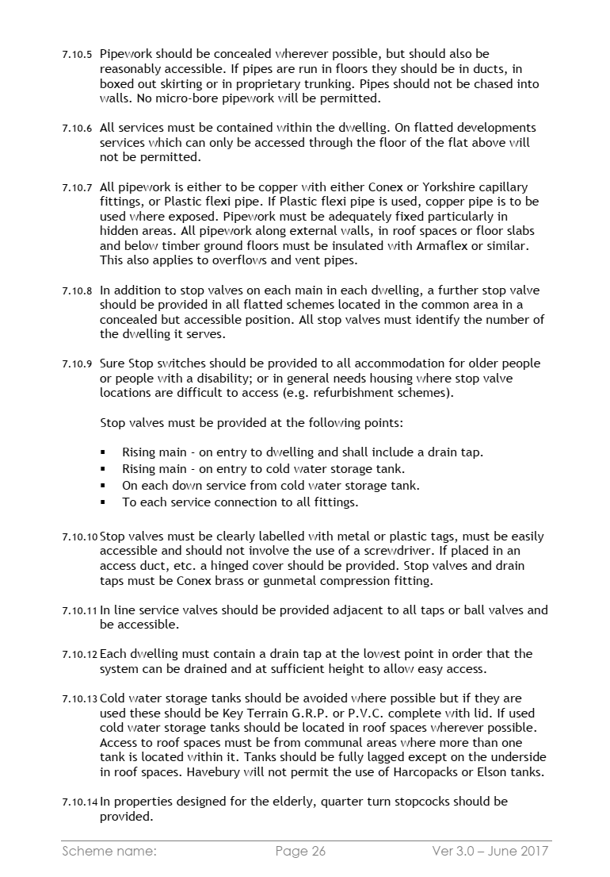

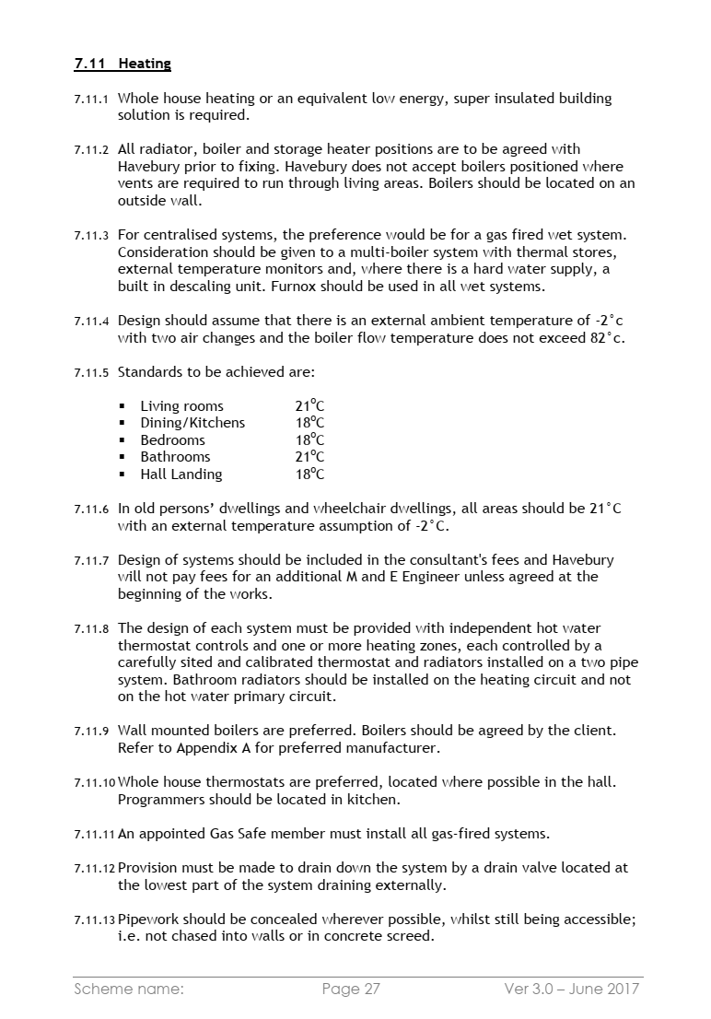

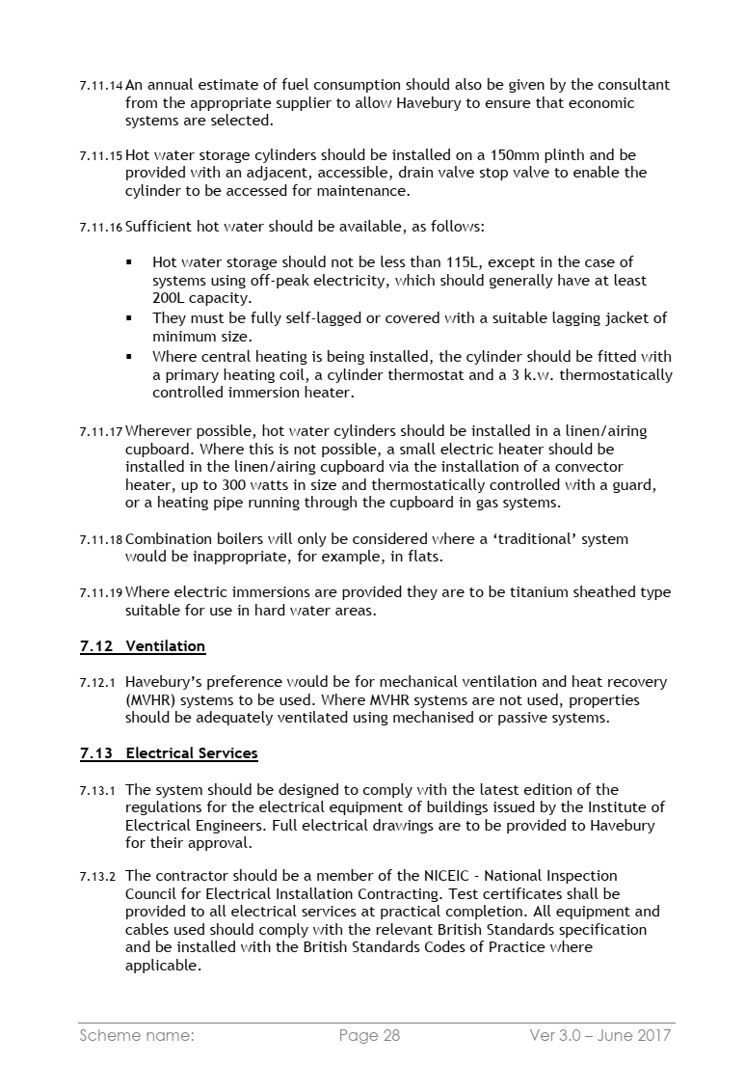

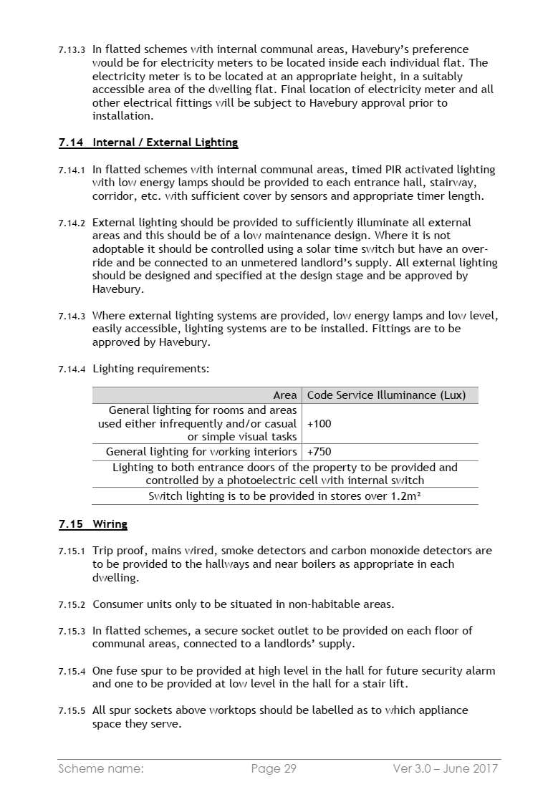

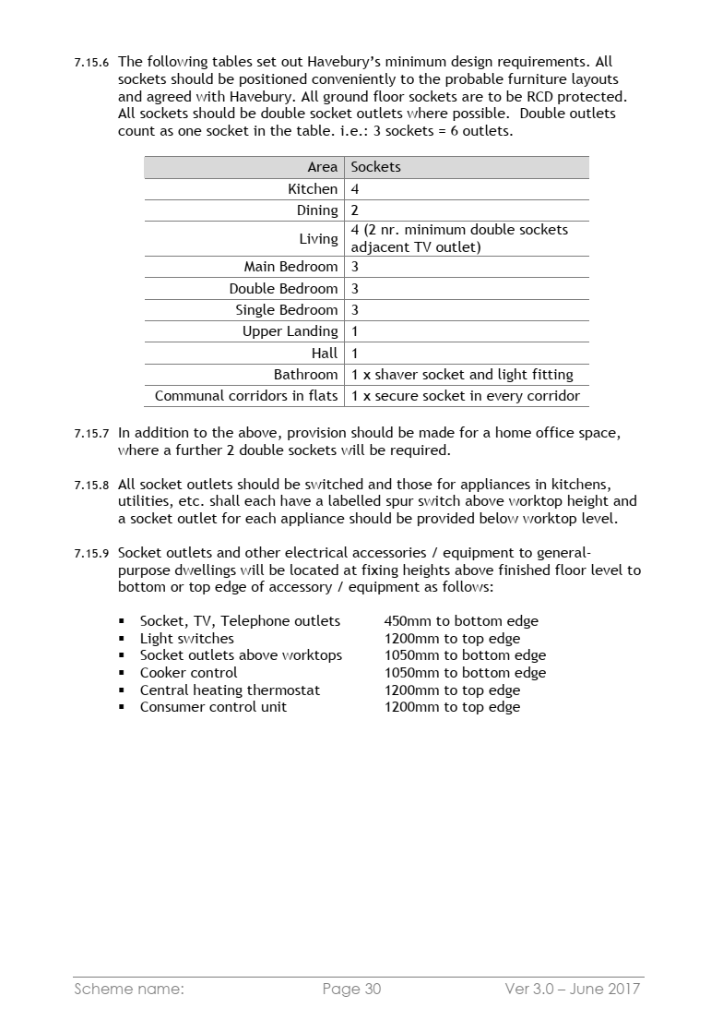

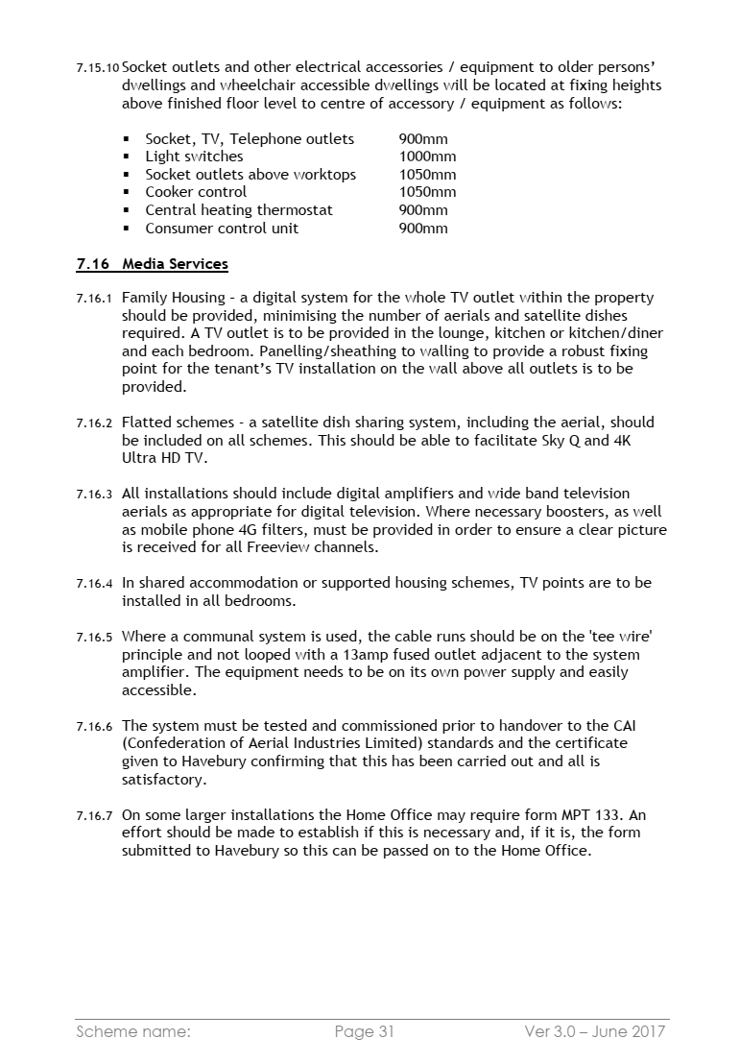

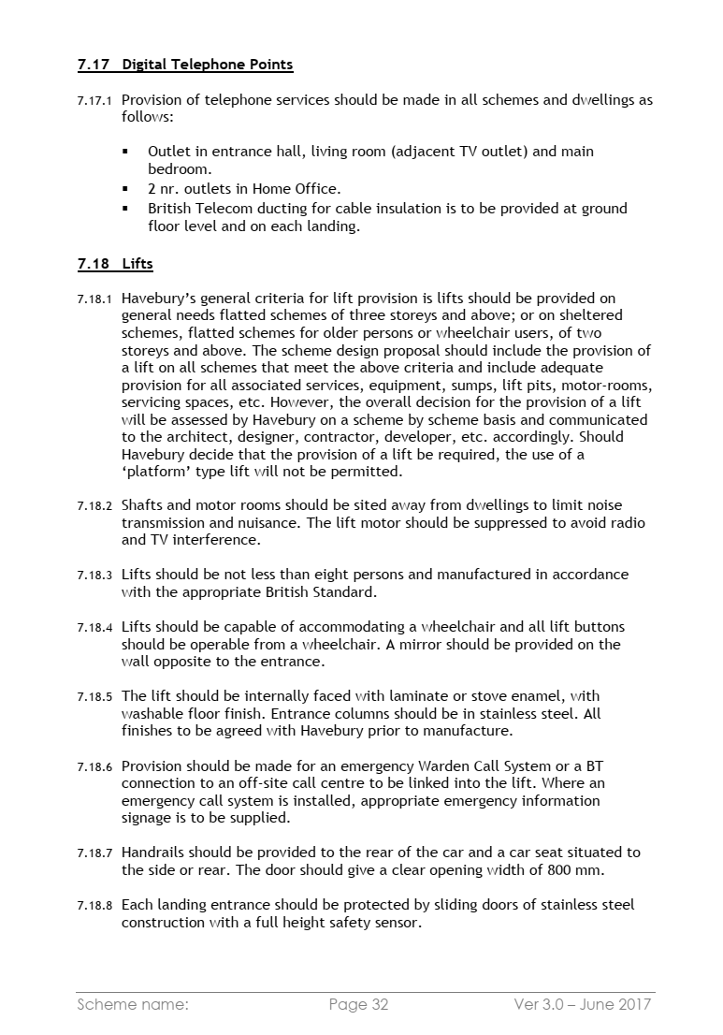

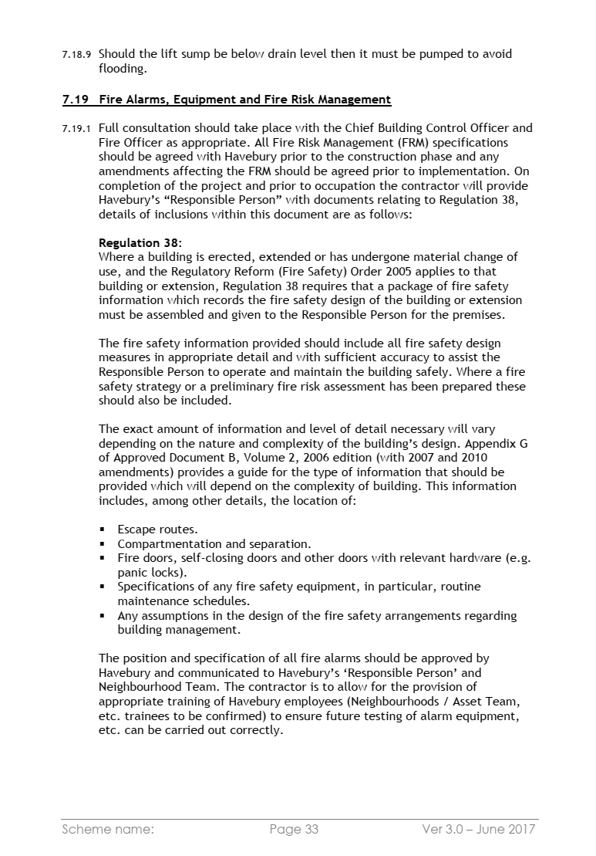

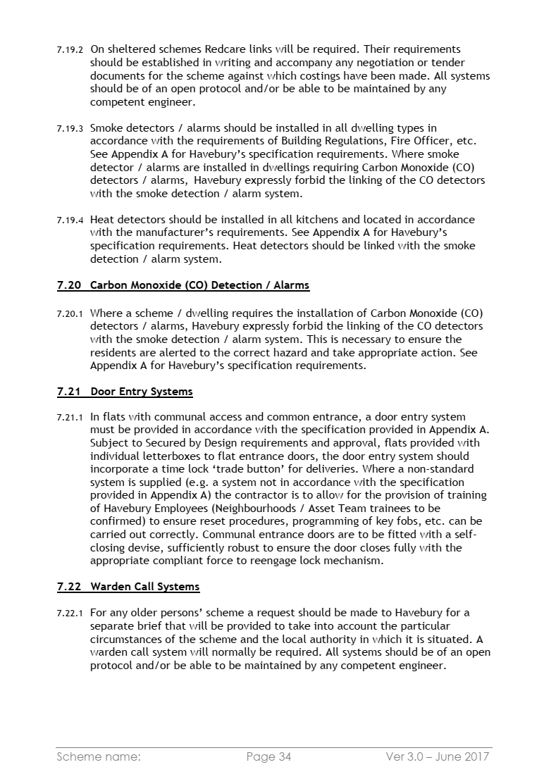

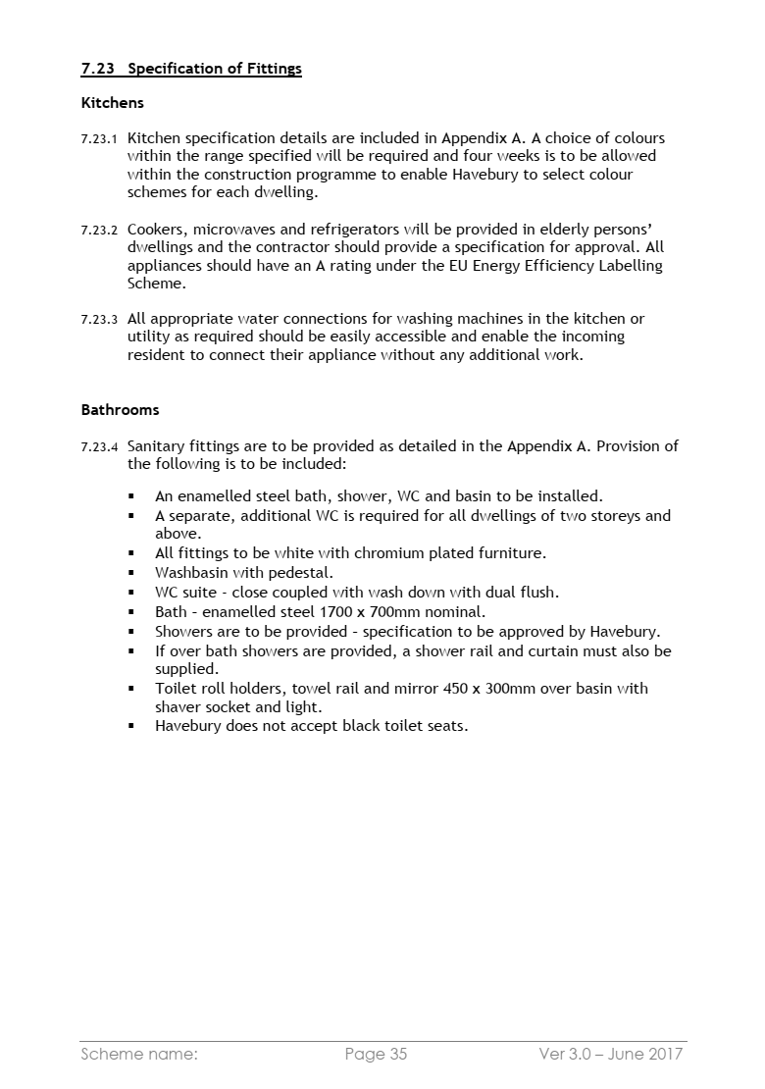

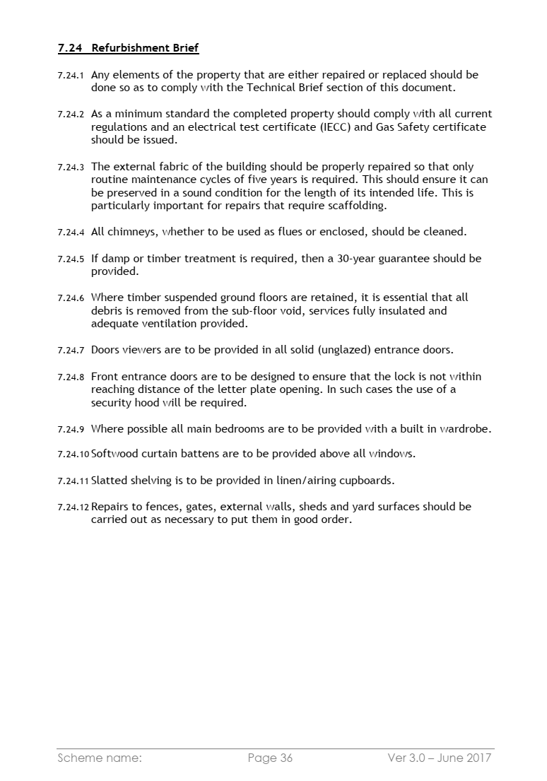

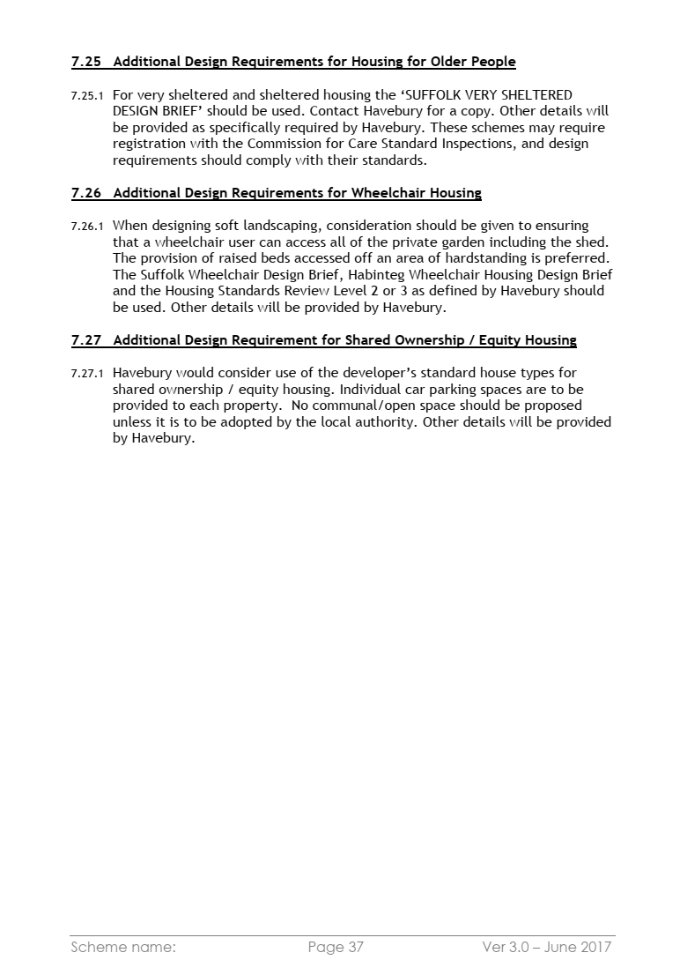

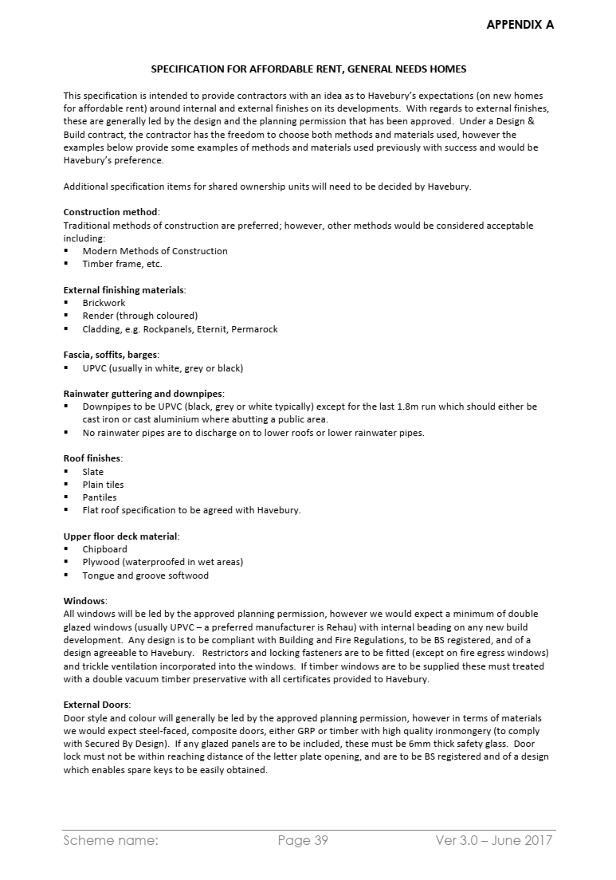

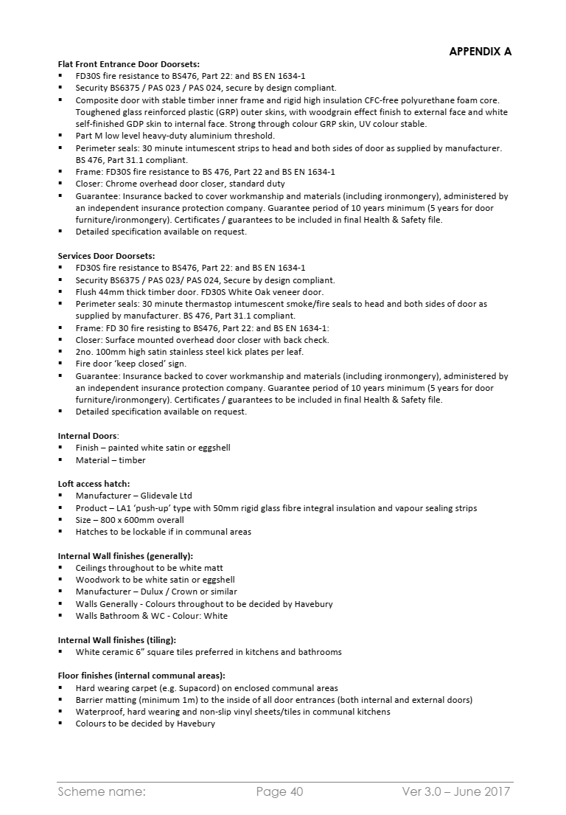

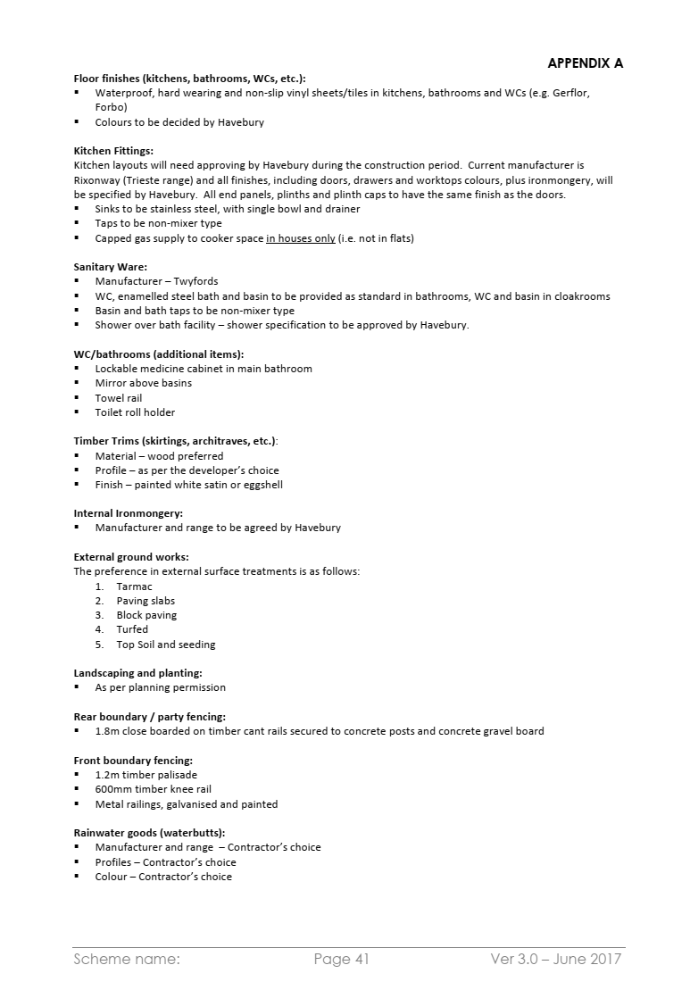

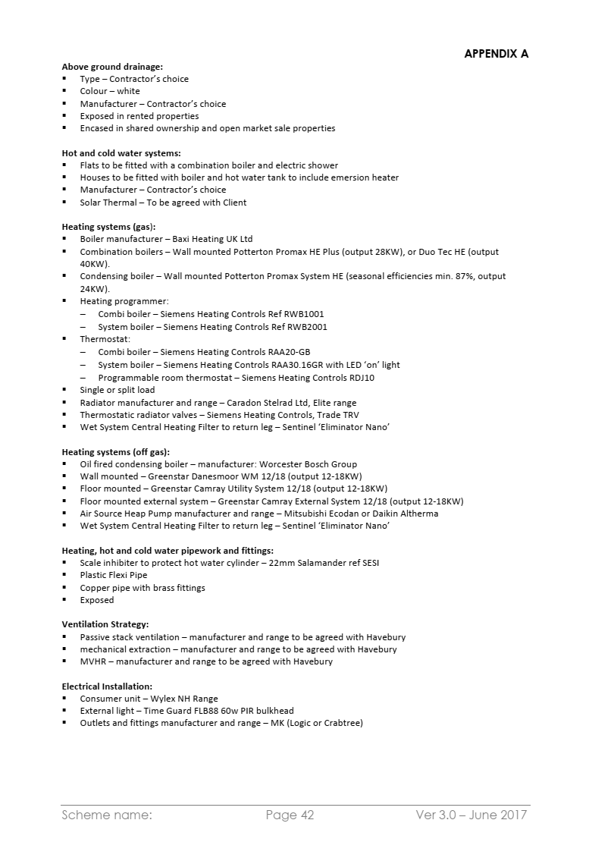

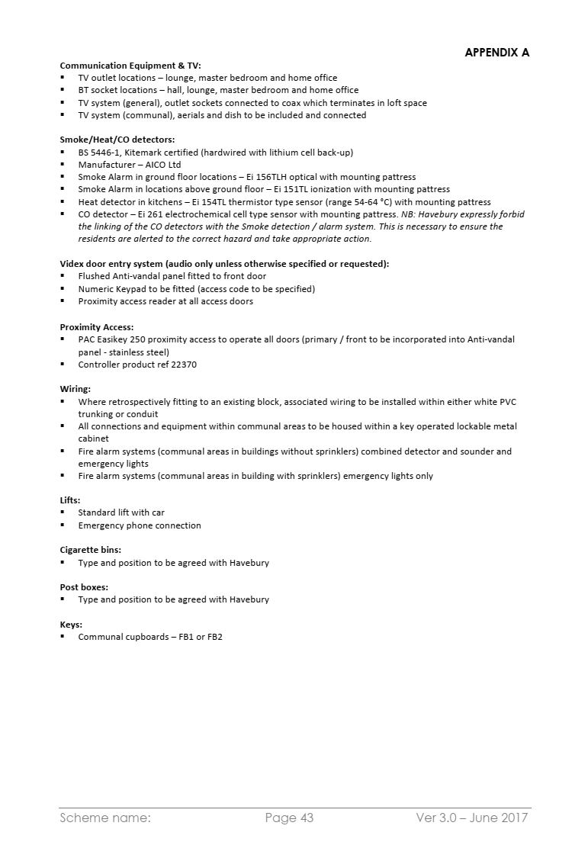

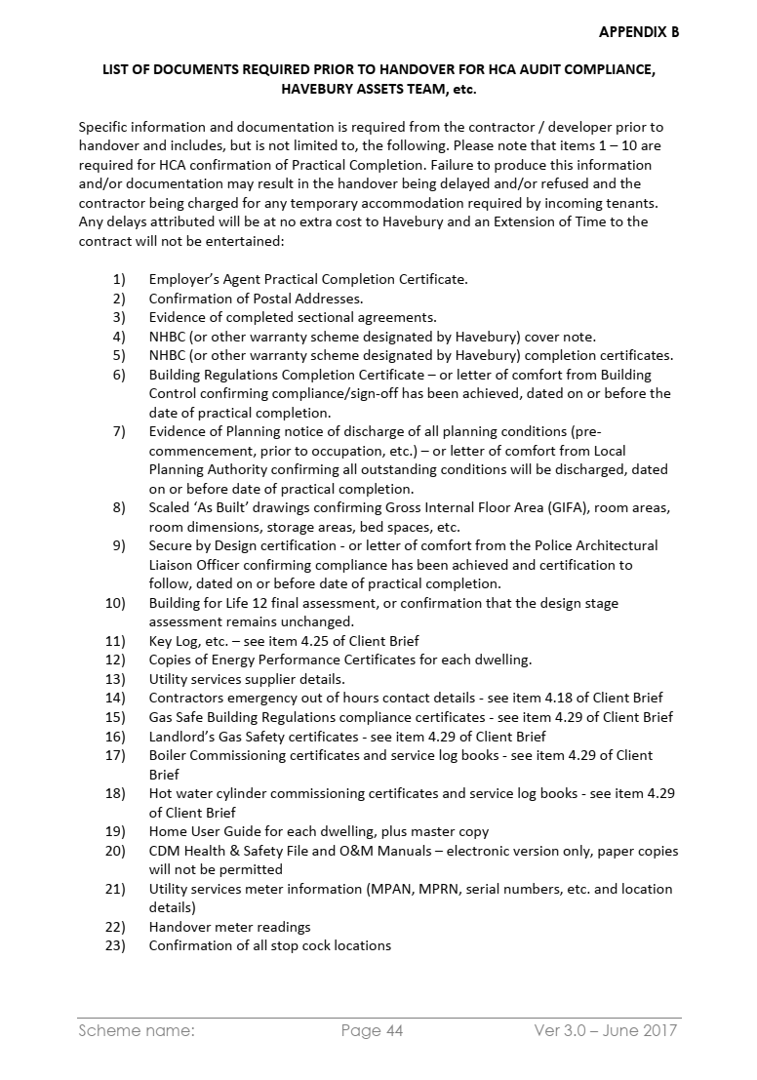

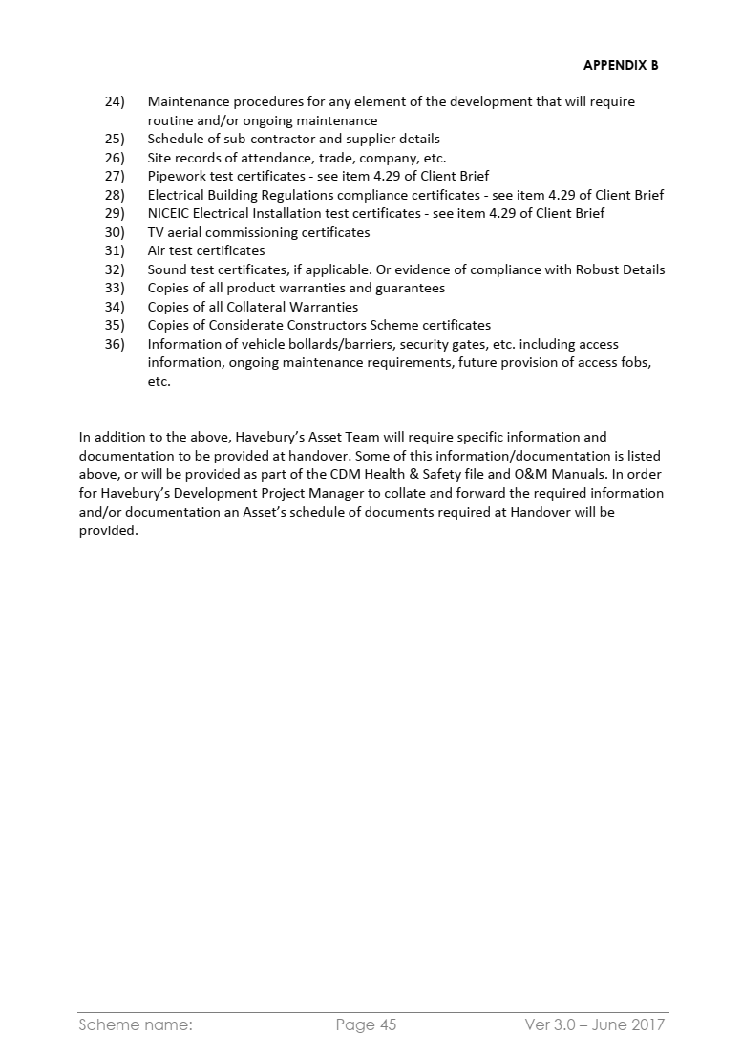

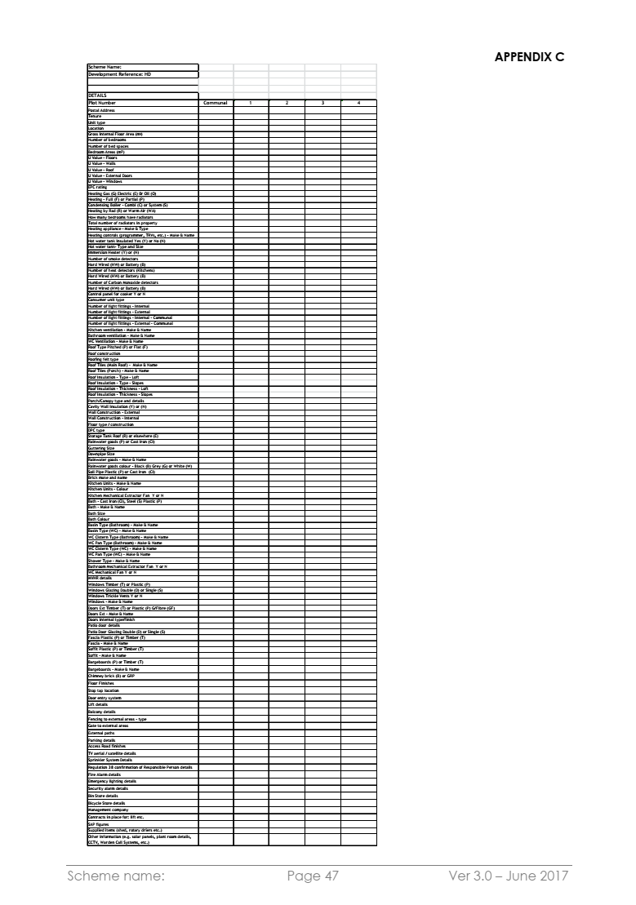

- Safety Requirements for Contractors

Safety Requirements
for Contractors

Issued by The Havebury Housing Partnership

The Havebury Housing Partnership Code of Practice requires of Contractors and Sub Contractors that all relevant legislation appertaining to construction and maintenance etc shall be observed particularly in respect of health and safety matters.

The details of this Code of Practice shall be made known and be available to all employees and sub-contractors of the contractor.

Issue19 - December 2016

Index
Introduction
Legal Requirements
PART 1 1 Reporting of injuries and dangerous occurrences
2 Personal Protective Equipment
3 Areas of work
4 Services
5 Machinery guards
6 Cranes, lifting gear and vehicles
7 Entry to Confined Spaces
8 Noise Control
9 Means of access/egress and place of work
10 Scaffolding
11 Excavations
12 Demolition work
13 Electrical Work
14 Good housekeeping
15 Dress Code
PART 2 1 Fire hazards during building operations
2 General site precautions
3 Waste Management and Disposal
4 Highly flammable liquids (Flash point <32°C)
5 Flammable liquids (Flash point between 32°C and 66°C)
6 Flammable adhesives and timber preservatives
7 Compressed gas cylinders
8 Flame producing apparatus
9 Temporary electrical supply
10 Temporary heating arrangements
11 Alterations to existing buildings
12 In case of fire
13 Smoking
14 Asbestos
APPENDIX 1 Use of ladders and access equipment in painting and maintenance contracts
APPENDIX 2 Additional requirements for protection of scaffold from intrusion
Code of Practice
Safety Requirements for Contractors (Including Direct Services)
Introduction
Contractors shall comply with the instructions contained in this Code of Practice in addition to any other conditions specifically relating to health and safety, detailed in the formal contract.
The requirements are additional to any others which may be necessary for the safety of operatives, members of the public or other occupiers of buildings in which Contractors may be working.
Throughout this document the expression “Havebury” means the Havebury Housing Partnership and the “Nominated Employee” or “HNE” means the employee appointed by Havebury to be responsible for supervising the Contract. Contractor includes all Sub-Contractors and any other persons working on the site under the control of the Contractor.
The specified requirements shall be varied only by written authority from Havebury’s Nominated Employee.
If the Contractor is in any doubt about any section of this code of practice, then Havebury’s Nominated Employee must be consulted.
Legal Requirements
Whilst this code of practice sets out certain mandatory requirements, it is not a complete statement of all requirements. It is the Contractor’s responsibility to ensure that all-relevant legislation is observed, particularly in respect of health and safety matters.
Without prejudice to the generality of the foregoing, such items of legislation include:
- The Health and Safety at Work etc. Act 1974
- Management of Health and Safety at Work Regulations 1999
- Workplace (Health and Safety and Welfare) Regulations 1992
- Provision and Use of Work Equipment Regulations 1998
- Lifting Operations and Lifting Equipment Regulations 1998
- Personal Protective Equipment Regulations 2002
- Manual Handling Operations Regulations 1992
- Construction (Design and Management) Regulations 2015
- Control of Substances Hazardous to Health 2004
- Electricity at Work Regulations 1989
- Control of Asbestos Regulations 2012
- Work at Height Regulations 2005

PART 1
1. Reporting of injuries and dangerous occurrences (RIDDOR)
1.1 The contractor’s attention is drawn to the Reporting of Injuries, Diseases and Dangerous Occurrences Regulations 2013. All notifiable injuries, diseases and dangerous occurrences must be reported to the Health and Safety Executive using the appropriate reporting forms. In addition Havebury’s Nominated Employee (HNE) shall also be informed.
1.2 First Aid facilities shall be provided by the Contractor as required under the Health and Safety (First Aid) Regulations 1981.

2. Personal Protective Equipment
2.1 The Contractor shall provide appropriate personal protective equipment/clothing as identified by the Contractor’s risk assessment. The Contractor shall also be responsible for ensuring that such clothing or equipment is used and in good condition.
2.2 On construction sites or works of engineering construction, safety helmets, high visibility vests and safety boots shall be worn at all times.

3. Areas of work
3.1 Contractors shall confine themselves to the area of their own work except when authorised by the HNE. Where practicable, contract work areas shall be fenced off and proper access routes shall be included.

4. Services
4.1 Under no circumstances shall the Contractor couple up equipment to Havebury’s electric supply, compressed air, water or other piped service without first obtaining permission from the HNE.

5. Machinery guards
5.1 Machinery guards and fencing etc shall be properly secured before any plant or equipment is used.

6. Cranes, lifting gear and vehicles
6.1 Contractors who bring cranes, lifting gear or similar appliances shall ensure that the statutory requirements relating to periodical testing and examination have been complied with. Independent examination certificates shall be produced if requested by the HNE.
6.2 Should any equipment belonging to Havebury be required to be used by the Contractor, the Contractor must apply to the HNE for permission to use it.

7. Entry to Confined Spaces
7.1 No tank, vessel, chamber sewer or other similar enclosed space shall be entered without a competent person first carrying out recognised tests for dangerous fumes, flammable gases and lack of oxygen. A permit to work system shall apply and Contractors will be expected to provide relevant risk assessments and method statements for the activity. These will be incorporated into the permit.
Attention is drawn to the Confined Spaces Regulations 1997.
8. Noise Control
8.1 Contractors shall ensure that all practicable measures are taken to control the noise produced by his operations and that the noise from all compressors and similarly noisy equipment is suitably attenuated. For particularly noisy operations (e.g. use of road breakers) ear protection shall be worn.
Attention is drawn to the Control of Noise at Work Regulations 2005 and to HSE Code of Practice for reducing the exposure of Employed Persons to Noise.

9. Means of access/egress and place of work
9.1 All routes to and from the workplace must be clear of any trip or slip hazards
9.2 All ladders shall be in good condition and when used shall be secured at the top and bottom, footed and afford a good handhold at the top.
9.3 See Appendix 1 for use of ladders and access equipment in contracts

10. Scaffolding
10.1 All scaffolding shall be erected by the Contractor in accordance with the Work at Height Regulations 2005 and supporting guidance, and as Appendix 1.
10.2 See Appendix 2 for protection of scaffold against intrusion.

11. Excavations
11.1 Contractors shall make sufficient enquiries before any excavation work is attempted, to ensure there are no buried cables, piping etc.
11.2 Any excavations or openings into which any person may fall shall be adequately fenced.

12. Demolition and dismantling work
12.1 All demolition and dismantling work shall be carried out by the contractor in accordance with the Construction (Design and Management) Regulations 2015.
13. Electrical Work
13.1 All electrical work and work involving the use of electric tools and equipment shall be carried out in accordance with the Electricity at Work Regulations 1989 and the IEE Regulations.
13.2 All portable tools shall operate on a supply of 110V or less unless specific approval for 240V operation, together with an earth leakage circuit breaker, has been given by the HNE.
13.3 All electrical contractors shall comply with the requirements of Part P of the Building Regulations.

14. Good housekeeping
14.1 Contractors shall ensure that the site and all areas of work are kept tidy at all times, in order to minimise slip, trip and fall hazards.

15. Dress Code
15.1 The minimum dress code for summertime working shall be full length trousers and sleeved tee-shirts. This does not preclude the wearing of any necessary PPE required for the working task. Shorts are not permitted.

PART 2
1. Fire hazards during building operations
1.1 Buildings in the course of erection or undergoing alteration, repair or maintenance are particularly vulnerable to fire and fire spread for a variety of reasons, such as:
- Combustible building materials being stored and used;
- Use of flame producing equipment and flammable adhesives;
- Fire protection equipment not being in position.
1.2 In occupied buildings staff and visitors in adjacent areas could be put in danger by a fire originating from a Contractors activity.
1.3 Buildings of historical and architectural value may not conform to present day standards for fire resisting structures. Extensive roof voids may exist.
1.4 The Contractor prior to the commencement of work should undertake a fire risk assessment, if there is a significant risk of fire.
1.5 All hot works will be carried out under a “Hot work permit system” and detailed in the approved method statement.
1.6 Quartz halogen lamps shall not be used inside any building.

2. General site precautions
2.1 Where possible, combustible materials should be stored outside the main buildings, with a suitable firebreak including building materials which are combustible or have easily ignitable packaging.
2.2 Materials when stored shall be in locked rooms or stores secure against intrusion and marked “No Smoking”.
2.3 Fire extinguishers will be unobstructed and fire escape routes and exits shall remain clear.
2.4 Space below raised huts shall be enclosed to prevent accumulation of rubbish.
2.5 Grass and undergrowth shall be kept short around temporary buildings and stores which are combustible.
3. Waste Management and Refuse Disposal
3.1 All Havebury construction sites are required to have a site waste management and disposal plan irrespective of value of contract. This shall range from simple to more complex plans, depending on the site. The plan shall include all materials to be recycled, reused and taken to landfill, in line with appropriate regulations.
3.2 Combustible refuse such as wood shavings, packaging materials etc. shall be regularly removed to a safe place, prior to disposal.
3.3 Burning of refuse shall not be permitted on site.
4. Highly flammable liquids (Flash point <32°C)
4.1 The Dangerous Substances and Explosive Atmospheres Regulations 2002 (DSEAR) and Petroleum (Consolidation) Regulations 2014 shall be complied with.
4.2 Highly flammable liquids shall be kept in screw-capped cans, steel barrels or drums capable of being securely closed. Petrol containers shall be marked “Petroleum Spirit - Highly Flammable”. Other containers shall be appropriately marked.
4.3 All flammable liquids shall be kept in suitable cabinets or bins of fire resistant construction and material and which are designed to retain spills of 110% of the largest vessel normally stored within; a maximum volume of 11 gallons/50 Litres.
4.4 Lockers and stores shall be marked to indicate the contents and carry a “No Smoking” sign and shall be in the open air (6m from boundary fences, roads, combustible materials, and electrical equipment capable of igniting vapour).
4.5 Transfer from one vessel to another shall be carried out in the open air (or in a flammable goods store).
4.6 Tanks of petrol engines shall not be filled whilst the engines are running. The transfer of liquid shall be undertaken using funnels and extended hoses.

5. Flammable liquids (Flash point between 32°C and 66°C)
5.1 Paraffin oil and similar liquids shall be stored in metal lockers or be kept in detached, non-combustible buildings, or in the open air away from buildings.
5.2 Flammable paints, in quantities greater than 50litres, shall be treated as flammable liquids.
6. Flammable adhesives and timber preservatives
6.1 The storage provisions set out in Paragraph 5.1 shall apply.
6.2 When laying floors or applying timber preservatives etc ventilation shall be adequately maintained and all sources of ignition removed from the area. “No Smoking” notices shall be displayed.

7. Compressed gas cylinders
7.1 All relevant requirements of The Pressure Systems Safety Regulations 2000, The Dangerous substances and Explosive Atmospheres Regulations 2002 (DSEAR) and Petroleum (consolidation) Regulations 2014 shall be complied with.
7.2 All cylinders shall be kept away from sources of heat or potential fire hazards.
7.3 Full and empty cylinders not in use shall be kept segregated and in a safe position - secured upright, undercover in the open air or in a well-ventilated store external to the main building.
7.4 LPG cylinders shall not be of greater capacity than 15Kg and when used for heating purposes, shall be sited externally. When not in use, the main valve shall be shut off.

8. Flame producing apparatus
8.1 Welding, cutting, brazing equipment; carried out under a “Hot work permit system” and detailed in the approved method statement; blow lamps and plumber’s furnaces shall be operated only by skilled workman under the following conditions:-
- Litter, rubbish and combustible materials shall be removed from the vicinity of the work or protected with non-combustible material e.g. sheet metal.
- The apparatus shall not be used on or near other containers of flammable liquids or compressed gases.
- The apparatus shall not be left unattended when alight.
- An adequate number of fire extinguishers shall be placed readily to hand.

9. Temporary electrical supply
9.1 All electrical installations and services shall be in accordance with the Electricity at Work Regulations 1989.
9.2 All cables and connections shall be maintained in good condition and be carefully routed and protected to avoid damage.

10. Temporary heating arrangements
10.1 Stoves etc. shall be sited on a concrete or similar base away from combustible materials and be adequately protected. Flue pipes shall be provided where necessary and comply with appropriate Building Regulations.
10.2 Temporary electrical heating appliances shall be used at bench level on metal stands, well clear of combustibles.
11. Alterations to existing buildings
11.1 If flame-producing apparatus is to be used in an occupied building, Havebury’s employee in charge of that building shall be notified before commencement of any work.
11.2 A Hot Work Permit is required for all hot works on any site and detailed in the approved method statement.

12. In case of fire
12.1 Means of fighting fire shall be provided and maintained in good and serviceable condition, and in sufficient numbers.
12.2 All site personnel shall be informed of the arrangements to be followed in the event of fire or the warning to be given and for informing the Fire Service.
12.3 All fires shall be reported to the HNE.

13. Smoking
13.1 Smoking is not permitted inside any property or construction site under the control of Havebury.

14. Asbestos
14.1 Asbestos surveys will be issued as appropriate to contractors before any work commences and all appropriate precautions as required under legislation must be in place.
14.2 In the absence of asbestos survey information work should not commence. Should any suspected asbestos containing material be found, work must stop; The HNE must be told and appropriate instructions will be given.

Appendix 1
USE OF LADDERS AND ACCESS EQUIPMENT IN CONTRACTS
SAFE USE OF LADDERS
Ladders should be placed at a suitable angle, ideally about 75° to the horizontal, ie about 1000 out of every 4000 in height.
The head of the ladder should rest against a solid surface able to withstand the imposed load. Where the surface may be fragile or brittle so that it cannot withstand such loads or it is necessary to position the ladder away from a surface, equipment such as a ladder stay may be used at the top of the ladder.
Ladders shall only be used for access and for the support of the operative and lightweight tools and materials to complete minor tasks.
All ladders must be securely footed.
ACCESS AND EQUIPMENT
The following criteria relating to height of actual work shall apply to this contract.
1. for minor work generally to ground floor windows, including fascias and gutters.
Use properly footed ladders.
2. for minor work generally to first floor windows, including fascias and gutters.
Use properly footed and stabilised ladders.
3. for minor work to barge boards and down pipes up to 5000mm above ground.
Use properly footed and stabilised ladders.
4. for any work on properties up to 5000mm above ground.
A manufactures ladder with combined working platform, guard rails and stabilisation may be used for any duration of work
5. for any work on 2 storey properties in excess of 5000mm.
Use tower with internal ladder access.
6. for any work on all properties where work exceeds 7500mm in height. Use full scaffold with proper ladder access.

7. A “Cherry Picker” device is acceptable in any situation provided appropriate test certificates are available from the hire company, the operative has approved certificated training and the machine is of the correct capacity.
Contractors should note that non-compliance with the above will be seen as a breach of the Havebury Health and Safety requirements and contractors may be prevented from continuing until remedial measures are taken.

Appendix 2
Additional requirements for protection of scaffold from intrusion

All scaffolds must be suitably protected at ground level from intrusion by anyone.
On estates where there is communal or public access, 2m high Heras fencing is to be erected, double clipped and on concrete feet and attached to the scaffold or other suitable fixing.
On open frontage properties anywhere, this will also apply.
Where scaffold is erected in rear/side gardens where there is no public or communal access then no fencing is required unless there is a risk from children/vulnerable adults climbing the scaffold in which case fencing must be provided.
All scaffolds must display the name of the scaffold company and completion inspection certificates must be made available on demand. The use of a visible tag system (which can be updated each time a check is carried out) to supplement inspection records is required.
Access ladders from ground to first lift must be removed during non-working times and either removed from site or locked away.

The above is part of Havebury’s Health and Safety Procedures.
Contractors should note that non-compliance with the above will be seen as a breach of the Havebury Health and Safety requirements and contractors may be prevented from continuing until remedial measures are taken.

- Contract Conditions

CONTRACT CONDITIONS

PROFESSIONAL CONSULTANCY SERVICES FRAMEWORK
FOR
HOUSING DEVELOPMENT

2020 - 2024

Date: November 2019

PROC/012/2019

CONDITIONS OF CONTRACT

The contract awarded by The Havebury Housing Partnership (the ‘Employer’) for the services shall be subject to the following terms and conditions:

1.0 DEFINITIONS AND INTERPRETATION
1.1 In this Contract save where the context otherwise requires, the following expressions shall have the meanings hereby assigned to them.
"Anniversary Date" means the date as specified in the Contract Documents.
“Annual Sum” means the cost as stated in the Pricing Schedule for providing the required routine maintenance works over a twelve month period.
“Commencement Date” means the date from which the Service Provider is instructed to commence and to carry out the Services.
“Conditions” means these conditions, any supplementary conditions and any variation agreed between the Employer and the Service Provider.
“Contract” means any formal contract document entered into between the Employer and the Service Provider.
“Contract Administrator” (CA) means the person appointed by the Employer or any person duly authorised by him to act on his behalf .
“Contract Area” means all the sites within which the Service Provider is liable to carry out the Services.
“Contract Manager” means the person nominated by the Service Provider to manage the Services.
"Contract Standard" means such standards as appear in the Service Requirement and as comply in each and every respect with all the relevant provisions of the Contract and where no criteria are stated in the Contract the standard is to be the satisfaction of the Contract Administrator.
“Contract Term” means the term of this Contract as stated in the Information and Instructions To Tenderers section of this document.
"Contract Year" means a year commencing on the Commencement Date of Each Anniversary thereof during the Contract Period.
“Contractor” means the person, persons or company whose tender is accepted, and to which the Contract is awarded.
“Default Notice” means any Notice of Default issued under these conditions.
“Employer” means The Havebury Housing Partnership or any successor.
“Havebury” means The Employer
“HHP” means The Employer
“Instructions” means any direction either verbal, written or described in any other way by the Contract Administrator or any person duly authorised by him to act on his behalf.
“Method Statement” means the Service Provider’s method of carrying out the Services as defined in the Programme.
"Normal Working Hours" means between 8.00 a.m. and 6.00 p.m. during weekdays, bank and statutory holidays are excepted.
“Notice” means any written communication.
“Notice of Determination” means a Notice served by the Contract Administrator on the Service Provider which terminates the Contract.
“Notice of Failure” means a Notice served by the Contract Administrator on the Service Provider for failure to provide the Services in accordance with the Contract.
“Pricing Schedule” means the price schedules for routine maintenance
works forming part of the Tender documents.
“Programme” means a programme of work submitted by the Service Provider in accordance with the requirements of the Tender documents.
“Rectification Notice” means a notice served on the Service Provider by the Contract Administrator for theService Provider’s failure to perform Services in accordance with the Contract.
"Service Provider" the person named as Service Provider in the Conditions of Contract.
"Services" means the whole of the services to be executed by the Service Provider in accordance with the Contract and includes any Variations thereto made pursuant to these Conditions.
"Service Requirement" means the requirement detailing the Services to be provided by the Service Provider and any Variation thereto as may from time to time be approved in writing by the CA.
“Statement” means a statement of indebtedness of the Employer to the Service Provider.
“Statistical Information” means information required of the Service Provider by the Employer in accordance with the Conditions of Contract.
"Tender" means the offer to provide the Services in the form accompanying the Conditions together with all documents evidence and information required by the Employer in accordance with the Instructions to Tenderers.
“Tender documents” means the tender documents relating to the award of this framework agreement for consultant services.
“Variation” means any variation, addition, deletion or omission made to any part of the Contract.
“Variation Order” means Notice of any Variation.
“Week” means seven consecutive days starting on Monday and ending on the following Sunday.
“Work Equipment” means any vehicle, machine, powered or hand tool, or other item of equipment used by the Service Provider for the purposes of the Contract.
1.2 A reference to an Act of Parliament or any Order, Resolution, Statutory Instrument or the like shall include a reference to any amendment or re-enactment of the same.
1.3 Except where the context otherwise requires words denoting the singular includes the plural and vice versa; words denoting any gender include all genders; words denoting persons include firms and corporations and vice versa;
1.4 Unless otherwise stated a reference to a clause, sub-clause or schedule is a reference to a clause or sub-clause of or a schedule to this tender document.
1.5 Clause headings are for ease of reference only and do not affect the construction of this Contract.
1.6 Stipulations as to time of payments by the Employer to the Service Provider are not of the essence of the Contract. Other stipulations as to time are of the essence.
1.7 Reference to any enactment, order, regulation or other similar instrument shall be construed as a reference to an enactment, order, regulation or instrument as amended or re-enacted by any subsequent enactment, order, regulation or instrument.
1.8 Reference to employees of the Service Provider shall be deemed to include the Service Provider's agents and sub-contractors and the employees and agents thereof unless the context otherwise requires.
1.9 The Contract shall be governed by and construed in accordance with English Law.

2.0 SUFFICIENCY OF TENDER
2.1 Service Provider shall be deemed to have satisfied himself before submitting his tender as to the accuracy and sufficiency of the rates stated by him in his tender which shall (except insofar as is otherwise provided in the Contract) cover all his obligations under the Contract.
2.2 Except as otherwise expressly provided, the several documents comprising the Contract are to be taken as mutually explanatory of one another. In the case of ambiguities or discrepancies the same shall be explained and adjusted by the Contract Administrator (CA) who shall issue to the Service Provider appropriate instructions in writing and the Service Provider shall carry out and be bound by such instructions. If any such adjustment results in an addition, omission or other change to the Services it shall be treated as a Variation under Clause 6.0 hereto. In this respect the decision of the CA shall be final.
2.3 If there are any discrepancies between the Conditions and the rest of the Contract the Conditions will prevail.
2.4 The Employer has provided in the Contract Documents, inter alia, a detailed Service Requirement for the provision of the Services. The Service Provider be deemed to acknowledge that he has not entered into any contract in reliance on any statement contained in such particulars or documents he having satisfied himself as to the contents of each and every statement contained in the documents by inspection or otherwise and that no warranty or representation has been made by the Employer, its employees or agents in relation to or in connection with the Contract Documents.

3.0 ERRORS AND OMISSIONS
3.1 Any error in description in the Contract or statement therein or omission therefrom shall not vitiate or invalidate the Contract nor release the Service Provider from the performance of the whole or any part of the Services or from all or any of his obligations or liabilities under the Contract or entitle him to compensation or damages. Any such error or omission shall be corrected by the CA and the correction shall be treated as a variation in accordance with clause 6.0 hereof.

4.0 CONFLICTS OF INTEREST

4.1 Havebury may exclude any Tenderer if there is a conflict of interest which cannot be effectively remedied. The concept of a conflict of interest as set out in Regulation 24 of the PCR 2015 (4.3 reference), includes any situation where relevant staff members have, directly or indirectly, a financial, economic or other personal interest which might be perceived to compromise their impartiality and independence in the context of the procurement procedure.

4.2 Where there is any indication that a conflict of interest exists or may arise then it is the responsibility of the Tenderer to inform Havebury and provide details of the conflict. Please note that routine pre-market engagement carried out by Havebury should not represent a conflict of interest for a Tenderer, provided that the engagement has been carried out in a transparent manner.

5.0 CONFIDENTIALITY

5.1 Service Provider’s must treat all information supplied by Havebury in connection with this procurement process as confidential (and shall ensure that their employees, consultants, subcontractors, advisers, insurers and funders shall treat documentation supplied in relation to this Invitation to Tender as confidential).

5.2 Service Provider’s shall not, without the prior written consent of Havebury, at any time make use of such information for its own purposes or disclose such information to any person, except:

5.2.1 Where the disclosure is required by law or any court, regulatory or government authority competent to require the same; or

5.2.2 to the extent where such information is brought within the public domain otherwise than by the breach of this paragraph by the relevant Tenderer; or

5.2.3 to the extent that the information becomes available to a party otherwise than pursuant to this procurement process; or

5.2.4 where such information is disclosed for the purposes of obtaining sign-off from insurers and legal advisers on the Contract, or for obtaining sureties, guarantees or commitments from proposed sub-contractors or suppliers and other information required to be submitted with their Tender.

5.3 Service Provider’s must treat this Invitation to Tender (and all the documents forming part of or appended or scheduled to this Invitation to Tender) and all other information provided by or on behalf of Havebury as private and confidential. No Service Provider should disclose that it has been invited to submit a Tender to Havebury or release details of this Invitation to Tender (and all the documents forming part of or appended or scheduled to this Invitation to Tender) other than on a strictly confidential basis and to the extent strictly necessary to such parties as the Service Provider needs to consult in order to submit a Tender.

5.4 Service Provider’s shall not at any time release any information concerning the Invitation to Tender and/or their Tender and/or any related documents and/or discussion with Havebury in this connection for publication in the press or on radio, television, screen or any other medium.

5.5 This Invitation to Tender is issued in confidence and remains the property of Havebury. The copyright in this Invitation to Tender is vested in Havebury and may not be reproduced, copied or stored on any medium without the prior consent of Havebury except in relation to the preparation of the Tender.

6.0 CONTRACT ADMINISTRATOR
6.1 The functions, rights and powers conferred by this Contract upon The Employer shall be exercised by the CA. The Service Provider shall in no circumstances question the existence or extent of the authority of any person nominated by the CA to act on his behalf and the duties and extent of authority will be given in writing to the Service Provider.
6.2 The Employer shall ensure that the CA or any officer duly nominated to act on his behalf is available for consultation with the Service Provider at all reasonable times.
6.3 The CA and any duly nominated officer acting on his behalf shall have full power and authority to issue instructions on any matter in connection with the proper performance of the Services and the Service Provider shall be bound by the same.
6.4 The CA may at any time without invalidating the Contract instruct any Variations to any part of the Services, as he considers necessary, to include all or any of the following:
    - To omit and cease to perform any part of the Services for such period as the CA may specify.
    - To perform the Services or any part thereof in such manner as the CA may reasonably require.
    - To vary the Programme and to perform the Services in accordance with the Programme as so varied.
    - To perform such additional Services in addition to the Services as the CA may require for such period as the CA shall specify provided that such additional Services shall be of the same nature or similar to the Services under the Contract and for such period as shall be agreed between the CA and the Service Provider.
    - To perform such additional Services as the Service Provider has agreed in writing to undertake outside the scope of the Services which may not be of the same nature or similar to the Services under the Contract and for such period as shall be agreed between the CA and the Service Provider shall immediately carry out all such instructions.

7.0 PREMISES
7.1 The Service Provider shall provide and maintain suitable premises within the contract area as are necessary for the proper performance of the Contract.
8.0 COMMUNICATIONS
8.1 The Service Provider shall provide appropriate mobile technology for maintaining Employer contact.
9.0 SERVICE PROVIDER’S EMPLOYEES
9.1 The Service Provider shall at all times during the Contract Period, employ or cause to be employed only such persons in and about the performance of the Contract as are properly and sufficiently qualified to current legislation competent, honest, experienced, instructed and supervised as necessary and appropriate for the proper performance of the Services. A copy of each employee Qualification Record should be submitted before commencement of the contract or during the contract when recruiting new employees.
The Service Provider shall at all times ensure that a sufficient reserve of persons is available to provide the Services during holiday periods, absences due to sickness and special events/emergencies.
9.2 The Service Provider shall provide a manned office during the Normal Hours of Work and shall notify the CA of the address and telephone number of the office before the Commencement Date. The Service Provider shall give Employer at least five working days’ notice of any change to the address or telephone number of this office.

10.0 CUSTOMER CARE
10.1 The Service Provider will comply in all respects with the duties and responsibilities falling upon the Service Provider (and upon any Sub-Contractor employed by the Service Provider in relation to the said Contract) and perform the Services/Works in accordance with Havebury Housing Partnership’s ‘Customer Care Policy HS004A (copy included with the tender documents).
10.2 Compliance will be monitored throughout the contract period via a variety of appropriate methods, including customer compliments and complaints.

11.0 PERFORMANCE MONITORING
11.1 The Employer shall monitor and assess the Service Provider’s performance by reference to any performance indicators stated or identified within the Tender documents.
11.2 The Service Provider shall provide to the Employer all information that he may reasonably require to monitor and assess the Service Provider’s performance against the targets for those performance indicators.
11.3 Where the Employer considers that a target for any of those performance indicators may not be met, he may inform the Service Provider who shall submit his proposals for improving his performance against that target to the Employer.

12.0 REPORTING AND REVIEW MEETINGS
12.1 The Service Provider shall attend monthly review meetings with the CA at The Employer’s office to discuss KPI’s and the performance of the service.
12.2 The Service Provider shall provide to the CA all information that he may reasonably require to monitor and assess the Service Provider’s performance against the targets for those performance indicators.
12.3 The Service Provider shall provide all statistical information, which the Employer may from time to time reasonably require.
12.4 KPI’s will be agreed upon between both parties at the Pre-Contract Meeting.

13.0 COMPLAINTS
13.1 The Service Provider shall deal with any complaints received (whether received orally or in writing from residents, leaseholders or members of the public) in a prompt, courteous and efficient manner.
13.2 All complaints shall be brought to the attention of the CA within 24 hours of receipt.
13.3 Unresolved complaints received or referred to The Employer may be investigated by the CA. The CA may advise the Service Provider what remedial work if any, is to be carried out as a result of the complaint and the time within which such work must be completed.
13.4 The Service Provider shall keep a written record of all complaints received (log) and the log shall include:
    - The nature of the complaint and whether it was in writing or otherwise;
    - The date the complaint came to the attention of the Service Provider;
    - The action taken to resolve the complaint;
    - The date the complaint was resolved;
    - The date the complainant was notified of the resolution of the complaint.
13.5 Such records shall be kept available for inspection by the CA at all reasonable times.

14.0 PAYMENT AND BILLING
14.1 The Service Provider shall submit to the CA or his representative requesting or instructing the required services, an account Statement in an agreed format indicating the value of services completed up to the end of each calendar month or upon completion of fixed price instructions.
14.2 The CA or his representative shall have the power to amend any Statement in respect of:
• Errors in calculations.
• Any deduction in respect of a failure to perform in accordance with the Contract requirements.
• Previous payments paid on account.
• Any other sums owed by the Service Provider to the Employer under the terms of the Contract.
14.3 The Service Provider shall then issue the CA with a Value Added Tax Invoice for the certified sum. The final date for payment of the certified sum shall be 28 days from the date of receipt of the Service Providers invoice(s).

15.0 REVIEW OF RATES/PRICES

15.1 The Service Provider shall submit to the CA, or his representative requesting or instructing the required services, an account Statement in an agreed format indicating the value of services completed up to the relevant work stage as stipulated in the agreed payment/drawdown schedule, or upon completion of fixed price instructions.

16.0 VALUE ADDED TAX (VAT)
16.1 Sums payable to the Service Provider pursuant to this Contract are exclusive of Value Added Tax ("VAT").

16.2 The Employer shall pay to the Service Provider in the manner hereinafter set out any VAT properly chargeable on the supply by the Service Provider of the Services at the appropriate rate.

16.3 The Service Provider must issue The Employer with a Value Added Tax invoice prior to any payment being made.

17.0 FIXED PRICE OVERSPENDS

17.1 The Service Provider will inform Havebury if they foresee a fixed price being exceeded, Havebury requires five working days’ notice of potential overspends exceeding 10% of agreed price. Such overspends will have to be approved in advance and in writing by Havebury. Havebury are not liable for any fixed price overspend which has not followed the procedure.

18.0 ENVIRONMENTAL REQUIREMENTS
18.1 The Service Provider shall ensure that all persons employed in the performance of the Contract when carrying out the Services and/or working on the Employer’s land or property, perform this Contract with a view to conserving energy, water, wood, paper and other resources to reduce waste and phase out the use of ozone depleting substances and minimise the release of greenhouse gases, volatile organic compounds and other substances damaging to health and the environment.

19.0 HEALTH AND SAFETY
19.1 The Service Provider shall in performing the Services adopt safe methods of work in order to protect the health and safety of his own employees, the employees of the Employer and of all other persons, including members of the public and shall comply with the requirements of the Health and Safety at Work Act 1974, The Management of Health and Safety Regulations 1992, Control Of Substances Hazardous to Health (COSHH) Regulations 1988 and 1994, and of the Road Traffic Act 1988 and of any other Acts, Regulations, Orders or any European Directive pertaining to the health and safety of employed persons.
19.2 The Service Provider shall review his health and safety policy and safe working procedures as often as may be necessary and in the light of changing legislation or working practices or the introduction of new Work Equipment and shall notify the CA in writing of any such revisions. The Contract Administrator may direct the Service Provider to review its health and safety policy and safe working procedures to ensure it complies with any change in legislation or working practices or required as a result of the introduction of new Work Equipment.

20.0 ETHICAL REQUIREMENTS
20.1 The Employer requires that the Service Provider carry out the services in an ethical and sustainable manner. Relationships are based on fair and honest dealings at all times which will extend to all residents, employees and any other third parties that the Service Provider deals with and will extend to the local communities.
20.2 The Service Provider is expected to comply with all current and relevant legislation regarding the environment and the ethical treatment of people.

21.0 EQUALITY AND DIVERSITY
21.1 The Service Provider will comply in all respects with the duties and responsibilities falling upon the Service Provider (and all subcontractors employed by the Service Provider in relation to the said contract works) within the provisions of The Equality Act 2010.

22.0 MODERN SLAVERY
22.1 The Service Provider will comply in all respects with the duties and responsibilities falling upon the Service Provider (and all sub-contractors employed by the Service Provider in relation to the said contract) within the provisions of the Modern Slavery Act 2015.
22.2 Documentary evidence to be submitted for verification when requested by the Employer.

23.0 SOCIAL VALUE ACT 2010

23.1 The Service Provider shall provide added Social Value for the benefit of either the environment, sustainability or economic welfare of those living within Havebury’s area of operations and its local communities as required within the contract documents.

24.0 SMALL BUSINESS ENTERPRISE AND EMPLOYMENT ACT 2015
24.1 Tenderers are to note that Havebury is subject to the Small Business Enterprise and Employment Act 2015 (SBEEA). Under SBEEA, the Government's Mystery Shopper service is empowered to investigate concerns raised on the Mystery Shopper website about public sector procurement exercises. Contracting authorities are required to assist all investigations and to provide relevant information and/or documents within 30 calendar days of a formal notice. This may require Havebury to disclose any information contained in any Tenders submitted by Tenderers.
24.2 By submitting a Tender, the Tenderer acknowledges and agrees that Havebury has complete discretion in deciding whether such documents and/or information should be disclosed under SBEEA (even where Tenderers have identified certain information in their submissions as confidential) and the Tenderer agrees to waive any contractual or other confidentiality rights and obligations associated with the disclosure of information under SBEEA.

25.0 COPYRIGHT

25.1 By submitting a Tender each Service Provider agrees and acknowledges that it shall have granted to Havebury and its advisors for all purposes related to the Services a non-exclusive, irrevocable, perpetual, royalty free licence to use, copy, modify, adapt and translate any drawings, specifications, materials, data and other information relating to any element of any solution proposed by the Service Provider during the procurement process (together with the right to grant sub-licences).

25.2 Each Service Provider warrants to Havebury that no document that it prepares as part of its Tender Submission shall infringe any intellectual property rights.

25.3 Each Service Provider undertakes to indemnify Havebury and to keep Havebury indemnified against all actions, claims, demands, liability, proceedings, damages, costs, charges and expenses whatsoever arising out of or in connection with any breach of the provisions of these Instructions.

25.4 Copyright in the Contract Documents shall vest in The Employer, but the Contractor may obtain or make at his own expense any further copies required for use by the Contractor in performance of the Services.

26.0 INTELLECTUAL PROPERTY RIGHTS

26.1 All Intellectual Property Rights in any guidance, specifications, instructions, toolkits, plans, data, drawings, databases, patents, patterns, models, designs or other material (the “IP Materials”):
26.2 furnished to or made available to the Service Provider by or on behalf of Employer shall remain the property of Employer; and
26.3 prepared by or for the Service Provider on behalf of Employer for use, or intended use, in relation to the performance by the Service Provider of its obligations under the Contract shall belong to Employer;
26.4 in addition, the Service Provider and his employee’s shall not (except when necessary for the performance of the Contract) without prior Approval, use or disclose any Intellectual Property Rights in the IP Materials.

26.5 The Service Provider hereby assigns to Employer, with full title guarantee, all Intellectual Property Rights, which may subsist in the IP Materials prepared in accordance with clause 26.1 This assignment shall take effect on the date of the Contract or as a present assignment of future rights that will take effect immediately on the coming into existence of the Intellectual Property Rights produced by the Service Provider.

26.6 Employer shall notify the Service Provider as soon as reasonably possible in writing of any claim or demand brought against Employer for infringement or alleged infringement of any Intellectual Property Right in materials supplied or licensed by the Service Provider.

26.7 The Service Provider shall at its own expense conduct all negotiations and any litigation arising in connection with any claim for breach of Intellectual Property Rights in materials supplied or licensed by the Service Provider, provided always that the Service Provider:
26.8 shall consult Employer on all substantive issues which arise during the conduct of such litigation and negotiations;
26.9 shall take due and proper account of the interests of Employer; and
26.10 shall not settle or compromise any claim without Employer’s prior written consent (not to be unreasonably withheld or delayed).

26.11 Employer shall at the request of the Service Provider afford to the Service Provider all reasonable assistance for the purpose of contesting any claim or demand made or action brought against Employer or the Service Provider by a third party for infringement or alleged infringement of any third party Intellectual Property Rights in connection with the performance of the Service Provider’s obligations under the Contract and the Service Provider shall indemnify Employer for all costs and expenses (including, but not limited to, legal costs and disbursements) incurred in doing so.

27.0 DATA PROTECTION

27.1 Requirement:
Comply with the provisions of the General Data Protection Regulation (EU) 2016/679 (the GDPR) and any subordinate legislation made under the GDPR from time to time together with any guidance and/or codes of practice issued by the Information Commissioner or relevant Government department in relation to such legislation. Where the GDPR is referenced, this would also apply to equivalent United Kingdom legislation derived from the Data Protection Bill 2017.

27.2 General processing:
- The Data Processor will only process personal data in accordance with the Written Instructions of the Data Controller, unless required to do so by law.

- The Data Processor needs to tell the Data Controller what they are required to do by law, before they do it (unless the law also prevents the Data Controller from being told for reasons of important public interest).

27.3 Appropriate measures:
- The Data Processor will ensure that persons processing the data are subject to a duty of confidence. The Data Processor must obtain a commitment of confidentiality from anyone it allows to process the personal data, unless they are already under such a duty by law. This covers the Data Processor’s employees as well as any temporary workers and agency workers. Data Subjects must have protection against non-compliant disclosures.

- The Data Processor will take appropriate measures to ensure the security of processing, including adoption of security measures including encryption, pseudonymisation, resilience of processing systems and backing up personal data to be able to reinstate the system.

27.4 Sub-processers:
- The Data Processor will only engage sub-processors with the prior consent of the Data Controller under a written contract.

- The Data Processor should not employ a Sub-Processor without the prior specific or general written authorisation of the Data Controller.

- If a Sub-Processor is employed under the prior general written authorisation of the Data Controller, the Data Processor should let the Data Controller know of any changes it has made and give the Data Controller a chance to object to them.

- If the Data Processor employs a Sub-Processor, then it must impose the contract terms that are required by Article 28.3 of the GDPR on the Sub-Processor. If the Data Processor employs a Sub-Processor, then the Data Processor will still be liable to the Data Controller for the compliance of the Sub-Processor.

27.5 Assisting the Data Controller:
- The Data Processor will assist the Data Controller in providing subject access and allowing Data Subjects to exercise their rights under the GDPR.

- The Data Processor will assist the Data Controller in meeting its obligations to Data Subjects under chapter III of the GDPR, by having appropriate technical and organisational measures.

- The Data Processor will assist the controller in meeting its GDPR obligations in relation to the security of processing, the notification of personal data breaches and data protection impact assessments.

- The Data Processor will assist the Data Controller in meeting its Article 32 obligation to keep personal data secure.

- The Data Processor will assist the Data Controller in meeting its Article 33 obligation to notify personal data breaches to its supervisory authority.

- The Data Processor will assist the Data Controller in meeting its Article 34 obligation to advise data subjects when there has been a personal data breach.

- The Data Processor will assist the Data Controller in meeting its Article 35 obligation to carry out data protection impact assessments (DPIAs).

- The Data Processor will assist the Data Controller in meeting its Article 36 obligation to consult with its supervisory authority where a DPIA indicates there is an unmitigated high risk to the processing.

- The Data Processor will delete or return all personal data to the Data Controller as requested at the end of the contract and submit to audits and inspections, provide the Data Controller with whatever information it needs to ensure that they are both meeting their Article 28 obligations, and tell the Data Controller immediately if it is asked to do something infringing the GDPR or other data protection law of the EU or a member state.

- The Data Processor must tell the Data Controller immediately if it thinks it has been given an instruction which doesn’t comply with the GDPR, or related data protection law.

- The Data Processor will provide the Data Controller with all the information that is needed to show that that both Data Processor and Data Controller have met the obligations of Article 28.

- The Data Processor will submit and contribute to audits and inspections that the Data Controller carries out, or another auditor appointed by the Data Controller carries out.

27.6 End of Contract:

- At the end of the contract, The Data Processor will, at the choice of the Data Controller, either delete or return to the Data Controller all the personal data it has been processing on behalf of the Data Controller; an exception to this general rule applies if the processor is required to retain the personal data by law.

27.7 Compliance:
- For these terms to become binding, authorised signatures are required from both Data Controller and Data Processor.

- Once signed, the terms will remain binding until the Data Processor has completed the deletion of return of all personal data to the satisfaction of the Data Controller.

- These terms may not be negotiated or amended in any way, or at any time.

- Indemnify: The Employer against all actions, costs, expenses, claims, proceedings and demands which may be made or brought against the Employer for any breach under the GDPR which arises from the use, disclosure or transfer of personal data by the Contractor and his servants or agents.

27.8 Written Instructions of the Data Controller (pro-forma included in Appendix J): Submit completed copy to CA at least fifteen working days before the contract commencement date stated in this document.

28.0 ASSIGNMENT AND SUB-CONTRACTING
28.1 The Employer shall be entitled to assign the benefit of this Contract or any part thereof to a statutory or other public body and shall give written notice of any assignment to the Contractor.

28.2 The Service Provider shall not assign the benefit of this Contract or any part thereof without the prior written consent of The Employer.

28.3 The Service Provider shall not sub-contract the provision of the Services or any part thereof to any person or company without the prior written consent of The Employer. Any such consent (if given) shall not relieve the Service Provider from any liability or obligation under the Contract and the Service Provider shall be responsible for the acts, defaults or omissions of any sub-contractor, agents or employees thereof in all respects as if they were the acts, defaults or omissions of the Service Provider or his agents or employees.

28.4 Any approvals given will be subject to the sub-contractor meeting the main Service Provider’s liabilities and approved quality control procedures for the appointment of sub-contractors.

28.5 Where the Service Provider proposes to use one or more sub-contractors to deliver some or all of the contract requirements, the Service Provider shall provide details of the proposed bidding model that includes members of the supply chain, the percentage of work being delivered by each sub-contractor and the key contract deliverables each sub-contractor will be responsible for.

28.6 Havebury recognises that arrangements in relation to sub-contracting may be subject to future change and may not be finalised until a later date. However, Service Provider’s should be aware that where information provided to Havebury indicates that sub-contractors are to play a significant role in delivering key contract requirements, any changes to those sub-contracting arrangements may affect the ability of the Service Provider to proceed with the procurement process or to provide the supplies and/or services required. Service Provider’s should therefore notify The Employer immediately of any change in the proposed sub-contractor arrangements. The Employer reserves the right to deselect any Service provider prior to any award of contract, based on an assessment of the updated information.

28.7 In line with the Public Contract Regulations 2015, any sub-contracting awarded by the successful Service Provider following the written approval from the Employer must contain the same 30-day payment terms from the Service Provider to the sub-contractor. This requirement applies to every Contract in the supply chain no matter how far removed from the Employer.
29.0 AGENCY
29.1 The Service Provider is not and shall in no circumstances hold himself out as being the servant or agent of the Employer unless specifically contracted to do so.

29.2 The Service Provider is not and shall in no circumstances hold himself out as being authorised to enter into any contract on behalf of the Employer or in any other way to bind the Employer to the performance, variation, release or discharge of any obligation.

29.3 The Service Provider has not and shall in no circumstances hold himself out as having the power to make, vary, discharge or waive any bylaw or regulation of any kind.

29.4 The Employees of the Service Provider are not and shall not hold themselves out to be and shall not be held out by the Service Provider as being servants or agents of the Employer for any purposes whatsoever.

30.0 EMPLOYEES
30.1 The Service Provider shall at all times during the Contract Period, employ or cause to be employed only such persons in and about the performance of the Contract as are properly and sufficiently qualified to current legislation competent, honest, experienced, instructed and supervised as necessary and appropriate for the proper performance of the Services. A copy of each employee Qualification Record should be submitted before commencement of the contract or during the contract when recruiting new employees.

30.3 The Service Provider/Supplier shall provide a manned office during the Normal Hours of Work and shall notify the CA of the address and telephone number of the office before the Commencement Date. The Service Provider/Supplier shall give Employer at least five working days’ notice of any change to the address or telephone number of this office
31.0 LIABILITIES OF THE SERVICE PROVIDER
31.1 The Service Provider shall be liable for and shall fully and promptly indemnify the Employer, its officers, employees, agents and other contractors against all liabilities, damages, costs, losses, claims, expenses, demands and proceedings to any persons or property whatsoever arising whether in contract, tort or otherwise directly or indirectly out of or in the course of or in connection with the provision of or failure to provide the Services or the breach by the Service Provider of any provision of the Contract.

31.2 For the avoidance of doubt the Service Provider's liability to indemnify the Employer pursuant to this Condition on account of loss or damage to any property of any nature whatsoever includes a liability to reimburse the Employer all costs and expenses reasonably incurred by the Employer in the reinstatement or replacement of such property whether or not such reinstatement or replacement results in an improvement on or to the property so lost or damaged.

31.3 The Service Provider shall be liable for and shall fully indemnify the Employer, its officers, employees, agents and all other contractors in respect of any death or personal injury caused to any employee of the Service Provider or to any third party by any employee or agent of the Service Provider (whether such injury is caused by negligence or in any other way whatsoever).

31.4 The Service Provider's liability and indemnity to the Employer arising under this Condition shall be without prejudice to any other right or remedy available to the Employer.

31.5 Save as provided by clause 44.6 below, the Employer shall not under any circumstances be liable to the Service Provider whether in contract, tort or otherwise for any loss, damage or injury howsoever caused or arising out of or in the course of or in connection with the provision of the Services by the Service Provider, his agents or his permitted sub-contractors of the Services or the use of the Employer’s property.

31.6 Clause 44.5 above shall not apply in relation to any failure by the Employer to make proper payment to the Service Provider in accordance with the terms of the Contract and any deliberate or negligent act or omission of the Employer or any of its employees and in particular any negligent act or omission giving rise to death or personal injury.

31.7 The Employer shall not in any event be liable to the Service Provider for any indirect or consequential loss whatsoever.

32.0 LIABILITIES OF THE EMPLOYER

32.1 The Employer shall not be liable for any loss or damage howsoever arising except for loss or damage directly arising from negligent acts or omissions of the Employer, its servants or agents. Damages arising from such negligent acts or omissions shall be limited to direct and unavoidable losses and the Service Provider shall take all reasonable steps to mitigate such losses.

33.0 OBSERVANCE OF STATUTORY REQUIREMENTS

33.1 The Service Provider will comply with all statutory and other provisions to be observed and performed in connection with the Services provided under the Contract and shall indemnify the Employer accordingly.

33.2 The Service Provider will immediately notify the Employer in writing of any legislative or regulatory changes which may affect the delivery or performance of either the Employer or the Service Provider in fulfilling their obligations within the contract or extending beyond it.
34.0 FEES

34.1 Each party shall bear its own legal and other fees in relation to the preparation and submission of the Tender Documents and any formal Contract documents arising therefrom.

35.0 INSURANCE

35.1 Without prejudice to its liability to indemnify the Employer under clause 44 the Service Provider shall at all times throughout the Contract Period maintain such policies of insurance with reputable insurers or underwriters approved by the Employer in accordance with law and in particular as are necessary to cover any liability to the Employer or any employee of the Employer or employee of the Service Provider or any other person arising under clause 44. Such insurance cover shall be not less than the values indicated below in respect of any one incident or such other sum as the Employer may determine from time to time and the Service Provider's insurance policy effecting such cover shall have the interest of the Employer noted thereon:
• Employer’s Liability - £10,000,000
• Public Liability - £10,000,000
• Professional Indemnity Liability - £5,000,000

35.2 The Service Provider shall at least 14 days before the commencement of the Contract and thereafter upon request produce to the CA a copy of the policies effecting the insurances referred to above together with such documentary evidence as the CA may require that such insurances are properly maintained.

35.3 Should the Employer become aware of any default by the Service Provider in insuring or continuing to insure as provided above, without prejudice to the other rights of the Employer under the Contract (including rights under clause 49.1 hereof) the Employer may itself provide such insurances and may charge the cost of such together with all properly incurred administration costs to the Service Provider either by way of deduction from amounts payable the Employer to the Service Provider under the terms of the Contract or by recovering the same as a debt due to the Employer from the Service Provider.

36.0 BRIBERY AND CORRUPTION

36.1 The Employer shall be entitled to terminate the Contract and to recover from the Service Provider the amount of any loss resulting from such cancellation if:

36.1.1 The Service Provider shall have offered or given or agreed to give any person any gift or consideration of any kind as inducement or reward for doing or forbearing to do or for having done or forborne to do any action in relation to the Contract or any other contract with the Employer or

36.1.2 The like acts shall have been done by any person employed by the Service Provider or acting on his behalf (whether with or without the knowledge of the Service Provider), or
36.1.3 In relation to any contract with the Employer the Service Provider or his Employees or person acting on his behalf shall have committed any offence under the Bribery Act 2010.

37.0 GRATUITIES

37.1 The Service Provider shall not whether by himself or by any Employee or agent solicit any gratuity or tip or any other form of money making or reward, collection or charge for any of the Services save as provided for in this Contract.

38.0 LEGAL FEES

38.1 Each party shall bear its own legal costs and other fees in relation to the preparation and submission of the Tender Documents and any formal Contract documents arising therefrom.

DEFAULT IN PERFORMANCE

39.0 RECTIFICATION NOTICE
39.1 If at any time the Service Provider has failed to perform any or all of the Services in accordance with the Contract and agreed programme, the CA shall issue in writing a Rectification Notice.
39.2 The Rectification Notice shall identify the failure, omission, default or matter giving rise to such failure and the period allowed in which to remedy the failure.
39.3 The period allowed in which to remedy the failure shall commence on receipt by the Service Provider of the Rectification Notice and the Service Provider shall carry out whatever works are necessary to effectively remedy the failure detailed on each Rectification Notice within 2 working days.
39.4 The Service Provider shall not incur any amendment or a reduced payment from the monthly account statement if he fully complies with the Rectification Notice.
39.5 The Service Provider shall inform the CA of what actions have been taken to resolve failure(s) detailed on each Rectification Notice at the monthly review meeting.

40.0 FAILURE NOTICE
40.1 If the Service Provider fails to comply with a Rectification Notice, then the CA shall issue in writing a Failure Notice specifying the Service Provider’s continued failure to comply with the Contract requirements.
40.2 The Failure Notice shall identify the failure, omission, default or matter giving rise to such failure and indicate whether:
40.2.1 The Works will/will not be completed by the Service Provider within timescale stated on the notice.
40.2.2 The Works will be completed by others directly employed by The Employer.
40.3 The issue of a Failure Notice shall entitle the CA to amend and deduct payments from the monthly account statement for the period and value of the services not carried out and recover from the Service Provider all or any of the following:
40.3.1 The additional cost of making alternative arrangements and employing others to undertake the Works not completed by the Service Provider in compliance with each Rectification Notice.
40.3.2 An administration fee of 15% of the final cost of making alternative arrangements.
40.3.3 Any direct, indirect and consequential loss suffered as a result of the Service Provider’s failure to comply with the Rectification Notice.
40.4 The CA reserves the right to invoke all or any aspect of the default in performance procedure depending on the seriousness of the failure to perform the Services.

41.0 WAIVER
41.1 Failure by the Employer at any time to enforce the provisions of the Contract or to require performance by the Service Provider of any of the provisions of the Contract shall not be construed as a waiver of any such provision and shall not affect the validity of the Contract or any part thereof or the right of the Employer to enforce any provision in accordance with its terms.

42.0 DISPUTE RESOLUTION

42.1 If any dispute arising out of or concerning or touching upon this Contract shall arise between the parties, the parties shall first attempt in good faith to resolve any such dispute promptly through negotiations between respective senior executives of the parties or through the parties’ legal representatives who have authority to settle the same.

42.2 If the dispute is not resolved through negotiation or if either or both parties require the dispute to be referred to adjudication such parties may give written notice to the other and such dispute shall then be referred to a person (“the Adjudicator”) who will resolve the dispute acting as an Adjudicator in accordance with the Housing Grants, Construction and Regeneration Act 1996. The Adjudicator would be appointed on the application of either party by the President or Vice-President of the Royal Institution of Chartered Surveyors
43.0 TERMINATION
43.1 The Employer shall be entitled forthwith upon the happening of any of the following events outlined below to terminate the whole or part or parts of this Contract such events being:
43.1.1 Failure by the Service Provider without reasonable excuse to commence the provision of Services or to suspend provision or to abandon the provision of the Service;
43.1.2 If the Service Provider suspends payment to or convenes or holds a meeting of creditors, or commits an act of bankruptcy or (being a Company) shall have a receiver appointed pursuant to the Insolvency Act 1986 or by the Court or any debenture holder or shall have an administrator appointed pursuant to the Insolvency Act 1986 or shall go into liquidation (other than for the purpose of amalgamation or reconstruction) or shall make any arrangements with creditors or any arrangements for the benefit of such creditors or if distress or execution shall be believed or threatened upon any of his goods or any judgement against the Service Provider shall remain unsatisfied for more than fourteen days; or
43.1.3 Should there be any change in control of the Service Provider or (where the Service Provider is a subsidiary company) it’s holding company or companies.
43.1.4 Where the Service Provider is persistently or seriously in breach of any of the obligations under this Contract.
43.1.5 Where the Service Provider has received a second Health and Safety warning from The Employer.
43.2 Upon the occurrence of any event contained in these clauses or elsewhere in the Contract entitling the Employer to terminate the Contract and without prejudice to any of its remedies under the Contract and without prejudice to any rights of action which shall accrue or shall have already accrued to the Employer, the Employer may at its option do any or all of the following:
43.2.1 Suspend payment of any monies due to the Service Provider and retain any payment due the Service Provider howsoever arising until the Service Provider has paid in full to the Employer all sums due under this Contract or to deduct therefrom any such sums due from the Service Provider under this Contract;
43.2.2 Where a part or parts of the Contract have been determined (whereupon a corresponding reduction in the payment to be made to the Service Provider shall be made as if such determination was a Variation) to provide or procure a third party to provide such part of the Services.
43.3 Upon such termination by the Employer in accordance with the Contract and in addition to such consequences as are set out elsewhere in this Contract, the Service Provider shall:
43.3.1 Cease to perform any of the Services as appropriate forthwith;
43.3.2 Fully and promptly indemnify the Employer in respect of the cost of causing the performance of such Services as would have been performed by the Service Provider during the remainder of the Contract Period to the extent that such cost exceeds such sums as would have been lawfully payable to the Service Provider for the performance of the Services. the Employer shall be at liberty to have such Services performed by any persons (whether or not employees of the Employer) as the Employer shall in its discretion think fit and shall be under no obligation to employ the least expensive method of having such Services undertaken.
43.4 The Service Provider shall be entitled to terminate the contract in the event that the Employer:
43.4.1 Has failed to instruct the Service Provider in the carrying out of the services;
43.4.2 Has failed to make payment to the Service Provider in accordance with the Contract;
43.4.3 Is otherwise in serious breach of its obligations to the Service Provider and the Employer has failed to satisfy the Service Provider within 14 days of receipt from him of a notice specifying the failure that the Employer is taking steps necessary to remedy the failure. Provided always that this right of termination is without prejudice to any other right or remedy, which the Service Provider may possess.
43.5 Either party shall be entitled to terminate this Contract on giving the other party not less than twenty-six weeks’ notice in writing. The notice of intention to terminate under this clause cannot be given earlier than twenty-six weeks from the date for commencement of the Contract.
43.6 If the Service Provider’s employment is terminated under clause 43.5, neither the Employer nor the Service Provider shall have any claims against the other in respect of any resulting loss or damage.
43.7 No notice to be served upon the Employer shall be valid and effective unless it is sent by recorded delivery post or delivered by hand to the Employer or to such other address as the CA may notify the Service Provider in writing. If a notice is delivered by hand a receipt must be obtained.

43.8 Any notice to be served upon the Service Provider shall be valid and effective if it is sent by Recorded Delivery post or delivered by hand, obtaining a receipt, to its last known registered office or its principal place of business or to the premises referred to in the Tender Documents or such other address as the Service Provider may notify the Employer of in writing.

- Form of Agreement
FORM OF AGREEMENT [SPECIMEN COPY]

THIS AGREEMENT is made the ____ day of _____ 2020
BETWEEN
1. THE HAVEBURY HOUSING PARTNERSHIP of Havebury House, Western Way,
Bury St Edmunds, Suffolk, IP33 3SP ("the Employer") and
2. ____________________ ("the Service Provider")
WHEREAS the Employer is desirous that _____________ ("the Services") should be performed as defined in the Service Requirement annexed hereto, and has accepted the Tender dated ___ day of ____ 20__ from the Service Provider for the provision of Services commencing on ____ day of _____ 20__ ("the Commencement Date")
NOW THIS AGREEMENT WITNESSETH as follows:
1. In this Agreement words and expressions have said meanings as are respectively assigned to them, in the said Service Requirement
2. The following documents shall be deemed to form and be read and construed as part of the Agreement, hereinafter called "the Contract":
(a) Invitation to Tender
(b) Form of Tender
(c) Contract Conditions
(d) Collusive Tendering Certificate
3. In consideration of the payments to be made by the Employer to the Service Provider as hereinafter mentioned, the Service Provider hereby covenants with the Employer to perform the Services in conformity in all respects with the provisions of the Contract with effect from the commencement date.
4. In consideration of the performance of the Services the Employer hereby covenants to pay to the Service Provider in accordance with the Conditions.

IN WITNESS whereof the parties hereto have caused their respective Common Seals to be affixed (or have hereunto set their respective hands and seals) the day and year first above written.
The common seal of
THE HAVEBURY HOUSING PARTNESHIP
hereunto affixed in the presence of:

Chief Executive

Company Secretary

Board Member(s)

The common seal of
___(SERVICE PROVIDER)___
was hereunto affixed in the presence of:

Director

Director/Secretary

Executed and delivered as a deed by
___(SERVICE PROVIDER)___
acting by two Directors/a Director
and the Secretary

Director

Director/Secretary
- Data Protection Risk Assessment

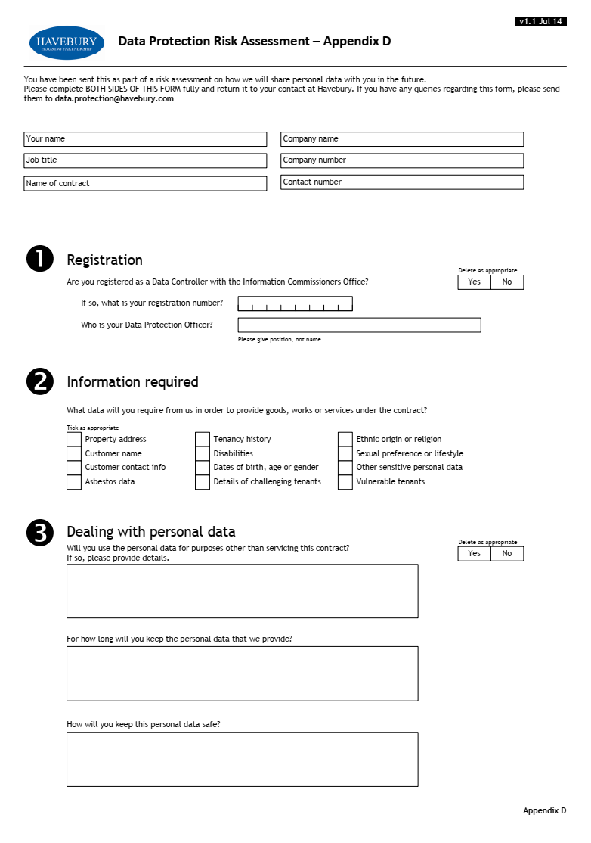

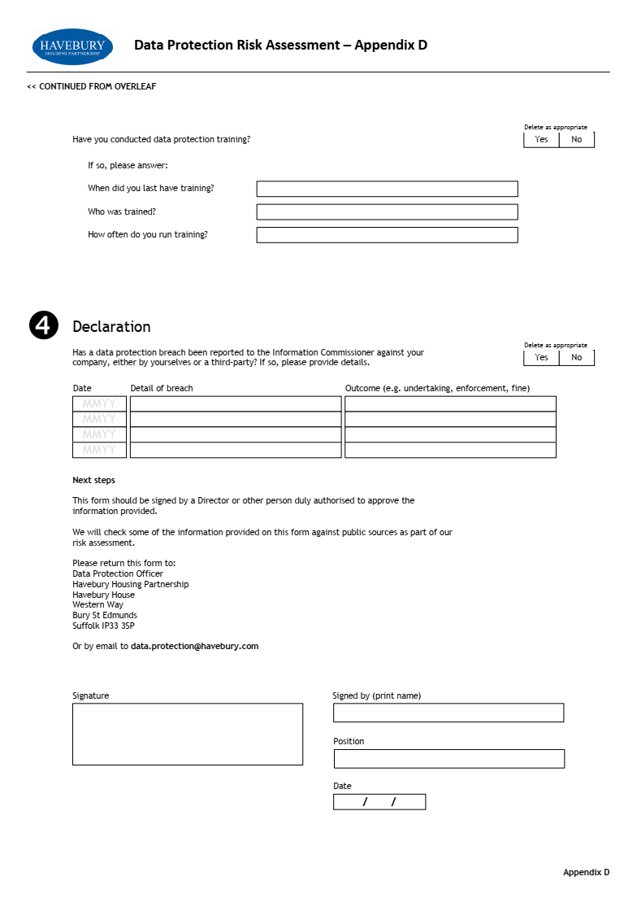
- Written Instruction of the Data Controller

